Handy hints for teaching students with vision impairment

Selection of entries submitted for the SPEVI Competition December 2011
Compiled and edited by Phia Damsma

Help Yr 2 student to read and write f and d in Braille
By Anne-Louise Butler, Support Teacher Vision Impairment, Queensland
(winning entry)

For f : “one fish has two eyes and four fins”.
This incorporates the dots 1, 2 and 4 in the letter f.
For d: “one dog has four legs and five doggy treats”.
Again using the dots 1, 4 and 5 in the letter d.

My student really liked these rhymes and it has fixed the problem she was having with these two letters.

Technique for using magnifying dome with a built-in underline
By Emily White, Visiting Teacher, Vision Impairment, Sadie McCarthy Learning Centre, VIC

My idea is for students who use one of the magnifying domes with a built-in underline. If they are struggling with decoding the word, they can turn the dome 90 degrees so that the line is vertical, and use the line to separate the word into "chunks". For example, if the word is "print", they could put the line between the r and the i, then sound out "pr" and then "int", moving it along the word as needed to definitively break it up without trying to use their (or your!) hand to cover up the other letters in the word, which is just about impossible when using a dome anyway!

Using music to develop reading speed, flow and confidence, through predictability and repetition.
By Lea Nagel, SVRC Victoria, Australia

Students: pre-school and early braille readers
This idea has been used in our Dot Power Program at SVRC with a group of approx. 10 braille reading children between the ages of 4 and 10.

Teach a song - a great fun one is "The Postman". It's a bit silly and funny and has a simple tune and repetitive, short verses. (see words below)

- Open the illustrated braille book to the song.
- Read through the illustrated book, paying attention to illustrations, match with plastic representations of pictures. Search for focus words & page numbers, and generally familiarise children with the book.
- Students read along with the braille while they sing. Sing slowly - slow enough for them to keep up. Pause while children turn pages, but use this opportunity to help them learn skills for efficient page turning, and encourage a little more speed each time.
- Repetition is easy with this song (and other songs!). Because singing is fun, children happily re-sing!
- Each verse is a repetition in itself!
- More repetition: Sing and read while pairs of children act out the part of the postman and a person receiving the weird mail! Use props - plastic bugs, letter, letter box, and costumes - postman helmet and silly home-owner's dress or apron. Laugh! Relax!
- Invite children to individually or in pairs read or sing the book to the rest of the group.
- Sing and read again later in the day or on other days as many times as the children want.
- Sing and/or read to parents, classroom teacher, principal ... whoever will listen.
- Take book home, read again for fun, read next week etc

Here are the words:
The postman came on a Monday and put a letter in the letterbox.
The postman came on a Tuesday and put a letter and a spider in the letterbox.
[Wednesday: add a bug, Thursday: add a frog, Friday: add a moth*]
The postman never came again. He was fired, and he was told, that he was a very silly boy.

To hear the tune - still in the learning process!
http://www.svrc.vic.edu.au/media/EPthepostman.mp3
* insects or bugs were chosen for their braille differences and availabilitiy of plastic bugs, eg spider, snail, slug, snake were all a bit too braille-similar

Braille ‘flashcards’ and little books using craft eyes (eye dots) to develop fine hand and discrimination skills.
By Trish Bishop, Resource Teacher, Vision, Blennz Palmerston North (late entry)

I would like to share what I did with my 5-6 year old student who is blind. She started school with very poor physical skills, evident in lack of spatial orientation, lack of confidence in moving, poor hand skills, and difficulty discriminating differences between textures. It was apparent that she could not discriminate between braille dots. To address the need to develop her fine motor skills, I made braille ‘flashcards’ and little books using craft eyes (eye dots). The idea was to develop her hand and discrimination skills from gross to fine.

A physical skills program was initiated to run
alongside this process to promote her gross motor development

I started off with using a marble block (as shown in the top right of Figure 1). My student had to place the marbles in the holes according to instructions given, eg. ‘put a marble in the top left, and top right hole.’ Real objects representing initial sounds were paired with this activity, eg. a car, cat, cup, candle etc, and we verbally discussed how many dots formed the letter ‘c’. This progressed and followed with these activities:
I made a letter in a marble block, and she had to copy it in her marble block.
Match the letter made in the marble block to a ‘eye’ letter, either from a flashcard or a book (Figure 1).

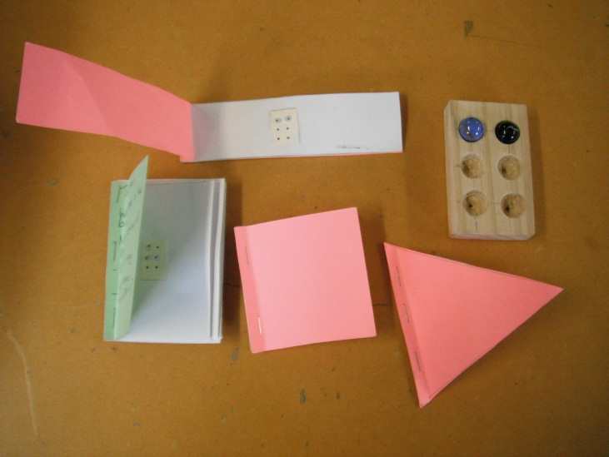
Figure 1: Marble block and little books with braille letters made from ‘eyes’.

Match a ‘eye dot’ flashcard to the marble block, or build the letter using the marble block, verbalising where the dots were, ie, top, middle and bottom left makes ‘l’. (This doubled as a hand skill activity, encouraging her to use her hands more effectively).
Placement of marble letter was recorded on her Dictaphone, and used as a homework motivation that afternoon.

As time went by, I used smaller and smaller ‘eyes’.
We progressed to piaf braille letters, matching these first to the ‘eye dot’ cards. (Figure 2) Phonic books with Velcro strips were made so that she had a book to take home and use for ‘reading’.
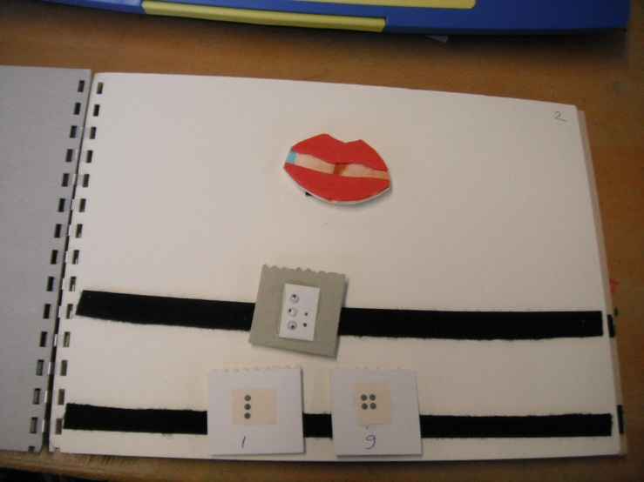
Figure 2: ‘l’ for lip; ‘eye’ card flashcards on top row, piaf dots on bottom row.

Piaf and ‘eye’ braille letters were then matched to conventional braille letters, as shown in Figure 3. She used the memory of the number of dots to remind herself how many dots forms a letter, and how they are orientated.

My student is gradually developing the fine discrimination necessary to discriminate between braille dots.
This process has taken a year. The advantage of this method is she has been immersed in literacy, developing the tactual skills she needs to read braille in the process.
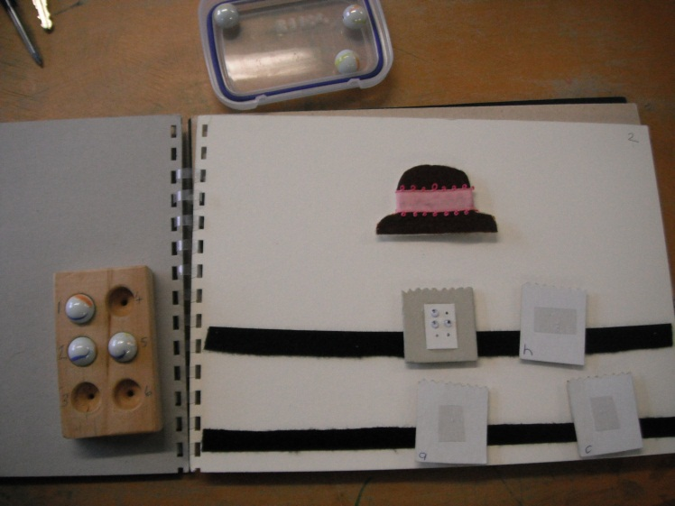
Figure 3: Matching ‘eye’ card to braille dots

