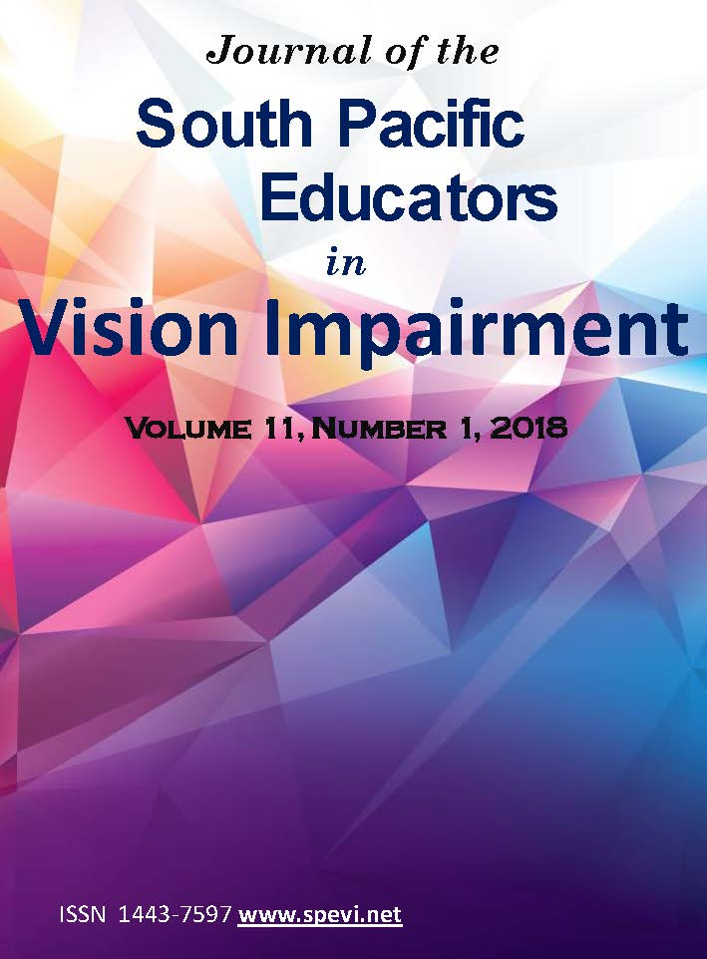

Table of Contents
Role of the SPEVI Journal 3
President’s Message 7
Editorial 10
Preparing for Higher Education: Readiness of Vision Impaired Students for Access to Materials 12
Learning English as a Foreign Language: A Case Study of Students with Vision Impairment at a Beninese University 26
Teaching Orientation & Mobility in NSW Public Schools: A Collaborative Approach 39
Audio Based Coding: An Innovative Approach to Accessible Coding for Children who are Blind 49
Space Camp for Interested Vision Impaired Students – (SCIVIS) 59
Report: International Council for Education of People with Visual Impairment 64
Report: New Sonokids’ audio based game apps for iPad 68
RIDBC to launch online braille mathematics training program 70
Congratulations Dr Frances Gentle AO 71
Tribute to Sharon Barrey Grassick 71
SPEVI Conference January 2020 73
About SPEVI 74

Role of the SPEVI Journal
The South Pacific Educators in Vision Impairment (SPEVI) Inc. is the major professional association for educators of students with vision impairments in Australia, New Zealand and the South Pacific region. SPEVI acts as the professional body in matters pertaining to the education and support of preschool and school-age students who are blind, have low vision, deaf-blindness, or additional disabilities.
The Editorial Committee intends the Journal to be a vehicle for informing researchers, administrators and educators working in government and non-government education organisations, as well as specialist and generic teachers, orientation and mobility (O&M) instructors, allied professionals, parents and others in our communities about research, issues, policies and their implications for practice in Australia, New Zealand and the Pacific Region.
Editorial Committee
Dr Bronwen Scott, Independent Options for Mobility, Victoria
Dr Frances Gentle AO, RIDBC Renwick Centre, Royal Institute for Deaf and Blind Children; the University of Newcastle and Macquarie University, NSW
Dr Elaine Gilmour, Blind and Low Vision Education Network New Zealand
Dr Michael Steer, AM, RIDBC Renwick Centre, the University of Newcastle and Macquarie University
Assoc. Prof. Paul Pagliano, School of Education, James Cook University, Townsville, QLD
Editorial Advisory Panel
Dr Jane Brown, Education Queensland
Dr Desirée Gallimore, Guide Dogs NSW/ACT & RIDBC Renwick Centre, NSW
Ms Josie Howse, Braille and Large Print Service, Department of Education and Communities NSW
Ms Michelle Knight, RIDBC VisionEd, Royal Institute for Deaf and Blind Children
Ms Debra Lewis, Statewide Vision Resource Centre, Victoria
Ms Sue Silveira, RIDBC Renwick Centre, the University of Newcastle and Macquarie University

Design of front cover by Lena Karam, RIDBC Renwick Centre, Royal Institute for Deaf and Blind Children
Printing by The Printing Hub, Carrum Downs VIC
© South Pacific Educators in Vision Impairment Inc. ISSN 1443-7597
This work is copyright. Apart from uses permitted under the Copyright Act 1968, no part may be reproduced by any process without written permission from SPEVI Inc. Requests and inquiries should be directed to the Convening Editor, Bronwen Scott, RIDBC Renwick Centre, Private Bag 29, Parramatta NSW 2124 Australia, Email: bronscott@iinet.net.au
Opinions expressed in this publication do not necessarily represent the views or policies of SPEVI, but have been presented to stimulate informed debate.
Permission to Copy
No specific permission is required to photocopy or reproduce a single copy of a complete article as it appears in the Journal of South Pacific Educators in Vision Impairment, if the reprint is for free distribution within an educational organisation or classroom. Permission for other reprinting or re-publication must be obtained from the Editors.
SPEVI Journal Subscription and Membership
SPEVI membership is open to educators, professionals and parent groups supporting children and adults with vision impairments. This Journal is available in an open access format at http://www.spevi.net/jspevi/. Membership information and forms are available on the SPEVI website, http://www.spevi.net/spevi/index.php. Please direct all correspondence regarding JSPEVI to the Convening Editor Bronwen Scott.
Call for Articles
Original manuscripts, reports and news items are sought for the refereed and non-refereed sections of the next issue of JSPEVI. Topics appropriate for the journal include, but are not limited to the following:
- original research studies, with practical relevance to education of persons who are blind or vision impaired,
- literature and book reviews,
- conceptual, policy or position papers,
- descriptions, reviews or evaluations of innovative instructional curricula, programs or models of education for persons who are blind or vision impaired, and
- letters to the Editor

Letters to the Editor
Members of the editorial committee wish to encourage discussions of important issues that affect the education of children and adults with vision impairments. The journal should be a vehicle for continuing dialogue about current and future directions. The editorial committee invites letters that explore the many issues facing professionals and families supporting learning with sensory disabilities, particularly those arising from articles in the journal.
Guidelines for Contributors
Manuscripts that are of a scholarly nature should be submitted electronically, with the content subdivided into the following two files:
File 1 Author information
Authors must submit a separate file containing (a) the manuscript title, (b) author or authors’ name, professional title/status and organisational affiliation of authors, and (c), preferred contact details (address, email, fax, telephone) for the principle author (or co-author) who will be handling correspondence.
File 2 Manuscript
Manuscript presentation: Manuscripts should be submitted in Arial 11-point font, double line spaced, with left aligned paragraphs, 2.54cm page margins (normal margin setting) and numbered pages. A running title header should be included on each page (with no authorship information included).
Size limit: The preferred size limit for scholarly manuscripts is 5000 words or less. The preferred size of agency reports is one A4 page of single line text.
Abstract: Academic manuscripts should include an abstract of 120 words or less, giving a brief summary of the overall content. The abstract may be followed by a list of key words.
Figures and tables: Numbered figures and tables should be included in the manuscript. Tables should be created using a table function, and figures submitted in Black and White, with consideration to the readability of the figure when reduced for publication.
Referencing guidelines: Citations and references included in manuscripts should conform in style to the American Psychological Association (APA). APA guidelines are available on the Newcastle University website: http://libguides.newcastle.edu.au/apa-6th, or the Curtin University website: http://libguides.library.curtin.edu.au/content.php?pid=141214&sid=1335391.

Acknowledgments and permissions: Please note that authors are responsible for all statements made in their work and for obtaining permission from copyright owners to reprint or adapt a table or figure, or to reprint a quotation of 100 words or more. In such instances, authors should write to the original author(s) and publisher(s) to request non-exclusive world rights in all languages to use the material in the article and in future editions. Please provide copies of all permissions and credit lines obtained. Credit (acknowledgement) should be included in the manuscript for any type of sponsorship, donations or grants, or technical assistance, or to professional colleagues who contributed to the content of the article, but who have not been listed as authors.
Compliance with ethics requirements: For manuscripts reporting original research studies, authors are responsible for ensuring that the reported research has been conducted in an ethical and responsible manner, with full compliance with all ethical requirements and legislation. This includes adherence to privacy and confidentiality guidelines regarding publication of participant information, including de-identification of participants’ information and data. Authors must confirm in the manuscript that written consent has been obtained prior to publication if participant information is included. Where such a person is deceased, authors are responsible for securing written consent of the deceased person’s family or estate. Authors are encouraged to consult the Australian Government National Health and Medical Research Council’s National Statement on Ethical Conduct in Human Research (2007) – Updated March 2014, see http://www.nhmrc.gov.au/guidelines-publications/e72.
Manuscript review process: Manuscripts will be acknowledged upon receipt. Following preliminary editorial review, articles will be sent to members of the Editorial Advisory Panel and where warranted, to consulting reviewers who have particular expertise in the subject. This journal uses the “blind review” system. Reviewer feedback will be sent to the author/s with an invitation to revise the manuscript content and/or respond to the reviewers’ comments. The review process may sometimes take up to three to four months. The names of consulting reviewers will periodically be published in the journal. Reviewed manuscripts will remain the property of South Pacific Educators in Vision Impairment (SPEVI). Authors will be advised in writing if their manuscripts are not accepted for publication.
Permission to copy: No specific permission is required to photocopy or reproduce a single copy of a complete article as it appears in the Journal of South Pacific Educators in Vision Impairment, if the reprint is for free distribution within an educational organisation or classroom. Permission for other reprinting or re-publication must be obtained from the Editors.
Manuscript submission: Please forward your contributions for the 2019 issue of JSPEVI to the Convening Editor, Dr Bronwen Scott, Email: bronscott@iinet.net.au.

President’s Message
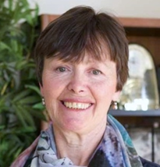
Phia Damsma and Dr. Frances Gentle AO, Presidents
Dear Readers
Welcome to the 2018 Volume of JSPEVI. As we write this message, preparations are underway for the 2020 SPEVI Conference which will take place in Adelaide from 12th to 15th January 2020. The event manager, conference venue and first keynotes have been locked in. The South Australia Local Organising Committee (LOC) has set the conference theme as “Creating a clear vision for the future”, and is currently preparing an exciting and informative conference program that will reflect current research, practice and innovation in the field of education for children and young people with vision impairment. We look forward to welcoming you to Adelaide, in January 2020!
SPEVI Office Bearers
SPEVI members in Australia, New Zealand and Pacific Island countries are supported by national and branch office bearers. It is the responsibility of office bearers to ensure that SPEVI’s activities are aligned with the Mission, Vision and Aims of the Association, as set out in the Constitution – see http://www.spevi.net/constitution-and-policies/.
The national office bearers in Australia and New Zealand are as follows:
- Presidents: Phia Damsma, Frances Gentle and Sharon Duncan
- Secretaries and Membership Secretaries: Carly Turnbull and Bronwyn Paine
- Treasurers: David Rice and Jude Shelley
- Convening Editor, JSPEVI: Bronwen Scott
- SPEVI Web and List Coordinator and Chair, SPEVI VI-NDIS Working Group: Phia Damsma
- Representative, International Council for Education of People with Visual Impairment (ICEVI): Ben Clare
- SPEVI Facebook page: Ben Clare and Linda Flavell
- Representative, Round Table on Information Access for People with Print Disabilities: Brian Conway
Office bearers in Australia also include Pranitha Moodley (Vice President), Sue Silveira (Public Officer), and Paul Pagliano (Executive Member).
Accessible 3D Printed Graphics research project
SPEVI is a proud sponsor of “Accessible 3D Printed Graphics”, an Australian Research Council (ARC) project at Monash University (Victoria). The project goal is to “overcome the existing barriers to accessible 3D printed models by developing evidence-based guidelines for their use and design, and building capability in the project partner organisations.” The research team will develop six work packages: (i) teaching STEM, (ii) teaching tactile literacy, (iii) maps and floor plans, (iv) teaching place and geography, (v) adding interactive audio labels and (vi), synthesis and dissemination of findings.
The Accessible 3D Printed Graphics project is aligned with SPEVI’s Mission and aims, and in particular our third aim which is “to encourage the highest standards in the educators of persons with vision impairment by promoting research and professional training for general and specialist teachers.” We look forward to supporting the research team, Kim Marriott, Matt Butler, Sonali Marathe and Leona Holloway.
SPEVI and the National Disability Insurance Scheme
The SPEVI VI-NDIS Working Group responded on behalf of SPEVI to an inquiry by the Joint Standing Committee on the National Disability Insurance Scheme (NDIS) into the provision of assistive technology within the NDIS. The Joint Standing Committee was established in 2016 by the Australian Government House of Representatives and is tasked with inquiring into the governance, administration, implementation and performance of the NDIS.
The SPEVI VI-NDIS Working Group submission was compiled from feedback from SPEVI members from a range of professions, including specialist teachers (VI), allied health professionals, technology consultants, and NDIS assessors and planners. The Final Report was published in December 2018 and links to the executive summary and full report are available on the SPEVI website – see http://www.spevi.net/ndis/spevi-vi-ndis-working-group/. We are pleased to note that the Report’s recommendations include several of the important issues that were raised by the SPEVI VI-NDIS Working Group.
SPEVI Website and Facebook page
We invite you to visit the SPEVI website at www.spevi.net, and to contribute to SPEVI’s Facebook page. These online platforms are regularly updated and offer a wealth of information and resources for professionals and families who support children and young people with vision impairment. The SPEVI website will provide you with up-to-date information on the 2020 SPEVI Conference, with links to the dedicated SPEVI Conference website, once this becomes available. The SPEVI website includes digital copies of previous volumes of JSPEVI – see http://www.spevi.net/jspevi/.
We acknowledge with thanks the Editorial Committee and content contributors.
Phia Damsma and Dr. Frances Gentle AO, Presidents
Email: phia@sonokids.com
frances.gentle@ridbc.org.au

Editorial
Welcome to JSPEVI’s eleventh volume. The journal aims to provide a forum for scholarly exchange among organisations and individuals who support and promote education for learners with vision impairment. Our first two articles in this issue explore some of the challenges for students with vision impairment entering the tertiary education sector. The first, from Holloway and Lewis, explores the gaps that need to be addressed for students entering higher education in Australia. The second is a paper from outside our region, the West African country of Benin, where Agbayahoun and Lanmantchion report on classroom practices for university students with vision impairments participating in English as a Foreign Language (EFL). It is interesting to compare both the similarities and the differences between these two regions.
The advents of the National Disability Insurance Scheme (NDIS) in Australia has bought significant change to how services such as orientation and mobility (O&M) are delivered. A paper from Traynor and myself discusses how these changes are impacting the provision of O&M to students in the New South Wales public school system. The following paper provides an exploration into the development of an iPad app that enables young children who are blind to learn foundation skills of coding. Damsma and Norgaard explain the concept of Audio Based Coding, which supports both sighted children and those who are blind to learn coding through a combination of audio and visual representations.
In our series of reports from around the region, we have a great account from teachers Moodley and Wallace on their exciting journey with three students to attend Space Camp for Interested Vision Impaired Students (SCIVIS) in the United States. SCIVIS is a NASA operated program that takes place at the US Space and Rocket Centre, in Huntsville, Alabama for a week every year, and is a fantastic opportunity for students to develop a range of skills and worldwide friendships.
Ben Clare and Frances Gentle provide an update on a number of projects that the International Council for Education of People with Visual Impairment (ICEVI) was involved with during 2018. They discuss a range of initiates involving our South Pacific neighbours of Kirabati, the Fiji Islands and Samoa, as well as global initiatives including upcoming SPEVI and ICEVI events. This year’s volume also includes updates on Sonokids’ audio based game apps for iPad, and an initiative from the Royal Institute for Deaf and Blind Children (RIDBC) to launch an online braille mathematics training program.
We conclude the volume with both congratulations and condolences. Firstly, congratulations to Dr Frances Gentle on being named in the 2018 Queen’s Birthday Honours list as an Officer on the Order of Australia. All of us involved with SPEVI know the countless hours Fran commits to both SPEVI and ICEVI and we congratulate her on this well-deserved recognition.
It is with sadness that I also include a tribute to Sharon Barrey Grassick who passed away in August 2018. Sharon was a personal friend and a wonderful mentor when I first entered the profession of O&M in Perth in the late 1980s. Dr Mike Steer has written a detailed tribute outlining the incredible contribution Sharon made to the field of deafblindness. She is truly missed.
In 2018, the decision was made to provide the journal in an online format accessible to all on the SPEVI website, and I would like to thank Phia Damsma for her hard work in provided downloadable editions of the journal from 2014 onwards. Many thanks also to Lena Karam who has provided administrative support to ensure the journal is fully accessible – this is very much appreciated! I would also like to thank the JSPEVI Editorial Committee, Advisory Panel and authors for their work in ensuring the quality and scholarship of the articles and reports featured in the volume.
See you in Adelaide in January 2020 for the next SPEVI conference!
Dr Bronwen Scott
Convening Editor

Preparing for Higher Education: Readiness of Vision Impaired Students for Access to Materials
Leona Holloway & Debra Lewis

Abstract
Lack of skills for navigating the university system pose a barrier to inclusion and achievement for students with vision impairments in higher education in Australia. Using results from a 3-year study into the experiences of students with vision impairments in higher education in Australia, we explore the gaps that need to be addressed for students with vision impairments to better reach their potential. In particular, students require more information about what to expect at university, strong self-advocacy skills, the right adaptive technology and the skills to use this technology.
Keywords: Vision Impairment, Higher Education

Introduction
The Victorian Department of Education and Training (DET) works toward a vision for "excellence in learning and development from the crucial first years of life, through school education to training and higher education, and the promotion of lifelong learning for adults" (Department of Education and Training, 2017, p. 2). The school curriculum is designed to prepare students to "reach their potential regardless of background, place, circumstance or abilities" (Department of Education and Training, 2017, p. 2). However, students with disabilities and impairments may require additional skills in order to reach their potential in the post-school study environment.
"Improving access to graphics for vision impaired students in higher education" (Butler, Holloway, Marriott & Goncu, 2017) was a three-year research project funded by the Australian Government Office for Learning and Teaching (OLT). While the study focused on access to graphics by students with vision impairments, lack of readiness for the higher education environment emerged as a recurrent theme.
In Australian primary and secondary schools, students with vision impairments may be eligible to receive additional support through specialist vision support programs (South Pacific Educators in Vision Impairment, 2016). For example, in Victoria DET employs Specialist Educators (Vision Impairment (VI)) who provide training, support and resources for students with vision impairments, their teachers and Educational Support Staff. DET also funds the Statewide Vision Resource Centre Support Skills Program (including Dot Power) that focus on teaching areas of the Expanded Core Curriculum (ECC), "the additional skills and strategies required by students with vision impairments in order to access the regular 'core' curriculum and participate in school life and beyond along with their sighted peers" (Statewide Vision Resource Centre, n.d., para. 1). The ECC is unique to each student and may include compensatory access, sensory efficiency, adaptive technology, orientation and mobility, independent living, social interaction, recreation and leisure, career education and self-determination. Students with vision impairments who have been supported by a qualified and experienced Specialist Educator (VI), should be confident users of technology, capable travellers and have the ability to communicate effectively, self-advocate and access information. The goal is to provide a consistent and robust approach, with strong emphasis on building skills and literacy through access to all elements of the curriculum.
The university learning environment differs markedly from the school setting in terms of scale, structure and expectations. All students, including those with vision impairments, require a high level of organisation, independence and self-advocacy as they navigate their chosen course.
Higher education institutions manage their own student population, each with its own Disability Support Service to oversee the needs of students with diverse profiles including mental health issues, learning difficulties and physical disabilities. Students with vision impairments represent less than 15% of students declaring a disability in higher education (DET, 2015a), and are not a homogeneous group.
The cost associated with providing accommodations for local students is shared equally between the university and the Commonwealth government through the Disability Support Program (DET, 2015b). The university offers a range of services but relies on the student to inform them of their needs and to request any reasonable adjustments that may be required.
Internationally, there is concern that the teaching of independence is often neglected in school education and that young people with vision impairments leave compulsory education without the necessary skills to successfully navigate higher education and the workplace (Douglas & Hewett, 2014; Sapp & Hatlen, 2010). Is this also the case in Australia?
We will explore in greater depth the skills and technologies that may be helpful for students with vision impairments to access learning materials in higher education, along with the issue of transition from secondary school.

Methodology
Data, observations and feedback from staff and students in the higher education disability sector were collected over four stages.
National online survey
A national online survey of students with vision impairments in higher education was conducted to gather information about their current level of access to graphics and whether it was adequate for their needs. Responses were received from 71 participants, of whom 60 completed the whole survey and 11 provided partial completion. All were either undertaking their studies in 2015 or had completed their studies in the previous five years. Participants represented 26 universities across Australia, with 47% from Victoria and none from Tasmania or the Northern Territory. The majority of students were undergraduates (70%) but there was a broad range of ages, with only 35% of respondents in the typical undergraduate age group of 18-24.
Semi-structured interviews
Semi-structured interviews were conducted with students with vision impairments and disability service providers in higher education to better gain an understanding of the students' access to learning materials. A total of 44 participants took part, including current or recent university students with a print disability (n=13), disability services staff (n=12), academics with experience teaching students with vision impairments (n=10) and staff involved in the production of accessible formats (n=9) across ten different organisations. Most interviews took 30 to 60 minutes and questions related to the participant's background, university materials, provisions for students with vision impairments and evaluation of current practices.
Pilot studies
The next phase of the project focused on trialling and evaluating practices and formats for improved access to graphics. Three pilot studies were conducted, in which strategies were implemented for seven students for at least one semester each. The project team worked closely with the student (n=7), their lecturers (n=9) and tutors (n=3), disability support staff (n=3) and accessible format providers (n=3) to gather observations, make suggestions and provide additional resources or training. Semi-structured interviews were conducted with all participants at the end of each semester.
Workshop
In the final stage of the project, participants from all prior studies were invited to take part in a one-day consultation workshop at which the results were presented, representatives of each stakeholder group shared their perspectives, issues were discussed and suggestions were made using a collaborative approach. Sixteen people attended: Students with vision impairments (n=5), disability services staff (n=3), academics (n=2) and accessible formats producers (n=6).

Results
Self-advocacy
Self-advocacy is a component of the ECC's self-determination, along with self-knowledge, awareness of individual rights and responsibilities, problem-solving and goal-setting. Self-advocacy involves being able to communicate one's needs and wants effectively and confidently.
Services for students with disabilities offered by universities may include provision of essential learning materials in electronic text or braille; note-taking in classes; alternative arrangements for exams including extra time, rest breaks, reader/scribe and separate exam venue; use of access technology at campus libraries; and short-term loan of equipment. While additional support and services for students with vision impairments may be available, it is up to the student to seek assistance.
Fifty percent of the national survey respondents stated that they "asked for the specific services I wanted" rather than being offered suggestions of what was available and suitable for their needs. Disability Liaison staff at universities admitted to having limited knowledge about the specialised needs of students with vision impairments.
We rely very much on students to tell us what they need, rather than being able to make suggestions or give referrals. (Disability Advisor)
However, students may be unaware of services for students with disabilities, unaware of the process for applying for this support, or lack the necessary self-advocacy skills to engage these services. Indeed, 50% of respondents to our survey had experienced a recent deterioration in vision. Once services and support has been negotiated and agreed upon through Disability Support Services, details may need to fine-tuned and confirmed. For example, graphics are usually not included in accessible format versions of learning materials unless the student specifies which diagrams are needed (and this is best done in consultation with their lecturer or tutor). Similarly, supplementary course material such as practice exams will often not be provided in accessible format unless specifically requested.
Academic staff, often dealing with very large student numbers, may not be aware of the range of individual needs of their student population. In this study, only 6% of respondents to the national survey reported that academics had initiated communication with them about accessibility. Instead, the students made contact with their lecturers at the beginning of semester (70%) and as issues arose throughout the semester (62%). Lack of awareness emerged as a key theme in response to a survey question about the main barriers to accessibility at university, and the subsequent need for self-advocacy was highlighted in many of the semi-structured interviews with students.
Academic staff ... were always understanding and helpful but often forgot about me until I reminded them of the issue. (Student)
One email among the 150 I receive every day ... was not enough to prompt me to plan ahead. (Lecturer)
I contacted the local lecturers close to day one so they knew I existed. I didn't contact guest lecturers but I will this year because it created trouble. (Student)
Students with vision impairments who participated in the national survey also commented on the importance of being assertive.
It has been a long battle over many years. (Student)
Less assertive students missed out on materials and learning opportunities because they were too hesitant to ask for help. For example, 84% of the survey respondents indicated that they had sometimes or often "skipped over graphical material and potentially missed important information because it was inaccessible".
I just don't bother [asking for help because] I don't want to look like a weirdo. (Student)
While it can be daunting for students to approach senior academics, it is helpful to know that university staff welcome such communication, with disability advisors, lecturers and tutors making numerous comments about the value of hearing from the student about their needs, and for feedback.
It is important to engage. Even if everything is okay, it's important to keep checking in. (Disability Advisor)
It is also worth noting that registrations for disability support occur at two peak times: At the beginning of semester and then just prior to the end of semester when assignments are due and examinations are pending. Students in this latter category need to go through the registration process while dealing with study pressures and would be better served by registering earlier. Given the lengthy lead times required for the production of accessible formats, all students with vision impairments would be well-advised to be organised, pro-active and assertive. Selection of units of study should take place early; and registration with Disability Support Services at least two months prior to the beginning of semester.
Timeframes are THE issue [with alternative format provision] for students, and particularly blind students. (Disability Advisor)
Access to technology
Students with vision impairments generally rely on adaptive technology (specialised hardware, software, and devices) that allow them to participate in their learning environment along with their sighted peers. It is too often assumed that students will arrive at university with the adaptive technology they require, however this is not always true. For example, students with vision impairments in Victorian government schools are provided loan equipment (that remains the property of DET and must be returned when the student leaves school (State Government of Victoria, 2018). Adaptive equipment can be very expensive, for example a refreshable braille display (the equivalent of a computer monitor) or braille embosser (the equivalent of a desktop printer) cost thousands of dollars each. The Disability Support Program covers adaptive software and equipment (DET, 2015b), however in practice universities generally provide only relatively low-cost software and equipment housed in adaptive technology rooms in the main library, or short-term loan equipment, for example a recording device.
According to the national survey responses (Table 1), the provision of adaptive equipment by universities is appreciated by students with vision impairments but there are many instances in which more or different equipment would be desirable.
Table 1 Number of students with vision impairment from national survey provided with adaptive technology services and whether the service was helpful
Service | Provided & helpful | Provided but not helpful | Not provided but could have benefited
Use of an adaptive technology room | 16 | 5 | 6
Adaptive technology loans | 9 | 2 | 10
Adaptive technology advice | 19 | 6 | 7
Adaptive technology training | 7 | 0 | 8
For expensive adaptive technology, external options should be explored. Students can request funding for adaptive technology through the National Disability Insurance Scheme (NDIS) (National Disability Coordination Officer Program, 2018) providing there is evidence that technology is for general use or to achieve lifelong goals. Vision Australia offers a Further Education Bursary annually, providing adaptive equipment for study at the post-school level for 330 students since 1996. The Bursary is available to Vision Australia clients in all states and territories except South Australia (Vision Australia, n.d.)
Skills
Students with vision impairments require a broad range of technology skills at a high level in order to successfully access information and manage and produce their own study materials at university. Such skills include the ability to take notes swiftly and efficiently; the ability to search for information on websites, the university library databases and other electronic sources; the ability to "switch" between different technologies for different activities (for example audio reading for information, braille reading for more detailed analysis or to check spelling); organisational skills, particularly efficient storage and retrieval of electronic files; the ability to work with a human reader for material that is inaccessible such as diagrams; and the ability to scan and OCR inaccessible documents. While some of these skills are similar to those required by sighted students; many are additional or more complex for students with vision impairments. Moreover, entirely new formats or technologies may be required for university studies. For example, a student who was primarily using braille at secondary school may need to make more use of electronic text at university. They may be changing to a different braille display or screenreading software. Or, they may be studying a new subject area such as statistics or computing with its own software and document types.
Technology training was a recurring theme in semi-structured interviews the national survey.
I need specialist training. (Student)
I lack training. It's really hard to access training. (Student)
I would love someone to be able to sit down with me and show me how to use Zoom and VoiceOver in a Mac environment. (Student)
Even when students felt confident to learn new technology skills, they did not have time to do this during semester.
I needed to be familiar with the methods first. It took me time to get up to speed. (Student)
I was too busy. I didn't have time to mess around. (Student)
At the workshop, all participants agreed on the importance of student skills or transition programs to build these skills.

Discussion and recommendations
Participants at each stage of this study noted the challenges for students with vision impairments making the transition from school to post-school education. There was general agreement that far fewer supports and services are available at university than students have been accustomed to at school. The importance of student skills and the transition to university was repeatedly highlighted by students and disability advisors as a key issue at all stages in the study. This in keeping with international studies of students with disabilities in higher education (Kann, 2001; Getzel & Webb, 2014).
With a strong culture of "provision upon request" at most universities, it is vital that students both have good self-advocacy skills and know what to ask for. In keeping our findings in higher education, there is evidence that independence skills are associated with positive employment outcomes for people with vision impairments (McDonnall, 2011; Wolffe & Kelly, 2011). Yet, self-advocacy skills are not enough; students must also be proactive in seeking out information about accommodations that are available. Our findings reflected those of a recent Australian study finding that almost half of students who register for disability services in higher education are unaware of the accommodations available to them (Kent, 2016).

Recommendations
Students with vision impairments are at risk of missing out on educational opportunities at university unless they are well prepared for the higher level of independence expected there.
The transition to post-school education begins while students are at school. Students with vision impairments should participate in career education and counselling along with work experience during their middle years of secondary college. There is evidence that active student participation in Support Group Meetings, family members who demonstrate strong advocacy skills, and links with a broad number of community support services throughout secondary school are associated with strong self-determination and better higher education outcomes for students with disabilities (Morningstar et al., 2010).
Along with these suggestions, participants in the research indicated that the following supports would promote successful transition for students with vision impairments to post-school education.
Transition programs
Transition programs can prepare students with vision impairments for higher education through the provision of information about university and coaching in required skills.
Internationally, residential and intensive customised courses for young adults with vision impairments are available from blindness agencies, such as the immersion courses by BLENNZ (New Zealand) (http://www.blennz.school.nz/school-centres-and-services/services-and-programmes/immersion-courses/) and vocational education by ChildVision (Ireland) (https://childvision.ie/site/programmes/education/). Students can select from a range of practical courses to develop skills to assist with independence and success in study or work, such as computing, adaptive technology, braille, orientation and mobility and other life skills. Similar opportunities are more difficult to find in Australia, however some individual courses and training programs for people with vision impairments are offered by blindness organisations such as Vision Australia, Guide Dogs Victoria and VisAbility.
It is worth considering whether additional time should be taken between completion of secondary school and commencement of higher education to undertake such transition programs.
Early contact between students and universities
As the provision of disability services is administered locally by each university, significant differences exist. Students are advised to visit university Open Days and make contact with Disability Support Services to find out about their services and culture as part of their initial decision-making process.
We recommend that universities ensure their disability services are promoted at Open Days and as part of enrolment information. When enrolling, student should not hesitate to declare their disability, however they should also be aware that this declaration will not automatically trigger any services.
Orientation programs
As pointed out by one of the students in the semi-structured interviews, universities provide induction programs for undergraduate and postgraduate students; the same approach is required for students with disabilities, explaining the services available and how to go about accessing them. Orientation programs specifically for students with disabilities are rarely organised by the university but could be encouraged in collaboration with blindness agencies and/or education departments. Students with vision impairments should also attend general university orientation programs to learn about other services offered such as tutoring, mentoring and advocacy.
Self-advocacy
Ideally, all students with vision impairments should register for disability support as soon as they have enrolled at university, even if they do not expect to require support, in case unexpected issues arise when assignments and exams are due. Similarly, it is recommended that students make direct contact with their lecturers and tutors before the beginning of semester to alert them to their needs. Regular feedback to academic staff and disability support staff is always welcomed; this should include thanks for things that are working well, reminders of what is needed and alerts about problems encountered.
Students who are hesitant to ask for help from busy senior lecturers or fellow students can request assignment to tutorials with the lead tutor who has subject-matter expertise and can be paid by Disability Support Services to provide additional assistance when required.
[The tutor] working with [the student] worked really, really well. (Disability Advisor)
Equipment provision
Students need to know what specialised equipment and software they require and make a case for its provision through the NDIS (if for general use), the university (if for education-specific purposes), or through other schemes such the Vision Australia Further Education Bursary. Adaptive technology providers and blindness organisations can play a part in providing this information.
Skills training
Again, universities may not have the specialist knowledge required to provide adaptive technology training. Moreover, a student will ideally master the skills they require before attempting to apply them in a pressured study environment. Preparation prior to commencing tertiary study is recommended.
Mentoring programs
Mentoring programs draw on the skills and knowledge of vision impaired professionals or students: Such an approach could assist with both the acquisition of technology skills and with passing on more general tips about navigating the higher education system. Peer mentoring, preferably by students at the same university with a similar disability, has proven an effective strategy in the past but is not standard practice so must be requested or arranged by the new student.

Conclusion
A summary of our recommended skills and preparatory steps is given in Appendix A, Checklist for students with vision impairments preparing for higher education. A similar resource is provided by the National Disability Coordination Officer Program (http://www.ndcovictoria.net.au).
Our investigation of access to materials by students with vision impairments at Australian universities revealed a mismatch in expectations between students and university staff, with a high level of independence and self-advocacy required. In order to achieve to their full potential at university, students require greater awareness of how the university support system works, preparation with technology access and use, and confidence to assert their needs. Preparation can and should begin at secondary school and during the break between school and university.

Acknowledgements
Support for the production of this research has been provided by the Australian Government Office for Learning and Teaching. The views expressed in this paper do not necessarily reflect the views of the Australian Government Office for Learning and Teaching.
Our thanks are extended to members of the Project Advisory Committee and their supporting organisations: Merrin McCracken and Alex Auletta (Deakin University); Matt Brett (La Trobe University), Kim Marriott, Matthew Butler, Thomas Perry and Matthew Salas (Monash University); Karen Roberts (University of Adelaide); Karl Hughes (Vision Australia); and Bill Jolley.
Sincere thanks also to the many students, disability support staff, academics and others who contributed to the survey, interviews, pilot studies or workshop and whose voices form the basis of our recommendations.

References
Butler, M., Holloway, L., Marriott, K. & Goncu, C. (2017). Understanding the graphical challenges faced by vision-impaired students in Australian universities. Higher Education Research & Development, 36(1), 59-72. doi: 10.1080/07294360.2016.1177001
Department of Education and Training (2015a). Higher education statistics commissioned data. Canberra: Department of Education and Training.
Department of Education and Training (2015b). Department of Education and Training Evaluation of Disability Support Program Final Report. Retrieved April 2016 from https://docs.education.gov.au/system/files/doc/other/dsp_evaluation_report_final_june_2015.pdf
Department of Education and Training (2017). Department of Education and Training 2017-2020 Strategic Plan. Retrieved July 2018 from https://www.education.vic.gov.au/about/department/Pages/stratplan.aspx
Douglas, G. & Hewett, R. (2014). Views of independence and readiness for employment amongst young people with visual impairments in the UK. The Australian Journal of Rehabilitation Counselling, 20, 81-99. doi: 10.1017/jrc.2014.12
Getzel, E. E. & Webb, K. W. (2014). Transition to post-secondary education. In M. L. Wehmeyer & K. W. Webb (Eds.), Handbook of adolescent transition education for youth with disabilities. (pp. 3-34). Routledge, Taylor & Francis Group.
Kann, C. H. (2001). Computer needs of students with disabilities. Planning for Higher Education, 30(1), 35-42.
Kent, M. (2016) Access and barriers to online education for people with disabilities. Report submitted to the National Centre for Student Equity in Higher Education. Retrieved August 2016 from https://www.ncsehe.edu.au/wp-content/uploads/2016/05/Access-and-Barriers-to-Online-Education-for-People-with-Disabilities.pdf
McDonnall, M. C. (2011). Predictors of employment for youths with visual impairments: Findings from the second national longitudinal transitions study. Journal of Visual Impairment & Blindness, 105, 453-466.
Morningstar, M. E., Frey, B. B., Noonan, P. M., Ng, J., Clavenna-Deanne, B., Graves, P., Kellems, R., McCall, Z., Pearson, M., Wade, D. B., & Williams-Diehm, K. (2010). A Preliminary Investigation of the Relationship of Transition Preparation and Self-Determination for Students with Disabilities in Postsecondary Educational Settings. Career Development for Exceptional Individuals, 33(2), 80-94. doi: 10.1177/0885728809356568
National Disability Coordination Officer Program (2018). Getting the Right Support at the Right Time from the Right People: A pre-planning Toolkit for people who are Blind or have a Vision Impairment entering Higher Education or Vocational Education and Training. Retrieved July 2018 from https://www.adcet.edu.au/download/attachment/9828-1/
Reed, M., & Curtis, K. (2012). Experiences of students with visual impairments in Canadian higher education. Journal of Visual Impairment & Blindness, 106(7): 414–425.
Sapp, W. & Hatlen, P. (2010). The expanded core curriculum: Where we have been, where we are going, and how we can get there. Journal of Visual Impairment & Blindness, 104, 338–348.
South Pacific Educators in Vision Impairment (2016). SPEVI Principles and Practice: Guidelines for quality education of learners with vision impairment, 2nd edition. Retrieved 15 May 2018 from http://www.spevi.net/wp-content/uploads/2016/08/SPEVI-Principles-and-Practice-2nd-Ed-Web.pdf
State Government of Victoria. (2018). Inclusive education equipment boost for schools. Retrieved 29 November 2018 from https://www.education.vic.gov.au/school/teachers/learningneeds/Pages/equipmentforschools.aspx
Statewide Vision Resource Centre. (n.d.). SVRC vision support skills program. Retrieved 29 November 2018 from http://svrc.vic.edu.au/support-skills
Vision Australia. (n.d.). Other benefits and funding options: further education bursary. Retrieved 10 October from https://www.visionaustralia.org/referral/benefits-and-funding/further-education-bursary
Wolffe, K. & Kelly, S. (2011). Instruction in areas of the expanded core curriculum linked to transition outcomes for students with visual impairments. Journal of Visual Impairment & Blindness, 105, 340-349.

Appendix A: Checklist for students with vision impairments preparing for higher education in Australia
Self-advocacy skills
- I understand my vision impairment and its impact on my ability to participate in my learning environment and to access information
- I am comfortable describing my disability and the accommodations I need to others
- I ask for accommodations when needed
- I am an active participant at my school Support Group Meetings
- I understand my legal rights, including those outlined in the Disability Standards for Education (2005)
- I have connections with a number of external support networks, including blindness agencies and support groups
Organisational skills
- I have a good system for filing and retrieving electronic documents
- I manage my own calendar
- I have good note-taking skills
- I complete tasks on time
Access to technology
- I have my own device to access electronic documents
- I am aware of a broad range of adaptive technology options; not just those I already use
Technology skills
- I am an efficient touch-typist (minimum 50 wpm)
- I am an efficient user of key commands
- I know how to download electronic documents
- I know how to use the university's library databases
- I know how to use university's online learning environment (e.g. Moodle)
- I know how to convert a print document to a format that I can access
- I am able to access text in more than one mode
- I am an efficient audio reader
- I am familiar with any new software that I will need to use at university
Choosing a university
- I have attended several university Open Days
- I have learned about the Disability Services offered at several universities, both through their web pages and by speaking with their staff
Familiarity with my chosen university
- I know how to independently travel to my university
- I am able to independently navigate within the university
- I have registered with the Disability Services Unit
- I know what services the Disability Service Unit can offer
- I know where to seek advocacy support at the university
- I know where to seek study support at the university
- I have enrolled early in the units that I wish to study in the first semester
- I have made contact with the lecturers teaching the units I wish to study in the first semester
Leona Holloway
Research Assistant, Monash University, Melbourne Australia
leona.holloway@monash.edu
Phone: 0420 426 823
Debra Lewis
Production Manager Statewide Vision Resource Centre, Melbourne Australia
lewis.debra.d@edumail.vic.gov.au
Phone: 03 9841 0242
All research was conducted in compliance with Monash University's Human Ethics requirements.

Learning English as a Foreign Language: A Case Study of Students with Vision Impairment at a Beninese University
Juvenale Patinvoh Agbayahoun & Flavien Dossou Lanmantchion

Abstract
This paper reports an inquiry into the classroom practices of a group of English as a Foreign Language (EFL) instructors and the points of view of their students with vision impairments (VI) in the English Department of a public university in the French-speaking West African country of Benin. The main purpose of the case study was to examine the EFL instructors’ pedagogical practices in order to determine whether or not they met their learners’ needs and expectations. An ethnographic research approach was used to observe and interact with participants. The results indicated a variety of challenges were experienced by the participating students with vision impairments during their tertiary training. These challenges were mainly due to the lack of preparation of both the teaching and administrative staff. Recommendations are proposed to help improve the learning conditions of this category of learners.
Keywords: Special education, Teaching English as a Foreign Language, teacher practices, students with vision impairment, learner needs

Introduction
In recent years, the Department of English at the University of Abomey-Calavi in Benin has been enrolling students with vision impairment (VI) in the same mainstream classes as sighted students, without professional preparation in special education provided for their teachers. The recurrent complaints heard from the students with VI relate to their limited involvement in classroom events and the provision of assessment formats that cater to the sighted students. No attention has been given to the way the students with VI were taught in the mainstream tertiary setting and the instructors were ill prepared to meet their learning needs.
In general, students with vision impairment are mixed with the mainstream sighted students for educational purposes. Although the Constitution of Benin clearly stipulates that people with disabilities people have the right to protection (High Council of the Republic of Benin, 1990, Article 26), there exists no specific law regarding their education.
Research rationale
The main issue of concern in this study related to how to provide students with disabilities with adequate learning conditions while acknowledging that disability does not mean inability. The rationale underlying the idea of this inquiry pertains to the nature of the learning carried out by students with vision impairments in a context where they are immersed in a mainstream university with sighted students. Therefore, the study has attempted to explore current understanding of education for students with vision impairments at the English Department under consideration. Classroom observation data and interview data collected from the participating teachers and students were analysed in order to gain a deeper insight into the teachers’ classroom behaviours, the meanings they attributed to education of their students with VI, and the students’ perceptions of their learning experiences in the mainstream classes.
Higher education and students with vision impairment: A review of literature
Literature in the area of special education is scarce in the Republic of Benin because the field of study itself is non-existent in university programmes. As a consequence, there has been no systematic enquiry to date into the teaching of English to tertiary students with vision impairment in the Republic of Benin. The present study therefore appears to be a pioneer study into higher education for students with vision impairments in Benin. As a result, most of the literature presented in this article relates to studies carried out in in other educational settings or countries.
Research by Lewis and Norwich (2001) found that accurate identification of students with vision impairments is essential when creating appropriate support and curriculum differentiation. However, Bolt (2005) noted that teachers may misinterpret the term “vision impairment” to mean that the student sees nothing at all, and as a result, they may not make the effort to create a teaching environment that is visually interesting for learners with low vision.
The majority of students with VI, including the students who participated in the present study, have some residual vision. Variations exist in the causes and severity of vision impairment, and the way it affects what the individual can see. Heward (2003) highlighted that people with the same eye condition might be able to see things in different ways to one another. There is no doubt that limitations in vision increase the difficulties that arise when people with VI people try to understand the world around them. As the teaching and learning environment relies heavily on visual cues, teaching practices might become more complicated if educators do not look for possible ways to meet the educational needs of their learners with VI (Heward, 2003). A building’s physical environment, for example, affects the comfort, concentration, and well-being of all learners and can affect what and how people with vision impairments can learn, their level of independence, and the level of physical access available to them (Hamayan, Marler, Lopez & Damico, 2007). A well-planned environment was identified by Hodgson (1985) as beneficial for all learners, that is, for those with sight and vision impairments.
For tertiary-level teachers to provide a meaningful education for learners with VI, Millar (1986) asserted they should make the teaching and learning environment active and engaging. This can happen when the teaching content reflects the access needs of the learners with VI; if participation, communication and involvement are built-in to lessons and if learners with VI are given help in establishing friendships (Millar, 1986). Additional issues to consider include the planning and presentation of teaching content, resource availability, pace of delivery, and assessment of student progress, and evaluation of teaching methods. Delivery of all aspects of the curriculum must include consideration of the short and long term needs of each learner (Millar, 1986).
People with vision impairments can access information using a range of different mediums and tools. This depends to a certain extent on the level of sight that they have remaining, when the condition was acquired, and whether they have learning needs in addition to their vision impairment. Some learners may be able to access enlarged print; others may be able to read standard print. Some like to receive audio material while others may prefer receiving the information in electronic format. Some braille readers like to access braille with no contractions while others prefer contracted braille which may help them to speed up while reading and may make braille books less bulky and so much easier to be carried around (Gilson and Dymond, 2011).
Mastering orientation and mobility skills supports the independence of learners with VI in education and in society at large (http://www.visionaware.org/info/everyday-living/essential-skills/an-introduction-to-orientation-and-mobility-skills/123). Mobility aids may vary, and include the long cane, symbol cane and guide cane. Some people would benefit from an adult assistant to get around, while others have greater independence of movement and travel. Acquiring Information Technology (IT) skills is essential for taking notes and accessing information independently. Furthermore, having good communication skills helps learners with VI to build friendships and form social networks that all support their inclusion (García and Tyler, 2010).
Previous studies have suggested that teachers have concerns about their knowledge of teaching pedagogy and resources to support children with vision impairment (Fanou & Lanmantchion, 2015). When formulating our research proposal, we reasoned that ensuring successful learning outcomes for these students’ success involves a new kind of teaching that requires instructors to combine their understanding of learning and pedagogy with responding to the needs of learners and the demands of their discipline, and developing strong connections between students’ experiences and the goals of the curriculum. The exceptionality of this study is to provide some alternatives to current practice in Benin the Republic, where English is taught as a foreign language.

Objectives of the Study
The overall objective of this study is to show the link between perceptions and Education for All. The following three research questions have been considered:
- What do the participating students with vision impairments think of the instruction they receive?
- What meaning do the participating EFL instructors make of teaching students with vision impairments?
- How are the participating students with vision impairments taught EFL in the context under investigation?

Method
Participants
We first of all collected and analysed data then investigated how an original solution can be used to make the teaching of EFL to VI students more effective. Two groups of participants were involved in the study. A group of four (4) visually impaired undergraduate students in the Department of English at the University of Abomey-Calavi, one female and three males, with age ranging from 18 to 25. The selected sample was small as unfortunately, there were only four VI students in the department. The second group of participants was composed of eight (8) instructors, two (2) females and six (6) males, who taught the participating students at the same Department. There is an unequal distribution of gender among the participating teachers because the majority of instructors in the department were male. All eight instructors had taught the students with vision impairments at one time or other.
Instruments
This study was carried out following the ethnographic research tradition. A large amount of in-depth interview data was collected from all four visually impaired EFL students through a series of three consecutive interview sessions with each student. The interviews were open-ended and presented as casual conversations to encourage the participants to talk freely about their learning experiences at the department and the meaning they made of their experiences in their own terms. Some descriptive questions were asked at the beginning to get them started with the talking. As the interview went on, some structural and contrast questions followed. These questions emerged from what the respondent visually impaired learners said. At the end of the series of interviews, the data collected were transcribed verbatim and analysed into grounded categories. Next, the eight teachers selected were observed during classroom teaching/learning events. Finally, follow-up interviews are conducted with those observed teachers to get a deeper understanding of their pedagogical practices as well as the meaning they make of teaching impaired students. Thematic analysis is carried out on the different sets of data.

Results
The results of the survey are reported under three headings: (1) opinions of the participating visually Impaired learners about their learning experiences, (2) understandings of the respondent teachers about the students with vision impairments’ education, and (3) the teachers’ pedagogical practices.
Opinions of the participating visually Impaired learners about their learning experiences
Thematic analysis was carried out on the interview data elicited from the students with vision impairments at the department of English. The following themes emerged from the descriptions they gave of their learning experiences in the mainstream classes alongside the sighted students: painful learning experience, inadequate training system, indifferent training staff, use of personal adaptation strategies, and classmates’ assistance.
The first theme that warrants attention pertains to the nature of the learning experiences that the students described as being difficult. Several times during the interviews, the students expressed how painful the whole EFL training had been. The students alluded to the different aspects of training, in particular the course content, teaching methods, teacher attitudes, materials and the evaluation system; all of which took no account of their presence in the mainstream classes. One of the students stated the following:
I am a visually impaired student. As a visually impaired student my learning at the department was difficult. I felt it difficult to follow the speed of the lecturers because the documents were not in Braille, they were not in audio version either for me to follow as my classmates are doing. I tried to make efforts to understand, but I couldn’t. (Paula)
Alluding to their difficulties with the courses, another informant pointed specifically to the Phonetics course and the literature courses in which he experienced most difficulty. He declared:
When I came to the department, the first year was difficult for me with Phonetics and with the literature. When the Phonetics teacher came, knowing that I am a special student, he tried as much as he could for me to understand, but he did not have the Braille symbols to describe what he explained on the board. In literatures, I have to call on my mates to have knowledge of the content of the novels. This was the great difficulty I faced in the first year. It was a bit difficult to be adapted. (Victor)
The informants also alluded to the teaching method, more specifically to the teachers’ pedagogical attitudes. They pointed to the fact that the majority of teachers took no notice of their presence in the classroom, and They conducted their teaching without showing any attention to the students with vision impairment. This confirms Steyl (2010) who conducted a study on the perceptions of visually impaired physiotherapy students regarding the level of support they received while studying at a tertiary institution in South Africa. Steyl revealed that the tertiary institution instructors do not have the required skills and practical experience in teaching students with vision impairments. Here is what one informant in the present study said about this issue:
The training that is supposed to be given to normal students is the same that is given to me. The lecturers are not necessarily aware of the presence of a visually impaired student in the class. They come and deliver their course as they were used to doing, and they go back. This affects my knowledge about the subject because I am not treated as I should be. (Ben)
The informant went on to express his frustration about his learning experience, blaming the administrative staff for not taking adequate measures to make it easy for students with vision impairments. This situation was observed in the way the students with vision impairments were treated by the administrative staff and the way the examinations were organized within the department. One of the informants confessed the following:
Learning at the department is not easy because the administration does not welcome special students as it is supposed to be. Before attending classes after registration, I introduced myself to the department staff for them to know that they are going to have a special student that year. Unfortunately, nothing was done to inform the lecturers on this situation. This was noticed by the fact that no specific manners were used by the lecturers to teach me. They give their courses and leave. This is also noticed during different examinations. The examinations papers are not translated in Braille before the examination date. It is on the day of the examination that I call on someone to come and read out the examination questions to me, and to write down the answers I give on my answer sheet. The way special students are evaluated at the department of English is not what it supposed to be. (Karl)
As far as the materials are concerned, the informants expressed their dissatisfaction as regards to their inadequacy, which added to the difficulty they experienced during the training. One of the informants contended as follows:
I felt it difficult to follow the speed of the lecturers because the reading documents are not in Braille nor in audio version for me to follow. (Victor)
From the description of the informants’ feelings about their learning experience during the training, the theme of inadequacy does not relate to the nature of the materials only, but to all aspects of the training. The students with vision impairment simply did not fit in a training program designed for a mainstream class composed of normally sighted students. The students with vision impairment constituted an isolated group nobody cared about, the teaching staff particularly. Steyl (2010) noted that academics do not design the curriculum in a flexible way that allows students with and without disabilities to access and engage with the learning material at their own pace in the present study, the teachers wouldn’t have been able to do what was required, even if they had wanted to, as they received no background training in special education. Here is what another informant said about this issue:
The training that is supposed to be given to others is the same that is given to me. It remains a lot to do for training special students like me at the department. The different methods used by the lecturers were not adequate. They have to receive specific training about special students for them to be able to manage adequately the different students they have in front of them. The administration does not take into account the situation of special students. We all have the right to be educated and no one has to be set apart. (Ben)
The participating students were faced with the non-existence of adequate official assistance and the indifference of both administrative and teaching staff. They were confronted with a serious lack of adequate support within the education system, specifically, the type of support that was likely to cater for the students with vision impairments. In Fanou et al.’s (2015) words, the informants tried to make some adjustments in their learning through personal attempts at adaptation. They came up with some solutions to their learning problems. One of the informants in the present study declared what follows:
It is a big problem. Since the first year, I’ve tried to adapt and this effort of adaptation makes me feel set apart. (Paula)
Paula’s adaptation strategies were varied, ranging from notes taking in Braille, audio recording of some of the courses, to seeking the help of classmates with reading to her the assigned reading materials. Here is an excerpt showing how Paula attempts to adapt:
When lecturers are giving the courses, I take notes in Braille writing. Sometimes, I make records of some courses because there are some lecturers who are so fast. In the second year, I got it difficult for taking notes clearly and sometimes, when we finish class, I call on some of my classmates to help me catch up. It was in the second year that I got a recorder to record directly what the lecturer said. In literature courses, I have to call on my classmates who are friends to me to have knowledge of the content of the novels assigned. They read and come to me to sum up what they have read. It is with these summaries that I can catch up and sit for the different exams.
The fifth theme that emerged from analysis of the student data related to their perceived value of their classmates’ assistance. They acknowledged the value of the assistance they received from them in terms of gratitude. One of them said:
Coming to my classmates, I thank them very much because they did a lot for me to be where I am today. They always accompany me everywhere I had to go. They helped me read the novels, translated examinations papers for me. They did a lot. (Victor)
Understanding of participating EFL instructors about vision impaired students’ education
The interviews with the respondent teachers in the English Department revealed that there existed no adequate teacher preparation to help learners with VI to acquire information, or preparation in how to deal with the students’ learning needs. Most respondent teachers admitted that they didn’t always provide a meaningful education for learners with VI. Most of the time VI students were mixed with sighted students in the mainstream classes, and the teaching content did not reflect the needs of the learners with VI. The planning and presenting of teaching, the available resources, and the assessment of progress did not meet the real needs of the students with vision impairment. In terms of the curriculum, the teachers did not consider the individual needs of their students with vision impairment in every aspect. The majority of the teachers interviewed had not always differentiated their teaching for the students with VI students. Policies at the English Department did not clearly articulate teachers’ responsibilities. This created a lack of accountability and a duplication of effort. Additionally, the Department’s services were weak, providing no systematic quality of education. The respondent teachers agreed that learners with VI go through the same mode of assessment as the other students. This is a relevant indication that something is going wrong in the department’s assessment system.
One consequence of non-differentiation of assessment was that the students with VI faced some challenges in terms of academic performance, as the teachers did not provide different types of assessment, including personalized-assessment, when they were evaluating the mainstream classes.
The teachers’ pedagogical practices
Analysis of the observational data revealed that the EFL teachers were not prepared to support students with VI, or provide them with a meaningful education. The teaching and learning environment was not active and engaging and the administrative services were weak. Specific issues identified include:
- No preparation of the teaching staff to work with students with vision impairment
The teaching staff did not provide a meaningful education for the learners with VI, or provide active and engaging teaching/learning environments. The teaching content did not reflect the learners with VI’s needs, resulting in low learner participation in the course. Additional issues to consider included the teachers’ lack of preparation to help the VI students to meet the language skills requirements. Indeed, the English Department faced a serious lack of qualified personnel to teach special students.
- Unsafe and insecure environment for students with vision impairment
The observation data revealed that the learning environment was not beneficial for students with vision impairments. The building is not inclusive for all the learners and the physical environment affected the comfort, concentration, and well-being of all learners. For people with a vision impairment, the physical environment can also affect what and how they can learn. The lighting was not well distributed and there was a lack of good acoustics, suitable surfaces and objects to help the VI learners to compensate for their lack of sight. Noises were not kept to a minimum, and activities were only made suitable for the mainstream sighted students.
- Negative attitudes toward students with vision impairment
Due to their learning material having to be converted to accessible formats and their eye conditions, the VI students sometimes had to face many challenges in accommodating during class sessions. Instead of having a proper understanding of the situation and making the necessary teaching adjustments, the teachers treated the students with VI differently or simply ignored them. The teachers’ negative perceptions affected these students with VI because their value as students was not taken into account. This finding supports Fraser and Maguvhe’s (2008) study that revealed a prevalent lack of skills to teach life sciences to students with VI.
- Lack of administrative assistance services for learners with vision impairment
The educational institution involved in the study did not understand the principles of inclusion and failed to provide equal access to everyone including the learners with VI. Analysis of the observational data suggested there was no effort made by the departmental staff to look for possible ways to meet the educational needs of their learners with VI. No training in special education was provided to teachers, and as a result, the students with VI reported that they were not assisted sufficiently by, or had a good impression of, the administration staff. It is recommended that the English Department adjust its teaching style so as to be able to address the challenges faced by and learners with VI and to educate these learners to their fullest potential. As an elementary school teacher confessed after 32 years of experience, “[…] In the past if Johnny didn’t learn, it was Johnny’s problem. But now, if he doesn’t learn, there’s something you are not doing…it is up to us.” (Lanmantchion, 2016).

Discussion and Implications of the results
It is clear from the results of the study that there were many issues that the students with VI faced in the Department of English. The study identified challenges in tertiary education, in particular the need to employ teachers who are specially trained to teach university students with disabilities, including those with vision impairment in the English Department of the University at Abomey Calavi. According to Moodley (2002), combating academics’ lack of skills to teach students with vision impairment requires teachers to adopt flexible curriculum approaches and a social rights model of education delivery, have positive attitude towards disabilities, and undergo ongoing training in inclusive teaching approaches. The educational needs of each VI learner should be studied separately in order to identify what learners need, and the facilities that should be available to help them have easy and equitable access to the educational environment on the same basis as their peers. Moodley (2002) also noted what teachers need to do to include all learners in their class sessions, and what the educational institutions need to provide to allow equitable access to everyone including learners with VI. In the present study, the informants’ experiences with the Phonetics course suggested that a differentiated approach was needed for the students with VI. This issue about Phonetics is revealing as it signals the absence of a flexible curriculum that caters for diverse student populations. Devlin et al. (2006) found that curriculum inflexibility gives students with vision impairment a negative learning experience and results in them falling under the ‘dis-studentship’ flag the authors assert that dis-studentship is the state of having students register with an institution of learning without giving them a sufficient chance to fully participate in their personal growth. In this context, the English Department opened its doors to students with VI without taking enough time to train their academic, administrative and support staff on how to include these students.
The study’s findings indicate that initial training and continuous training opportunities should be provided for the academic community on issues related to teaching students with vision impairment, such as the use of applicable technologies to facilitate learning. The academic community should be constantly exposed to, and sensitized on, how VI students learn. Furthermore, the study highlighted the need to carry out research that focuses on applicable technologies for teaching some subjects to VI Students. Our proposed future study will investigate the design and performance evaluation of an innovative tool for teaching English phonetics to students with vision impairments at a university in the Republic of Benin.

Conclusion
The key issues of this study were the meaning of learning for students with vision impairments, and teachers’ pedagogical practices at the Department of English at a University. The findings illustrate the academic community’s lack of adequate understanding of students with vision impairments. The study found that the teachers did not use their academic power to promote a transformational and inclusive agenda; they allowed their attitudes to perpetuate exclusionary practices which result in negative learning experiences for the participating students with VI. The study shows that the way the academic community perceives students with VI in the focus English Department poses a challenge to the achievement of “education for all” goals. As emphasised by UNESCO (2000), all educational institutions should “create safe, healthy, inclusive and equitably resourced educational environments that are conducive to excellence in learning, with clearly defined levels of achievement for all” (p. 9). It is important that the English Department and staff rise to the challenge of appropriately identifying and addressing the needs of the students with VI in order to reduce any negative long term impacts. The Education Department should consider providing systematic training and the implementation of reliable identification and intervention practices. As teachers, we possess a tremendous power to make a child’s life miserable or joyous. We can be a tool of torture or an instrument of inspiration. We can humiliate or heal. In all situations, it is our response that decides whether a crisis will be escalated or de-escalated and a child humanized or dehumanized.

References
Bedny, M. & Pascual-Leone, A. Saxe, R. (2009). Growing up blind does not change the neural bases of Theory of Mind. PNAS, 106(27), 1312-1317.
Bolt, D. (2005). From blindness to visual impairment: Terminological typology and the Social Model of Disability. Disability and Society, 20(5), 539-552.
High Council of the Republic of Benin. (1990). Constitution of the People’s Republic of Benin. Retrieved from https://ihl-databases.icrc.org/applic/ihl/ihl-nat.nsf/0/cf2ff43e6cfeb09dc125768e0048233f/$FILE/19243233.pdf/Benin%20-%20Constitution.pdf
Devlin. R, & Pothier, D. (2006). Introduction: Toward a critical theory of dis-citizenship. In: R. Devlin & D. Pothier (Eds.): Critical Disability Theory: Essays in Philosophy, Politics, Policy, and Law. pp. 1-22. Vancouver: University of British Columbia Press.
Dyson, A. (2001) Special needs in the twenty-first century: where we've been and where we're going. British Journal of Special Education, 28(1), 24-29.
Fanou, C. & Lanmantchion, F. (2015). Exceptional students in Beninese EFL classes: A meta-analytic review of the relationship between teachers’ practices and students’ performance. Les Cahiers du CBRST Cotonou. 7(31), 546-558 ISSN: 1840-703X.
Fraser, W. & Maguvhe, M. 2008. Teaching life sciences to blind and visually impaired learners. Journal for Biology Education, 42(2), 84-89.
García, S. & Tyler, B. (2010). Meeting the needs of English language learners with learning disabilities in the general curriculum. Theory into practice, 49(2), 113-120.
Gilson, L. & Dymond, K. (2011). Constructions of disability at a university in Hong Kong: Perspectives of disabled students, staff members and instructors. The Society of Disability Studies, 31(2), 103.
Hamayan, E. & Marler, B. Lopez, C. & Damico, J. (2007). Special education considerations for English language learners: Delivering a continuum of services. Philadelphia, PA: Caslon Publishing.
Heward, J. (2003). Disability Awareness. Retrieved from: http://www.openroad.net.au/access/dakit/disaware/handout12.htm
Hodgson, A. (1985), How to integrate the visually impaired. British Journal of Special Education, 12, 35–37. doi: 10.1111/j.1467-8578. 1985.tb01345.x
Lanmantchion, F. (2016). Teacher development and student academic achievement in Benin EFL classes. Galda Verlag, Franz-Schubert-Str. 61, 16548 Glienicke, Germany.256 P. ISBN 978-3-941267-45-9.
Lewis, A. & Norwich, B. (2001) 'A critical review of systematic evidence concerning distinctive pedagogies for pupils with difficulties in learning', Journal of Research in Special Educational Needs, 1(1), Retrieved from http://www.blackwell-synergy.com/
Moodley, S. (2002). Inclusive education: challenges for distance learning, policy and practice. Paper presented in Pathways 6 Conference, Sydney Convention Centre, Australia, December 1 to 4, 2002.
Mpofu, J. & Shumba, A. (2012). Perceived challenges faced by visually-impaired students in open and distance learning centres in Zimbabwe. Journal of Social Science, 31(2), 127-135.
Pavri, S. & Luftig, R. (2000). The social face of inclusive education: Are students with learning impairments really included in the classroom? Preventing School Failure, 45, 8-14.
Soderstrom, S. & Ytterhus, B. (2010). The use and non-use of assistive technologies from the world of information and communication technology by visually impaired young people: A walk on the tightrope of peer inclusion. Disability and Society, 25(3), 303-315.
Steyl, T. (2010). Visually impaired physiotherapy students’ perception of support while studying at a tertiary tuition. Journal of Community and Health Sciences, 5(1), 10-15.
Tilstone, C., Florian, L., & Rose, R. (1998). Promoting inclusive practice. London: Routledge
Trevor, M. (1986). Factors involved in supporting visually impaired children in mainstream schools. Support for Learning, 1(4), p. 16. Wiley Online Library.
UNESCO (2000). The Dakar Framework for Action: Education for All. Grathoprint: France.
Yeo, R. Moore, K. (2003). Including disabled people in poverty reduction world: “Nothing about us without us”. World Development, 31(3), 571-590.
Dr. Juvenale Patinvoh Agbayahoun
Maître-Assistant, CAMES, Teacher Training School, Porto-Novo, 01 BP 923 Porto Novo, University of Abomey-Calavi, Benin
Email: dossa0259@yahoo.com
Dr. Flavien Dossou Lanmantchion
Maître-Assistant, CAMES, University Institute of Technology Lokossa, BP 133 Lokossa, UNSTIM Abomey, Benin.
Email: flavienlam81@yahoo.fr

Teaching Orientation & Mobility in NSW Public Schools: A Collaborative Approach
Anna Traynor & Bronwen Scott

Abstract
Orientation and mobility (O&M), a core element of the Expanded Core Curriculum (ECC), involves teaching skills and concepts to students with vision impairment so they can safely and efficiently navigate their environment and fully participate in their lives. Within the New South Wales (NSW) public school system, the majority of O&M service provision to date has been provided by Vision Support Teachers: Department of Education teachers who have additional training in delivering the ECC, including O&M, to students. However, the recent implementation in Australia of the National Disability Insurance Scheme (NDIS) has resulted in externally funded O&M service providers entering government schools, challenging the realm of Department of Education (DoE) teachers. This paper calls on teachers and O&M specialists to place students at the centre of decision-making by combining their expertise and working collaboratively to deliver the best possible comprehensive and inclusive O&M education to students in NSW public schools.

Introduction
Orientation and mobility (O&M) is a core element of the expanded core curriculum (ECC) (Allman, Lewis & Spungin, 2014), which concerns itself with teaching skills and concepts to students with vision impairment so they can safely and efficiently navigate across their environment and participate in their lives (Fazzi, 2014). It is “an integral part of the curriculum in the comprehensive delivery of service to children with vision impairments in public school settings” (Hill, n.d., para. 1). In New South Wales (NSW) public schools, provision of O&M is essential so that students with vision impairments can learn the necessary concepts and skills to be able to participate in their education on the same basis as their sighted peers (SPEVI, 2016) and go on to lead an active role in society and reach their potential. Effective O&M skills “increase independence, minimise the impact of vision loss and build confidence for further education, employment and social participation” (Guide Dogs NSW/ACT, n.d., para. 2). Furthermore, research suggests that youth with vision impairment who have higher ratings on community travel skills are more likely to be employed up to six years after high school (Cmar, 2014).

The O&M curriculum
Whilst historically O&M instructors focused on long cane use (Skellinger & Hill, 1991), there is now a much broader understanding of the vast array of skills and concepts which underpin successful O&M and which must be explicitly taught to students so that they may actively participate in society on the same basis as their sighted peers (Deverell, 2011; Fazzi, 2014). O&M curricula organise relevant content into sections to facilitate teaching (Mausolf & Pozniak, 2011). The Teaching Age Appropriate Purposeful Skills O&M Curriculum (Pogrund et al., 2012), better known as TAPS, takes this one step further, providing goals, objectives, teaching strategies and functional tasks as well as comprehensive assessment and ongoing evaluation.

The O&M service provider
Effective O&M delivery in school settings requires a student-centered and collaborative team approach to meet the specific needs of each student with vision impairment (Fazzi, 2014). However, this ideal is falling short in some NSW public schools due to debate over who should deliver this O&M instruction: Itinerant Vision Support Teachers (ISTVs), who are accredited DoE teachers with additional knowledge and qualifications in the ECC, or O&M specialists, professionals with specialised qualifications and/or experience in the specialist field of O&M (Deverell, Scott, Battista & Hill, 2014).
Prior to the implementation of the National Disability Insurance Scheme (NDIS) in 2013 (NSW Government, 2017), O&M education in many NSW schools was provided solely by Itinerant Vision Support Teachers (ISTVs) while O&M Specialists were responsible for delivering O&M services in the wider community. For example, in 2009 when student Jack* (visual acuity 3/60) transitioned to his local high school, his O&M Specialist provided him with O&M instruction to and from his new school and his ISTV provided the school orientation (N. Riley, personal communication, 8-11 December, 2009). Essentially the domain of the ISTV was the school and the O&M Specialist’s responsibility encompassed everything beyond the school gates; neither encroached on the realm of the other.
At this time, operating under a service-centred approach, government funding for provision of O&M services in NSW was issued directly to Non-Government Organisations (NGOs) such as Vision Australia, and block funding agreements defined the services to be included (NSW Government, 2010). Service provision did not extend to public schools as this was already funded by the DoE. The introduction of the NDIS saw funding redistributed to the NDIS to facilitate a person-centred approach, and to enable people with disabilities and/or their families to make independent choices about service provision and delivery (Green & Mears, 2014; National Disability Insurance Scheme, 2015).
Empowered with funds to support their children with vision impairment, parents began requesting specialist O&M service delivery in NSW public schools. In 2017, the DoE responded by publishing guidelines for principals and parents around the use of external service providers in DoE schools, essentially granting permission for specialists to support students in public schools, subject to the service being in the best interest of the student, not impacting on his/her educational access, and providing legal and policy requirements were met (NSW Department of Education, 2017).
Concern was voiced by some ISTV’s, worried about specialists encroaching on their roles and threatening job security. During a professional development day for three vision support teams in the Sydney metropolitan area, one ISTV provided the following feedback:
O&M lessons within the school environment should remain the responsibility of the student’s ISTV. With ‘inclusion’ being the current education philosophy it can already be difficult to be able to work with our students individually on disability-specific needs from the ECC. The student will miss too much learning time if external providers also provide O&M services during the school day.
(Anonymous ISTV, private communication, 3 August 2018)
These concerns gained momentum when, as part of its “Every Student, Every School” initiative, the NSW Department of Education and Communities (DEC) collapsed Itinerant Support Teacher Behaviour, Autism and Learning Difficulties roles (PhillipsKPA, n.d). These itinerant teachers, experts in their fields, were redeployed to a single school as Learning and Support Teachers (LSTs) rather than having the opportunity to share their specialist knowledge across the wider school community (NSW Department of Education and Communities, 2012). At the same time, Sydney Catholic Schools began consolidating and centralising support services and implemented changes to vision and hearing support programs, reducing the number of itinerant teachers from twenty to nine, to the detriment of students with sensory disabilities (Barrett, 2014).
The research literature suggests that educational decisions must be based on the best interests of each student (Stefkovich & Michaele-O’Brien, 2004), and decisions around delivery of O&M services are no exception. Hill (n.d.) insists that best practice is for O&M instruction to be delivered by a qualified O&M specialist rather than an ISTV or other school personnel - but do we have to make a choice? The South Pacific Educators in Vision impairment (SPEVI) guidelines state that “every learner who is blind or vision impaired must have access to the services of a qualified specialist vision teacher and an orientation and mobility instructor” (SPEVI, 2016, p. 6, emphasis added).

The Inclusive Model
In 2014, as part of its “Every Student, Every School” initiative to improve student outcomes, the NSW DoE moved to place student need at the heart of educational decision-making (NSW Department of Education, 2018). Teachers replaced the existing service delivery model of remediation and service provision outside the classroom with a more inclusive model of functional programming and integrated service delivery (PhillipsKPA, n.d). Delivery of O&M services in NSW schools followed suit. No longer was it considered best practice for students to learn campus related O&M skills off-campus with an O&M specialist, nor have the ISTV withdraw them from class to practise cane skills. Rather, as recommended in the literature, O&M service delivery for students with vision impairment occurred during the routine of the school day, alongside their peers (Scott, 2009; Fazzi, 2014).
There are numerous benefits of integrating skills traditionally considered as “therapy” into the classroom. McWilliam and Scott (2001) highlight that this practice provides students with functional opportunities to learn in situ so they can learn skills where they will use them, foster social relationships, and engage in regular practice throughout their day without missing out on other curriculum content. This approach also allows a range of school personnel to feel confident in taking advantage of incidental “teachable moments” (Hyun & Marshall, 2003, p. 112) to reinforce O&M skills and techniques, significantly contributing to the successful implementation of O&M within the school setting (Scott, 2015a).
It is suggested therefore that there are three key practices to providing effective O&M service delivery in the inclusive public school setting: implementing adjustments, utilising a routines based approach to intervention, and practicing effective collaboration.
Adjustments are actions or modifications which enable students to access educational content and outcomes (NSW Department of Education, 2016). Under the Disability Standards for Education 2005 (Australian Government Department of Education and Training, n.d.), teachers have a legal obligation to ensure all students are able to participate in the curriculum “on the same basis as a student without a disability” (p. 15). Adjustments to facilitate O&M acquisition might include implementing environmental modifications such as adding braille signage, handrail and stair-edge highlighting, and utilising inclusive equipment such as audible balls to maximise participation in physical education (Fazzi, 2014; Telec, Boyd & King, 1997). Adjustments to pedagogy are also recommended; in particular, using descriptive language and kinaesthetic learning to facilitate concept development (Fazzi, 2014).
Employing a routines-based approach to intervention (McWilliam, 2010) ensures students are learning and practising key O&M concepts regularly within their inclusive setting. This approach has its foundations in early childhood intervention but has growing relevance in both primary and secondary classroom settings (Fazzi, 2014). McWilliam’s (2010) model is built on an extensive research base that demonstrates children with disabilities learn best “through everyday experiences and interactions with familiar people in familiar contexts” (p. 6). Elements of the routines-based approach include the development of functional goals, integrated service provision, collaborative consultation, and classroom based intervention (McWilliam, 2010). In practical terms, the process involves the O&M specialist, ISTV and the Classroom Teacher infusing functional O&M goals into the student’s weekly routine or timetable to exploit the countless transitions occurring throughout the school day. Trips to the library, canteen, assembly hall or playground can all be engineered into valuable learning opportunities for students to learn directionality, engage in problem solving, and practise long cane techniques (Independent Options for Mobility, n.d.).
The benefits of using a modified routines based approach extend to increasing practice opportunities across meaningful settings and ensuring consistent input from all team members. However, the success of this approach in the school setting is dependent on effective collaboration and upon upskilling all members of the school Learning and Support Team including the Classroom Teacher, School Learning Support Officers (SLSOs) and peers (Dinnebeil, Pretti-Frontczak, & McInerney, 2009; Wolffe & Rosenblum, 2014).
Thirdly, of equal importance to a professional’s disciplinary expertise is his/her ability to work collaboratively (Baglieri & Shapiro, 2012). Collaboration is best defined as how teachers work together, rather than what they do (Friend & Bursuck, 1999). In the context of inclusive O&M service delivery, effective collaboration involves the O&M specialist, ISTV and school staff working together, assessing, planning, implementing adjustments and designing differentiated learning activities where necessary, to maximise student outcomes in the regular classroom (Scott, 2015a; Forman & Arthur-Kelly, 2017).
The need for support from an O&M specialist in the inclusive classroom should in no way be interpreted as a reflection of the competencies of the ISTV or Classroom Teacher - rather it should be viewed as an opportunity to grow, share knowledge and problem solve. For O&M instruction to be successful in inclusive settings, a process of teamwork is necessary whereby O&M specialists and ISTVs communicate their skills and knowledge so a shared perspective toward the student’s O&M program develops (Scott, 2015b). This process allows all individuals involved with the student to feel a sense of personal investment, professional empowerment and responsibility for the program (Lieber et al., 1997; Soodak et al., 2002), increasing the potential for O&M techniques and goals to be successfully and consistently integrated into the student’s daily school routine (Scott, 2015b).
As both the O&M and ISTV roles are itinerant with limited time at each school (Brown & Beamish, 2012), it is critical that all professionals feel comfortable imparting knowledge to others in educational teams who are at the ‘coal face’ and who are in the best position to support the student on a daily basis (Stainback & Stainback, 1992). Developing the capacity of classroom teachers and SLSOs must be a priority to ensure all involved with the student feel confident, in the absence of specialist support, to facilitate student goals or adjust the curriculum as necessary, thus increasing student participation and maximising opportunities for student learning. This capacity building can occur through formal professional learning opportunities, however there is strong evidence in the literature that professional learning must also be combined with more specific coaching in order to affect change in the classroom (Fixsen, Naoom, Blasé, Friedman & Wallace, 2005; Dinnebeil et al., 2009). Coaching is defined as the provision of “observation, demonstration, and feedback” (Dinnebeil et al., 2009, p.438), which allows the behaviours required to implement any intervention practice (such as O&M) to be shaped in functional educational settings (Fixsen et al., 2005). In other words, a combination of professional learning and effective coaching allows for O&M skills to be embedded into the student’s daily school routine and reinforced in a consistent manner by all involved with that student. Consequently, it makes sense for O&M specialists and ISTV’s to foster close working relationships that embrace the principles of coaching to ensure the best possible outcomes for their students.

Conclusion
The inclusive classroom is an exciting and vibrant learning platform offering boundless opportunities to provide functional O&M learning experiences. Teachers and O&M specialists need to put students at the centre of the decision-making process; working together to generate the best model for providing effecting O&M service delivery in NSW public schools. Providing timely adjustments, implementing a routines-based approach, and practising effective collaboration are equal parts of the puzzle to ensure this occurs. Shared professional development and coaching can only add to the toolbox of skills that ISTV’s and O&M specialists possess to ensure knowledge is effectively transferred within the team and ultimately to the student. As professionals in the field of vision impairment, we need to continue to collaborate, research pedagogy, and trial different approaches to O&M delivery in the classroom to form an improved picture of how we can best support our students to participate in inclusive and equitable education and access lifelong learning opportunities thereafter.

References
Allman, C. B., Lewis, S., & Spungin, S. (2014). ECC essentials: Teaching the expanded core curriculum to students with visual impairments. New York: AFB Press.
Australian Government, Department of Education and Training. (n.d.). Disability Standards for Education 2005. Retrieved from https://www.education.gov.au/disability-standards-education-2005
Baglieri, S. & Shapiro, A. (2012). Disability studies and the inclusive classroom: Critical strategies for creating least restrictive attitudes. New York: Routledge.
Barrett, R. (2014). Sydney Catholic school parents fear changes to hearing and vision impairment program will see their children fall behind. Retrieved from: http://www.abc.net.au/news/2014-11-22/catholic-schools-to-dump-sensory-aide-teachers/5908852
Brown, J. E., & Beamish, W. (2012). The changing role and practice of teachers of students with visual impairments: Practitioners' views from Australia. Journal of Visual Impairment & Blindness, 106(2), 81.
Cmar, J.L. (2014). Orientation and mobility skills, outcome expectations, and employment for youth with visual impairments: Findings from the National Longitudinal Transition Study-2. Retrieved from: http://www.escholarship.org/uc/item/67h0k0mc
Deverell, L. (2011). Orientation and mobility framework. Kew, Vic. Guide Dogs Association of Victoria, Children’s Services.
Deverell, L., Scott, B., Battista, M. & Hill, J. (2014). Developing O&M standards in Australasia. International Journal of Orientation & Mobility, 6(1), 34-44.
Dinnebeil, L., Pretti-Frontczak, K. & McInerney, W. (2009). A consultative itinerant approach to service delivery: Considerations for the early childhood community. Language, Speech, and Hearing Services in Schools, 40(4), 435-445. doi:10.1044/0161-1461(2008/08-0028)
Fazzi, D. L. (2014). Orientation and mobility. In C. B. Allman, S. Lewis & S. Spungin (Eds.), ECC essentials: Teaching the expanded core curriculum to students with visual impairments (pp. 248 -282). New York: AFB Press.
Fixsen, D., Naoom, S., Blase, K., Friedman, R. & Wallace, F. (2005). Implementation research: A synthesis of the literature. Tampa, FL: University of South Florida, Louis de la Parte Florida Mental Health Institutes, The National Implementation Research Network (FMHI Publication #231). Retrieved from http://nirn.fpg.unc.edu/sites/nirn.fpg.unc.edu/files/resources/NIRN-MonographFull-01-2005.pdf
Foreman, P., & Arthur-Kelly, M. (2017). Inclusion in action. Sydney: Cengage.
Friend, M. & Bursuck, W.D. (1999). Including Students with Special Needs. (2nd ed.). Boston: Allyn & Bacon.
Green, J., & Mears, J. (2014). The implementation of the NDIS: Who wins, who loses? Cosmopolitan Civil Societies: An Interdisciplinary Journal, 6(2), 25-39.
Guide Dogs NSW/ACT. (n.d). What we do. Retrieved from: https://www.guidedogs.com.au/what-we-do
Hill, E. (n.d.). The Role of the Orientation and Mobility Teacher in the Public Schools. Texas School for the Blind and Visually Impaired. Retrieved from: http://www.tsbvi.edu/orientation-and-mobility-items/2110-the-role-of-the-orientation-and-mobility-teacher-in-the-public-schools-1
Independent Options for Mobility. (n.d.). A routines-based approach to orientation and mobility (O&M) in schools. Retrieved from http://options4mobility.com.au/programsandresources/a-routines-based-approach-to-orientation-and-mobility-om-in-schools-iom/
Lieber, J., Beckman, P., Hanson, M., Janko, S. Marquart, J., Horn, E., & Odom, S. (1997). The impact of changing roles on relationships between professionals in inclusive programs for young children. Early Education and Development, 8(1), 67-82. doi:10.1207/s15566935eed0801_6
Mausolf, D., & Pozniak E. (2011). O&M Curriculum. South Australian School for Vision Impaired. Retrieved from: http://www.sasvi.sa.edu.au/docs/o_m_curriculum.pdf
McWilliam, R. (2010). Routines-based early intervention. Supporting Young Children and Their Families. Baltimore: Paul H. Brookes Publishing.
McWilliam, R., & Scott, S. (2001). Integrating therapy into the classroom. Retrieved from: http://csd.wp.uncg.edu/wp-content/uploads/sites/6/2012/12/Integrating-Therapy-Into-Classrooms1.pdf
National Disability Insurance Scheme. (2015). NDIS NSW roll out provider pack. Retrieved from: https://www.ndis.gov.au/html/sites/default/files/documents/our-sites/NDIS-NSW-roll-out-Provider-pack.pdf
NSW Department of Education. (2016). Adjustments to teaching and learning. Retrieved from: https://education.nsw.gov.au/teaching-and-learning/disability-learning-and-support/personalised-support-for-learning/adjustments-to-teaching-and-learning
NSW Department of Education. (2017). Disability learning and support; Itinerant support teachers. NSW Department of Education. Retrieved from: https://education.nsw.gov.au/teaching-and-learning/disability-learning-and-support/programs-and-services/itinerant-support-teachers
NSW Department of Education. (2018). Every student every school at a glance. Retrieved from: https://education.nsw.gov.au/our-priorities/improve-student-outcomes/every-student-every-school-at-a-glance
NSW Department of Education and Communities. (2012). Every student. Every school. Retrieved from https://schoolsequella.det.nsw.edu.au/file/d98404c4-4d09-49d1-bd87-ffea7e3fd1d8/1/ESES%20-%20Learning%20%26%20Support.pdf
NSW Government. (2010). Stronger together; a new direction for disability services in NSW 2006-2016. The next phase 2011-2016. Retrieved from: https://www.facs.nsw.gov.au/_data/assets/pdf_file/0010/236359/898_StrongerTogether_2.pdf
NSW Government. (2017). Inquiry into the provision of education to students with disability or special needs in government and non-government schools in New South Wales. Retrieved from: https://www.parliament.nsw.gov.au/committees/DBAssets/InquirySubmission/Body/57274/0135%20NSW%20Government.pdf
PhillipsKPA, (n.d.). More Support for Students with Disabilities 2012-2014; Changing the roles of special education teachers; MSSD output 9: modifying lesson plans. Retrieved from: https://docs.education.gov.au/system/files/doc/other/changing_roles_of_special_education_teachers_cm.pdf
Pogrund, R., Sewell, D., Anderson, H., Calaci, L., Cowart, M.F., Gonzalez, C.M., Marsh, R.A., & Roberson-Smith, B. (2012). TAPS: Teaching age appropriate purposeful skills: An orientation and mobility curriculum for students with visual impairments (3rd ed.). Austin: Texas School for the Blind and Visually Impaired.
Scott, B.S. (2009). Orientation and mobility in the Australian education system: A challenge for professionals. Journal of the South Pacific Educators in Vision impairment, 4(1), 30 – 33.
Scott, B.S. (2015a). Developing effective collaboration between O&M specialists, visiting teachers, parents, and schools. [PowerPoint slides]. Retrieved from http://options4mobility.com.au/wp-content/uploads/2013/01/Collaborative-Practice-SPEVI2015-BScott.pdf
Scott, B.S. (2015b). Opening up the world: Early childhood orientation and mobility intervention as perceived by young children who are blind, their parents, and specialist teachers. (Doctoral dissertation). University of Sydney, Sydney, Australia. Retrieved from https://ses.library.usyd.edu.au/handle/2123/12862
Skellenger, A. C., & Hill, E. W. (1991). Current practices and considerations regarding long cane instruction with preschool children. Journal of Visual Impairment & Blindness, 85(3), 101-104.
Soodak, L., Erwin, E., Winton, P., Brotherson, M., Turnbull, A., Hanson, M. & Brault, L. (2002). Implementing inclusive early childhood education: A call for professional empowerment. Topics in Early Childhood Special Education, 22(2), 91-102.
South Pacific Educators in Vision impairment. (2016). SPEVI principles and practice; Guidelines for quality education of learners with vision impairment. Sydney: SPEVI.
Stainback, S. & Stainback, W. (1992). Curriculum considerations in inclusive classrooms: Facilitating learning for all students. Baltimore: Paul H. Brookes Pub.
Stefkovich, J. A., & Michaele-O’Brien, G. (2004). Best interests of the student: An ethical model. Journal of Educational Administration, 42(2), 197-214.
Telec, F., Boyd, A., & King, J. (1997). Vision impairment; a reference for schools. Sydney: NSW Department of School Education.
Wolffe, K.E. & Rosenblum, L.P. (2014). Self-determination. In C. B. Allman, S. Lewis & S. Spungin (Eds.), ECC essentials: Teaching the expanded core curriculum to students with visual impairments (pp. 470-512). New York: AFB Press.
Anna Traynor
Itinerant Support Teacher, Vision (ISTV), Institute of Teachers, Turramurra Australia
Email: anna.traynor@det.nsw.edu.au
Dr, Bronwen Scott
Orientation & Mobility Specialist, Independent Options for Mobility, Melbourne Australia
Adjunct Fellow, Macquarie University, Sydney Australia
Email: bron@options4mobility.com.au

Audio Based Coding: An Innovative Approach to Accessible Coding for Children who are Blind
Phia Damsma & John Norgaard

Abstract
This article presents the why and how of the development of an innovative, educational iPad app that enables young children who are blind to learn the foundation and concepts of coding. The app implements a new design concept, called Audio Based Coding. It aims to fill a gap in the learning opportunities of young children who are blind, who have no experience with coding and are novice users of VoiceOver, the built-in screen reader on iOS devices. In the app, support, engagement, user interface, and coding output, are provided through audio, while being inclusive for sighted children by way of visual representations as well.

Introduction
In today’s world, technology underlies almost everything. Coding is not just about programming, and it is more than technical skills. Coding is considered to be a core learning area, which involves and stimulates computational thinking, creative thinking, problem solving, innovation and collaboration. Many agree with American professor of computer science Jeanette Wing who stated in 2006 that “computational thinking is a fundamental skill for everyone, not just for computer scientists. To reading, writing, and arithmetic, we should add computational thinking to every child’s analytical ability” (Wing, 2006, p. 33). The Australian National School Curriculum’s Learning in Digital Technologies (n.d.) starts from the very first year of school, and coding is part of the topic Computational Thinking. This means that sighted children start learning about coding from a young age. However, the educational resources and programs needed to build these skills often have very limited levels of accessibility and/or usability for young students with vision impairment, particularly for those who are blind. Against this background, as Sonokids app developers we set ourselves the challenge to develop an accessible coding app specifically designed for young children who are blind (6+), as a very first experience in the coding arena. Computational thinking may be relevant not just for those who want to go into computer science, but imagine that some of these children do really get on their way to coding as a profession. Wouldn’t it be good to have more engineers and programmers who know the importance of accessibility from their own life experience, building websites, applications and technology devices? Sonokids aims to enable young children who are blind to get acquainted with coding early on, like their sighted peers.

Existing Coding programs
Block-based programming, or visual programming, such as Blockly (https://blockly-games.appspot.com) is widely used in Australian classrooms to enable young students to develop and apply computational thinking. Block-based programming uses an interface with graphical elements, which is why it is so user friendly for sighted children. It’s also why this type of programming creates accessibility challenges for students who are blind. Tickle (Tickle Labs, Inc., n.d.) is screen reader accessible, but is a more complicated developer environment. Blocks4All (Milne & Ladner, 2018) is a promising research project of a block-based programming language with a design and interface that works around barriers of accessibility.
Text-based programming is used in the curriculum for secondary school students, because demands on syntax, typing, and understanding of concepts of coding make it unsuitable for young children.
Tangible coding, or physical programming, uses physical resources or toys. It appears to gain popularity for teaching coding to young children, but is in most cases not fully accessible to students who are blind: although the hands-on aspect is beneficial, the output of the coding process is still mostly visual. TACO Playbits (https://www.robotixedu.com/taco-playbits/) offers some braille and audio accessibility, and Microsoft (2017) Project Torino, which is in a beta testing stage, specifically aims to include students with vision impairments in tangible programming.
In 2016, Apple launched the Swift Playgrounds app for iPad which champions learning to code for all (https://www.apple.com/au/swift/playgrounds). It uses Swift, the programming language for iOS apps, and is designed for users aged 10 years and over. Its design is mostly graphic, but the app is VoiceOver accessible. To use the Swift Playgrounds app, users who are blind require quite advanced VoiceOver skills. And even though the app is developed for ‘first-time coders’, it also presumes an understanding of language, concepts and skills which young children who are blind may not necessarily have had the opportunity to develop yet.

New Method - Audio Based Coding
In view of the apparent lack of accessible coding programs with the specifications that we felt were relevant and essential for the young target group, as Sonokids app development team we wanted to turn things around by creating a fully accessible iPad app for coding, specifically designed to support children who are blind or vision impaired to acquire basic skills required to learn to code.
Our objectives were:
- To build a bridge to mainstream coding programs such as the Swift Playgrounds app, to enable young children who are blind to start to participate equally in learning how to code
  - To get children who are blind or vision impaired on the path of coding, and empower them by learning programming concepts and foundation skills in a first step to learning how to code
  - To achieve this not through tangible coding, but by developing an innovative, engaging, interactive learning experience on iPad, which offers high levels of accessibility and usability for young children who are blind, by way of audio.
Thus, instead of making a visually engaging app accessible, this app is designed from the start to be engaging through audio, and for the audio to be accessible and guiding, and the core of the user interface. Basic images and animation are added to ensure that sighted friends can play and learn alongside. We have called this innovative concept Audio Based Coding.

Design considerations and specifications
The App
‘Ballyland Code 1: Say Hello’ (http://www.sonokids.org/ballyland-early-learning/ballyland-game-apps/ballyland-code-1-say-hello) is the first Audio Based Coding app, and is a very first, simple introduction to coding. The purpose of this iPad app is to be accessible and user friendly for young children who are blind and have no coding experience at all.
We implemented design features from previously released Sonokids Ballyland apps for iOS (http://www.sonokids.org/ballyland-early-learning/ballyland-game-apps). For example: to support children who are reasonably new to using an iPad, the app doesn’t use VoiceOver. Although some basic VoiceOver finger gestures are used for navigation in the games (which can be learnt through the Ballyland apps), the app is self-voicing, and allows for mistakes without immediate unwanted software behaviour, as may otherwise happen when you make a wrong VoiceOver gesture in a VoiceOver enabled environment. This educational framework enables a child without advanced VoiceOver skills to learn step-by-step, and explore the touch screen without any fear or concern that anything can seriously go wrong. It also means that instead of the synthetic voice of VoiceOver, the storytelling inside the game can be done with a real human voice, which adds to the fun experience. A synthetic voice (Karen) is only used for the optional self-voicing menu navigation. Lastly, children who have played with other Ballyland apps before, will already be familiar with the world of the Ballylanders, which will also positively impact their learning experience with the new app.
User Interface and Coding Output
With regards to the user interface and the coding output, we identified important accessibility targets, based on analysis of existing barriers in (non-accessible) programs, similar to what is described by the Blocks4All researchers (Milne & Ladner, 2018).
- Easy access to the pieces of code and Easy navigation of code sequencing/editing
The coding app provides user friendly navigation. There is no need to type any text. Pieces of code are selected in an accessible panel, by way of finger gestures.
The accessible coding interface requires only simple finger gestures. The coding panels use Flick right with one finger to move to next line of code or Flick left with one finger to move to the previous line of code, then for each line, flick down or up with one finger to select a piece of code. This is very similar to the finger gestures and process of setting the so-called Rotor in VoiceOver, as taught in the Ballyland Rotor app (http://www.sonokids.org/ballyland-early-learning/ballyland-game-apps/ballyland-rotor). To edit, you can go back to a line in the panel and make another selection, set a line to blank, or use ‘pinch in’ to delete all the code at once. You can double tap with one finger anywhere on the active screen to run your code.
- Optimal usability of the output of the coding program.
In most other programs, the little audio output that accompanies the graphical output is far less meaningful, engaging, and motivating than the visual effects (such as a hiding monster or a carrot eating rabbit) are for sighted children who learn to code. ‘Ballyland Code 1: Say Hello’ offers audio description, audio effects and audio alerts that combine into truly meaningful and engaging output for players who are blind.

Learning objectives
Coding is introduced in a very simple and straightforward way. To make the app a general introduction to coding, no specific programming language is used.
The app is designed to build an understanding of programming and computational thinking such as:
- Programming concepts and foundation skills in a first step to learning how to code
- Decomposition
- Sequencing
- Patterning
- Basic maths
- Directionality
Spatial relations and directionality can be difficult concepts for children who are blind (Marek, 2000-8). Wheelie, the (ball-shaped) car from Ballyland, was specifically chosen as the ‘lead character’ in the coding challenge for coding of movement though a grid, because it is immediately clear which way he will move if you give the coding command ‘forward’: a car can only move forward in the direction in which it is facing.
Mental mapping, memory and decomposition skills are built when considering which commands make Wheelie move correctly and unobstructed to the desired location, step-by-step. For further support of mental mapping in the grid, spoken feedback about which way Wheelie is facing (left, right, up, down) and his current position in the grid, is provided at any time throughout the challenge.
The app consists of two main sections, ‘Play with Coding’, and ‘Challenge 1, Wheelie to greet Tinkleball’, with three levels. The menu design guides a child to start with ‘Play with Coding’ and to only move on to the coding challenge if and when he or she has understood and framed the basic concept of coding by way of that first section of the app. Each section is discussed in the next paragraphs.

Play with Coding
The app starts with ‘Play with Coding’, which provides a playful introduction to the basic concept of coding. The accessible coding panel which appears on the touch screen has only four lines, or steps, of coding (see screenshot in Figure 1). In each line, you select an option, by flicking down or up with one finger. You start with choosing a Ballylander, then what he/she needs to do, then how many times, and then you pick the end. The specific sequence of all these selected options determines the outcome when you run your code, which is a mini audio play around the Ballylanders. By really experimenting with the panel, so not just going through step 1 to 4 one time, but going back to lines of code and selecting different options, the child can experience the importance of the selection of each piece of code, and how a specific sequence plays out differently.
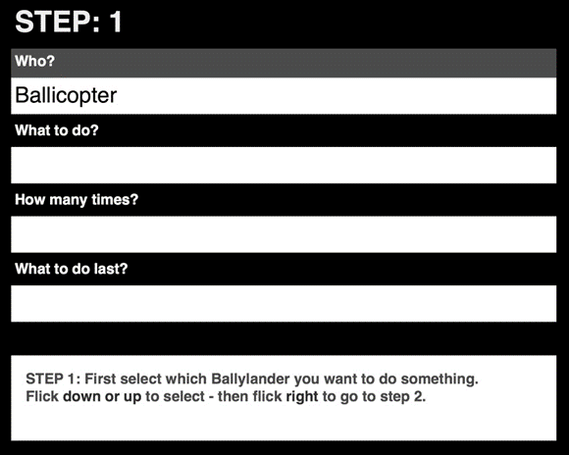
Figure 1 Screenshot Coding panel ‘Play with Coding’

Coding Challenge
Starting with ‘Play with Coding’ prepares the child for the second section of the app: ‘Challenge 1: Wheelie to greet Tinkleball’. The Challenge offers three levels, with increasing difficulty. In this Challenge, Wheelie moves through a digital grid, which is a top view representation of the Ballyland landscape (see Figure 2). The use of a top-view grid is necessary to track and map the movement of Wheelie and the position of barriers and targets inside the game grid. The grid is kept small, with 3 rows by 3 columns, as the processing of this concept draws heavily on spatial awareness and mental mapping skills.
In the Challenge, the rows and columns are spoken, and Wheelie always starts in row 1 column 1, facing right. The concept of rows and columns is introduced in the Ballyland Sound Memory app (http://www.sonokids.org/ballyland-early-learning/ballyland-game-apps/ballyland-sound-memory).
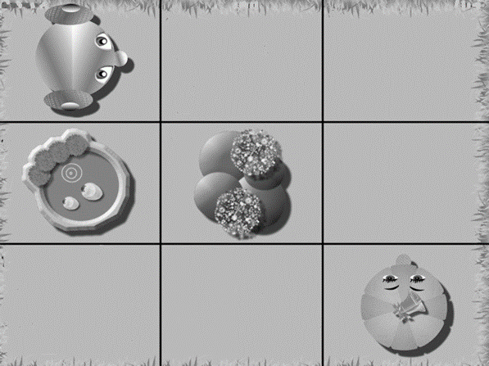
Figure 2 Screenshot Challenge 1, level 2. Wheelie in the grid
Coding Challenge
The challenge sets a specific goal for Wheelie. Any code that fulfils the requirements of the challenge is identified as correct, but it is encouraged to sequence the shortest possible code. The larger coding panel offers a choice of coding commands for movement of Wheelie in the grid, rather than specific actions of Ballylanders in a mini story, as in ‘Play with Coding’. It also allows to set a line to blank to clear the code from that line, and you can use a three finger flick left gesture to clear all code from the panel.
Coding Options
In the Coding Challenge, the coding options are:
- MoveForward
- TurnRight
- SayHello
- Empty line
In the Challenge, you need to give Wheelie the correct commands to move to Tinkleball (another Ballylander) in the grid, avoid any obstacles, and when Wheelie reaches Tinkleball, for him to say ‘Hello’ (see Figure 3). Wheelie always starts in row 1, column 1, facing right. Finger drag enables exploration of the grid, so that children can discover where Tinkleball and obstacles (rubbish bin and pond) are positioned.
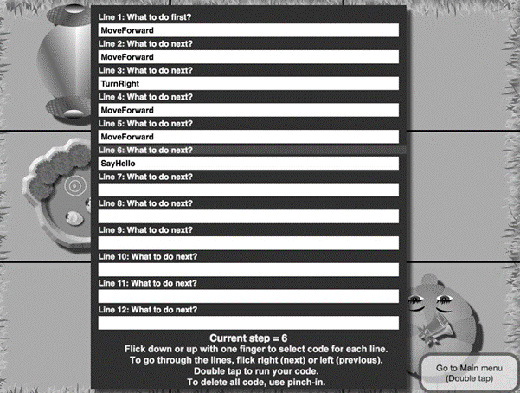
Figure 3 Coding panel Challenge 1, level 2, with correct code
Editing the code
During the game, the code can be put together line by line. You can run your code at any time (double tap with one finger) and then explore the grid again with finger drag to see how best to continue. Wheelie’s position in the grid will be dynamically updated and spoken aloud when you finger drag over the cell that he is in.
Corrections to the code are very easy to make, if you find you have made a mistake. You can go back and change the line of coding, or set the line to blank. All audio feedback is meaningful, and sound effects ensure fun engagement for children who are blind. Whether Wheelie bumps into the rubbish bin, or tries to drive into the hedge, or finds Tinkleball and says ‘Hello’, the sounds are fun for all.
In summary, the features of Ballyland Code ‘n Wheelie are the following:
- Very first app using Audio Based Coding
- First of series of Ballyland Code apps
- Suitable for very young children who are blind or have low vision
- Basic first step to learning how to code
- Interaction and coding output are audio based, with fun but meaningful audio, to ensure that children who are blind are able to enjoy the outcome of their coding efforts
- Challenge also has simple animations to include sighted siblings and friends.
- Easy navigation and editing in accessible coding panel
- Requires only basic VoiceOver finger gesture skills
- No programming skills required
- No need to drag and drop code
- No need to type, eliminates typos and syntax errors
- Provides educational support, and enables building skills step-by-step and scaffolding skills before continuing
- Accessibility beyond audio descriptions, using meaningful sound effects and alerts
- VoiceOver is not used. Instead, the app is self-voicing, with a real, human voice for spoken information in the games, and a synthetic voice (Karen) for the optional self-voicing menu navigation
- Includes a small grid with top view of the Ballyland landscape (grid with rows, columns)
- Familiar Ballyland characters, landscape, and sounds
- Optional use of Ballyland 3D printed game grid and learning tools for tactile exploration, ‘mental mapping’ and orientation of the digital iPad game grid

Conclusion
The Sonokids app developers looked at different types of existing coding programs that are available to sighted children and young people, and identified a gap in the capabilities of these programs to sufficiently support young children who are blind and are beginning users of VoiceOver in their learning. Based on previous experience and new findings, Audio Based Coding was developed as a concept and applied to a coding iPad app for children who are blind, ‘Ballyland Code 1: Say Hello’. The Sonokids team trusts that Audio Based Coding proves to be a valuable support for young children who are blind to confidently take their first steps into the fascinating world of coding. Your feedback is appreciated, so please don’t hesitate to get in touch.

Acknowledgements
We would like to thank for their valuable input Professor Boguslaw Marek (OBE), Director of KUL CAN – Centre for Inclusion of Students with Special Needs at the John Paul II Catholic University of Lublin and developer of the Hungry Fingers series of educational resources for totally blind learners, and Phillipa Enright, Advisory Visiting Teacher, Vision Impairment, Queensland Department of Education, Training and Employment.

References
Apple (2018). Swift Playgrounds - Learn serious code on your iPad. In a seriously fun way. Retrieved from https://www.apple.com/au/swift/playgrounds/
Australian Curriculum, Assessment and Reporting Authority (n.d.). Digital technologies. Retrieved from https://www.australiancurriculum.edu.au/f-10-curriculum/technologies/digital-technologies
Diagram Center (2017). Accessible Coding in Education. Retrieved from http://diagramcenter.org/coding.html
Damsma, P. (2017). Supporting children and young adults who are blind or have low vision in learning the gestures and concepts of VoiceOver on an Apple iOS touch device, 2017 VISCON RIDBC Renwick Centre Biennial Vision Conference, 7-8 September 2017, Sydney, Australia, Retrieved from http://www.sonokids.org/ballyland-early-learning/ballyland-game-apps/
Digital Technlogies Hub. (n.d.). Computational thinking. Retrieved from http://www.digitaltechnologieshub.edu.au/teachers/topics/computational-thinking
Marek, B. (n.d.) Filling the gap: From Tactile Picture Books to Tactile Graphics. In P. Claudet & P. Richard (Eds.) Les Doigts qui Revent, 2000-08 The Typhlo and Tactus Guide to children’s books with tactile illustrations, (pp. 95-96). Retrieved from http://www.tactus.org/guide_lines_typhlo_anglais.pdf
Microsoft (2017, March 15). With Project Torino, Microsoft creates a physical programming language inclusive of visually impaired children. Retrieved from https://blogs.microsoft.com/ai/project-torino-microsoft-creates-physical-programming-language-inclusive-visually-impaired-children/
Milne, L & Ladner, R.E (2018). Blocks4All: Overcoming Accessibility Barriers to Blocks Programming for Children with Visual Impairments. Proceedings of the 2018 CHI Conference on Human Factors in Computing Systems, (Paper No. 69). DOI: 10.1145/3173574.3173643
Tickle Labs, Inc (n.d.). Tickle: Program Star Wars BB-8, LEGO, Drones,Arduino, Dash & Dot, Sphero, Robots, Hue, Scratch,Swift, and Smart Homes on your iPhone and iPad. Retrieved from https://www.tickleapp.com/
Wing, J. (2006). Computational Thinking. Commun. ACM 49, 3 (Mar. 2006), 33–35. Retrieved from https://www.cs.cmu.edu/~15110-s13/Wing06-ct.pdf
Phia Damsma
Creative Director Sonokids Australia
Email: phia@sonokids.com
Mobile: 0415 886 565
John Norgaard
Chief Programmer Sonokids

Space Camp for Interested Vision Impaired Students – (SCIVIS)
On Thursday, 27 September, three very excited students Isaac Field, Vincent de Souza and Cooper Toms together with their two teachers Pranitha Moodley and Robyn Wallace, acting as their chaperones, from RIDBC, flew out of Sydney to Alabama to attend SCIVIS. This was the start to an unforgettable journey.
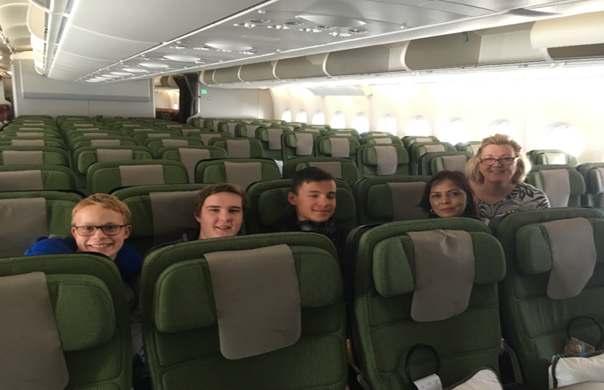
Figure 1 On route to Space Camp
SCIVIS (a NASA operated program) takes place at the US Space and Rocket Centre, in Huntsville, Alabama for a week every year. RIDBC, for the past three years, has provided Scholarships for our students to attend SCIVIS. This year RIDBC was able to offer three Scholarships to students with Vision Impairments to attend 6 days at SCIVIS and 2 days in Disneyland. The team travelled with Qantas airlines stopping over at Dallas Fort Worth airport and then boarded another flight into Huntsville.
When arriving at SCIVIS our students were shown to their rooms, the dorms referred to as the HABITAT, are designed to resemble futuristic space stations. There were almost 200 students and almost 100 chaperones from 12 different countries attending a week of space exploration, space missions, simulated moonwalking, team building, rocket making and experiencing weightlessness in a diving tank. At camp, accessible computers with adapted programs with speech, large print output and braille are set up for missions. A large variety of international meals is served in the cafeteria.
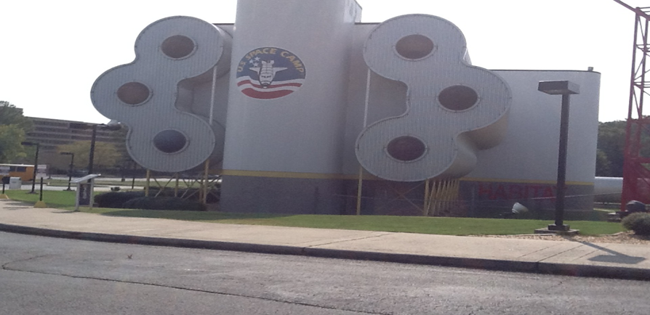
Figure 2 The Habitat
SCIVIS provides the opportunity to meet other students with vision impairment experiencing the same challenges and isolation. It has enabled our RIDBC students to develop long lasting friendships with people from all corners of the globe. All three students who attended SCIVIS this year have very noticeably, grown in confidence and are more interactive with their peers and family members. On the Thursday before camp ended the students graduated in the Davidson Centre for Space Exploration under the huge overhanging Saturn V rocket.
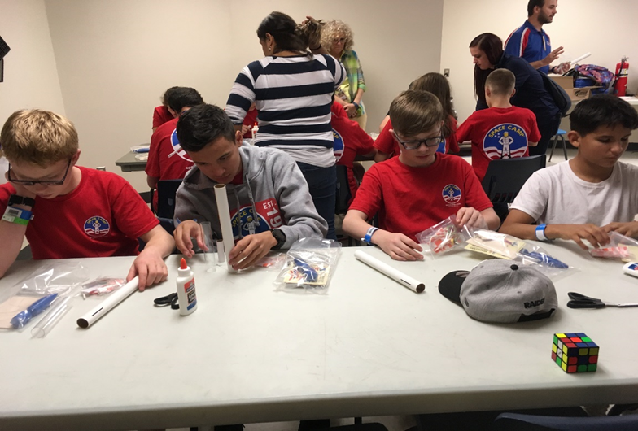
Figure 3 Space campers at rocket building class
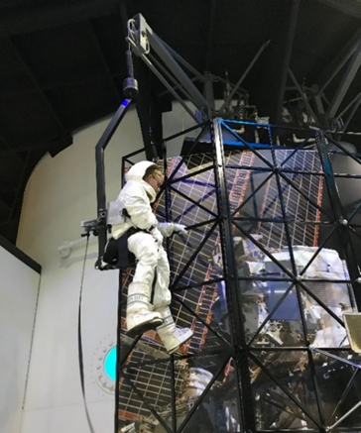
Figure 4 Space Explorer
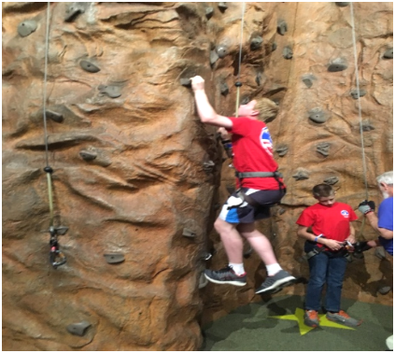
Figure 5 Rock climbing challenge
From the time we left Australia, our three students developed their self-confidence and self-esteem through international and domestic travel. They were constantly involved with decision-making in their travels and responsible for their luggage, money and passports. The experiences all student gained from attending SCIVIS is life changing. SCIVIS is a unique once in a lifetime experience for our students.
As one of our students said, “It was great to meet people with different visual needs, and the admiration and resilience in combating these hardships.” Another student commented, “I want to stay at SCIVIS! I loved it that much. I’m coming back next year!” Thank you to the people who made it possible.
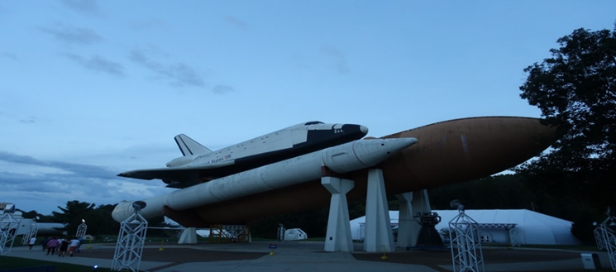
Figure 6 Challenger Space Shuttle
Figure 7 Enjoying an outdoor lesson on rockets
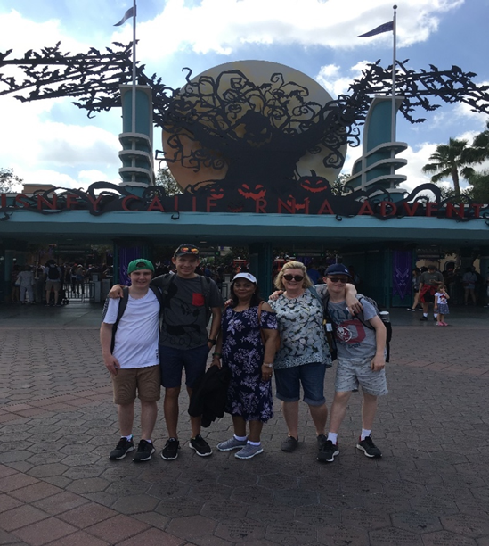
Figure 8 Disneyland fun day out
Robyn Wallace
Specialist Teacher (Vision), Royal Institute for Deaf & Blind Children (RIBDC)
Email: robyn.wallace@ridbc.org.au
Pranitha Moodley
Specialist Teacher (Vision), Royal Institute for Deaf & Blind Children (RIBDC)
Email: pranitha.moodley@ridbc.org.au

Report: International Council for Education of People with Visual Impairment
Ben Clare, Chairperson, ICEVI Pacific, and Member, SPEVI Committee of Management; and Dr Frances Gentle AO, President, ICEVI, and Co-President, SPEVI
The International Council for Education of People with Visual Impairment (ICEVI) is an international organisation that shares with SPEVI the goal of promoting equitable access to quality education for children and young people who are blind, have low vision, deafblindness or additional disabilities. At the global level and within its seven world regions, ICEVI works closely with its international partner members, the World Blind Union, the International Agency for the Prevention of Blindness, United Nations agencies, the World Health Organisation, and government, civil society, parent and disability organisations that support children and young people with vision impairment or other disabilities.
This report presents an overview of ICEVI activities during 2018 in the Pacific Region and globally. The report commences with Ben Clare’s account of his Pacific activities as Chairperson of the ICEVI Pacific Region and ICEVI’s representative on the SPEVI Committee of Management. Ben’s report is followed by an overview of several key global initiatives that took place during 2018.

Pacific Region
Kiribati
The Kiribati Facility, an Australian government initiative in partnership with the Kiribati Ministry of Education and Ministry of Labour is greatly expanding the higher education sector in Kiribati. The Kiribati Institute of Technology (KIT) has partnered with TAFE Queensland and TAFE South Australia to offer Kiribati-based automotive, hospitality and English courses that are fully integrated with the Australian TAFE system. TAFE qualifications gained at the Kiribati Institute of Technology are fully recognised in Australia, and many graduates from KIT are successfully gaining temporary employment in hospitality and agriculture in Australia as part of the Pacific Seasonal Workers Scheme. It is pleasing and exciting to see that I-Kiribati people with disability have full access to this higher education initiative and Ben Clare is proud to be contributing to the joint initiative. Although is in its infancy, eight students with vision and hearing impairment have successfully graduated from KIT foundation courses in ICT and carpentry, and these students will be fully mainstreamed in the KIT from January 2019. The Kiribati Facility has also resulted in three I-Kiribati people with disability gaining fulltime employment.
Fiji Islands
The Fiji Society for the Blind (FSB), a long-time friend and partner of SPEVI, is working to expand its inclusive education support services. The Society is partnering with the Fiji Ministry of Education to deliver an itinerant/visiting teacher service, Braille and large print materials and other support services for students with vision impairment who are studying at regular primary and secondary schools in Suva, Nadi and Lautoka. The Society is also working closely with the Ministry of Health’s community based rehabilitation program to expand FSB services to include children and their families who are blind and live in rural areas of Vitilevu and other Fiji islands. The Society is in the process of constructing a comprehensive early intervention program which will be rolled out once sufficient funding has been secured. Ben Clare was fortunate to recently spend several months at FSB working with the Braille production team to create high-quality documents in braille for students in regular schools, including production of brailled school examinations and tactile graphics.
Samoa
The Samoa Blind Association is a newly formed group of advocates who work with the education sector, directly supporting students with vision impairment who are enrolled in regular primary and secondary schools. The Samoan government recently awarded the Samoa Blind Association a contract to be the sole producer of Braille materials for various government ministries. Two embossers have now been installed at the Association and at the time of writing, Ben Clare was preparing to depart for Samoa to provide follow-up training on the production of Braille materials using the Duxbury Braille Translator.

Global initiatives
Model teacher training curriculum
ICEVI has launched a start-up teacher training curriculum, with the aim of supporting the enrolment of children with vision impairment in the existing educational systems of countries that do not yet educate children with disabilities, or that do so without a supporting system of teacher training. The curriculum is suitable for teacher training in developing countries with limited resources, without supplanting the work accomplished by ICEVI partner members or faculty in institutions of higher education. The curriculum was developed by an ICEVI working group that was chaired by Prof Kay Ferrell, with members drawn from ICEVI partner organisations. It consists of 17 chapters that address such topics as the anatomy and physiology of the eye, preschool and early childhood education, and the various areas of the expanded core curriculum. The working group will revise and update the curriculum over time to reflect global changes in education of children and young people with vision impairment. The curriculum is available on the ICEVI website, http://www.icevi.org, for free download to a computer, mobile phone or other device.
Country Champions program
ICEVI has implemented a “country champions program” to promote an increase in demand by parents and professionals for education of children with vision impairment. The aims of the program include identifying and working with young adults with vision impairment who are able to advocate on behalf of others with vision impairment and influence policy and program development at national and local community levels. The “champions” receive training in such topics effective public speaking and how to launch high-impact publicity campaigns that convey a united message. The program empowers participants to draw upon their lived experience of disability to campaign for positive change. To date, programs have been implemented in the Philippines, India, Nepal, Latin America and Fiji.
Higher education and transition to employment initiative
The joint ICEVI and Nippon Foundation higher education and employment initiative continues to positively impact on enrolment and achievement rates of young people with vision impairment in Cambodia, Indonesia, Laos, Mongolia, Myanmar, Philippines and Vietnam. The program commenced in Indonesia in 2007 and has resulted in the successful enrolment of over 2300 higher education students and employment of 239 graduates with vision impairment over a ten-year period. The program is generally delivered through scholarships which are generally awarded to students through a competitive application process. In addition to receiving tuition, the students are provided with the software, computers, alternative formatted texts and other materials that are necessary for the successful completion of their studies.
Mathematics project
The ICEVI CEO, Dr MNG Mani, has commenced work on a series of teacher training videos that address 150 to 200 mathematical concepts for primary and secondary-age students with vision impairment. The concepts are drawn from the ICEVI publication entitled “Mathematics made easy for children with visual impairment” (2005/06) that is available for free download from the ICEVI website. The first group of videos have been successfully piloted in South Africa with mathematics teachers and teacher educators, including teachers with vision impairments. It is anticipated that the first set of 40 to 50 videos will be launched in early 2019. The videos will be available for free download via YouTube. ICEVI acknowledges the support of the Nippon Foundation in making this important project possible.

SPEVI and ICEVI events
SPEVI-ICEVI Conference in Fiji
The SPEVI Committee of Management is exploring the possibility of holding a joint SPEVI-ICEVI conference in Fiji in 2021. Fiji is a strong SPEVI country and Fiji-based members of SPEVI have long talked about the possibility of hosting a conference. A joint SPEVI-ICEVI conference would maximise the involvement of people from the Pacific region, including civil society, parent and disability organisations, the World Blind Union, United Nations agencies and other organisations working in the Pacific Region. Ben Clare is planning to meet with the Fiji delegation during February 2019, when the feasibility of holding a joint SPEVI-ICEVI conference in 2021 will be decided. The ICEVI Principal Officers and members from other ICEVI regions have expressed interest and excitement about the possibility of a joint conference with SPEVI in our region.
2020 WBU-ICEVI General Assembly and Congress
The third joint WBU-ICEVI General Assembly will be held at the Hotel Marriott in Madrid Spain, from 19th June to 24th June 2020. The General Assembly will be hosted by ONCE, the National Organisation of the Blind in Spain. ONCE is a long term partner member of ICEVI and WBU, and the three organisations have commenced work on establishing the international and local committees that will be tasked with planning the joint program. The overall structure of the Joint Assembly is as follows:
19, 20 June 2020: WBU General Assembly
21, 22nd June 2020: WBU-ICEVI Joint Days of Presentations
23, 24 June 2020: ICEVI Paper Presentation Days and General Assembly
SPEVI, ICEVI and WBU will provide more details about the joint GA in the coming months via their websites and publications. ICEVI plans to send out a Call for Abstracts in early March 2019 for its two days of paper presentations.
In conclusion, Frances Gentle acknowledges with thanks, the support provided by the Australian government and her organisation, the Royal Institute for Deaf and Blind Children (RIDBC) that has enabled her to fulfil the responsibilities of ICEVI President and to contribute to the global initiatives of ICEVI during the 2017-2020 quadrennium.
Ben Clare
Chairperson, ICEVI Pacific, and Member, SPEVI Committee of Management Sydney Australia Email: bwclare@gmail.com
Dr Frances Gentle AO
President, ICEVI, and Co-President, SPEVI
Email: frances.gentle@ridbc.org.au

Report: New Sonokids’ audio based game apps for iPad
Phia Damsma
‘Ballyland’ is a series of educational software and apps, designed for children who are blind or have low vision. Currently available: Ballyland keyboarding software for PC’s and Mac computers, and apps for iPad: Ballyland Magic (learn VoiceOver gestures), Ballyland Rotor (learn the Rotor gesture), and Ballyland Sound Memory (learn about a digital grid). These fun apps uniquely support development of essential digital skills, as well as learning of VoiceOver finger gestures and concepts for use on an iPad. VO Lab is another app by Sonokids, developed specifically for adolescents and older learners.
New release - Ballyland Stay Still, Squeaky! (3+)
A new app for beginning users of iPad: a fun ‘Cause & Effect’ Story that responds to touch with audio feedback, plus a Game that helps to develop important finger drag skills and build spatial awareness on the iPad.
New release - Ballyland Code 1: Say Hello (5+)
An accessible introduction to coding! For children who have basic VoiceOver gesture skills (as introduced in Ballyland Magic and Ballyland Sound Memory). Learn basic coding concepts and skills that will be applicable to any programming language. Get introduced to coding with the Tutorial ‘Play with Coding’, then take on your very first Coding Challenge, using simple coding commands. Make Wheelie, the little car from Ballyland, move around a digital game grid to go and say ‘Hello’ to Tinkleball. This innovative app is the first in a series of Audio Based Coding apps. It creates unique accessibility for learners with vision impairment, including adults who are keen to find out what coding is about. With thanks to teachers and students for their feedback!

Ballyland 2D and 3D print files
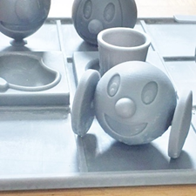
The Sonokids website (www.sonokids.org) will offer for purchase 3D printable files of a Ballyland tactile grid plus mini characters and accessories (pond, rubbish bin etc), specifically designed for use with the new Ballyland Coding app, to support mental mapping; You can also download for free 3D print files for large models of all five of the Ballylanders, as well as files to print tactile images of the Ballylanders.
Phia Damsma
Creative Director of Sonokids/SPEVI Co-President
Email: phia@sonokids.com
Web: www.sonokids.org

RIDBC to launch online braille mathematics training program
Dr Frances Gentle AO, RIDBC Renwick Centre
The Royal Institute for Deaf and Blind Children (RIDBC) is proud to announce its planned launch of “UEB Mathematics Online” during the May 2019 Conference of Round Table on Information Access for People with Print Disabilities in Brisbane. The launch will mark the fifth anniversary of “UEB Online” for sighted people and the fourth anniversary of “Accessible UEB Online” for people with vision impairment or other print disabilities. These two online training programs in Unified English Braille have attracted more than 18,000 registered users between 2014/15 and November 2018. The success of UEB Online was recognised by the World Braille Council at its May 2018 meeting in Ottawa, Canada. The Council has passed a resolution to work with the World Blind Union and ICEVI to promote UEB Online in developing countries where access to braille instruction is limited, and to promote development of similar online braille training programs in other languages.
UEB Mathematics Online will consist of two training modules that address Primary and Secondary school mathematics. The content of the Primary school module will be organised by Stage, commencing with Early Stage 1 mathematics (first year of formal schooling) through to Stage 3 (Years 5 and 6). The content of the secondary school module will address Stage 4 mathematics (Years 7 and 8) through to Stage 6 (Years 11 and 12). The online registration process will involve creating a profile and personal password using a Desktop PC, Mac or laptop. Once registered, users will be offered the option of selecting ‘visual access’ or ‘non-visual access’ for completing lessons. The non-visual access option will support the use of refreshable braille displays and/or screen readers.
UEB Mathematics Online is suitable for professionals, families and classmates who wish to develop their knowledge of braille mathematics. Prior knowledge of the UEB literary code is considered essential in order to build an understanding of the braille mathematics content. The key beneficiaries of the program will be the children and young people with vision impairment who are keen mathematicians and require the support of educators and families who are knowledgeable of braille.
RIDBC acknowledges with thanks, the substantial contribution of Craig Cashmore of PeppaCode P/L, http://peppacode.com.au. Craig has been instrumental in the design and development of UEB Online, Accessible UEB Online and UEB Mathematics Online. RIDBC also acknowledges our content writer, Josie Howse, and RIDBC’s funding partners who have provided the necessary financial support.

Congratulations Dr Frances Gentle AO
Congratulations to Dr Frances Gentle AO, current co-president of SPEVI, on being named in the 2018 Queen’s Birthday Honours list as an Officer on the Order of Australia!
Frances’ citation reads:
Dr Frances Irene GENTLE
For distinguished service to people who are blind or have low vision, particularly in the area of special education, and to policy development and practice on inclusiveness and standards.
All of us involved with SPEVI congratulate Frances on this well-deserved recognition.

Tribute to Sharon Barrey Grassick
Dr Mike Steer, RIDBC Renwick Centre
After a very lengthy struggle with cancer, Sharon Barrey Grassick, aged 68, passed away on Saturday, 25 August 2018 in the Bethesda Hospice at Claremont, Western Australia, surrounded by her close friends and Rob, her much loved son. Sharon (Sha to her close friends) was widely regarded as Australia’s leading teacher and researcher in the complex area of communication skills for children and adults who are Deafblind. She was author of a number of major journal articles, substantial training manuals and specialist videos as well as a presenter at numerous national and international conferences on deafblindness and CHARGE Syndrome. Sharon was instrumental in establishing the Western Australian Deafblind Association (WADBA) and headed that organisation for many years before it amalgamated in 2001 with the Royal WA Institute for the Blind to become Senses Foundation.
Originally from Upstate New York, Sharon was awarded a M.Sc. in Deaf Education in 1973 from the State University of New York at Geneseo. She was recipient of a Rotary International Award (1980), to study at Sydney’s Macquarie University as Research Assistant at North Rocks Deaf and Blind Children’s Centre. Here she developed a passion for building communication with children who are deafblind. She was initially a classroom teacher, then visiting teacher, university lecturer and coordinator of services for individuals with deafblindness. She also taught the Deafblind Communication modules in the Auslan Studies Course at TAFE and was Team Leader of the Deafblind Education Service based at WA Institute for Deaf Education (WAIDE) as well as Adjunct Lecturer in Sensory and Multiple Disability at the RIDBC Renwick Centre, North Rocks, NSW.
She was as well, Secretary of the Australian DeafBlind Council (ADBC) and WA Director of the CHARGE Syndrome Association of Australasia. Sharon presented at numerous forums nationally and internationally and was Scientific Committee Chairperson for the 14th World Conference of DbI (Deafblind International) held in Western Australia in 2007.
Should you wish to remember Sharon’s life of dedication in a tangible way, the Cancer Support Group WA maintains a website at https://youarebeautiful.gofundraise.com.au/page/sharon_barrey through which you might contribute in her memory.
Figure 1 Sharon Barrey Grassick

SPEVI Conference January 2020
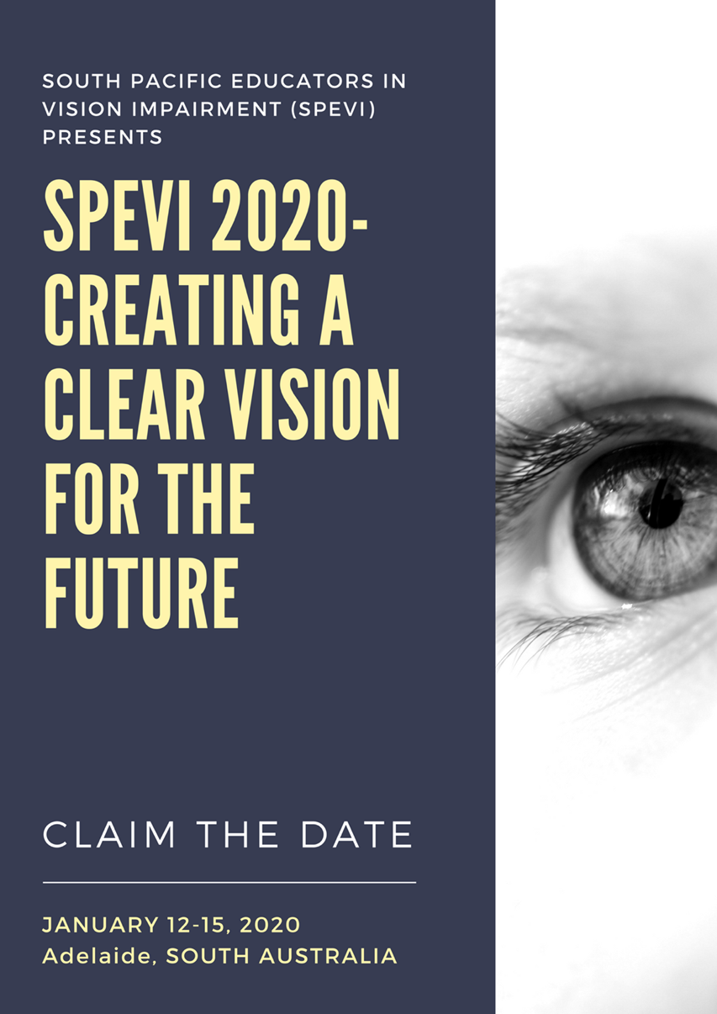

About SPEVI
The South Pacific Educators in Vision Impairment (SPEVI) Inc. is the major professional association for educators of students with vision impairments in Australia, New Zealand and the South Pacific region. SPEVI acts as the professional body in matters pertaining to the education and support of persons who are blind, have low vision, deaf-blindness, or additional disabilities. SPEVI membership is open to educators, professionals and parent groups who support and promote education for persons with vision impairment.
SPEVI Inc is an Association incorporated under the laws of NSW, Australia – Registration number INC9889733.

SPEVI Vision
To promote educational systems in Australia, New Zealand and the South Pacific in which diversity is valued and disability is not viewed as a characteristic by which to judge a person’s worth.

SPEVI Mission
To stimulate professional and public debate and action on vision impairment issues and change which affect, or have the potential to affect the daily lives of persons who are vision impaired, while emphasising concepts of inclusive, responsive educational communities and interdependence between learners and families within those communities where all people are valued.

SPEVI Aims
- To be recognised as the professional body of educators whose specialty is in matters pertaining to the education of persons with vision impairment in Australia, New Zealand, and Pacific Island Countries.
- To advocate on behalf of members, persons with vision impairment and parents/carers for equitable education access and participation, in accordance with international and national disability anti-discrimination legislation.
- To encourage the highest standards in the educators of persons with vision impairment by promoting research and professional training for general and specialist teachers.
- To promote and facilitate the interchange of information and collaboration among educators, professionals, parent groups and the broader community concerning education and equal opportunity for persons with vision impairment.
- To encourage the use of appropriate mainstream and assistive technologies, resources and optical and non-optical aids, in the education of persons with vision impairment, and to promote teacher education programs in the use and care of existing and new techniques and technology.

SPEVI Structure
SPEVI operates at two levels:
- National level, by means of the Committee of Management;
- Local level (state/territory), by means of a Branch comprising SPEVI Councillors and members who reside in the location.

SPEVI Code of Ethics
- All members of SPEVI will:
- Work for the good of SPEVI and actively support and promote its Aims as defined in the SPEVI Constitution;
- Act honestly and with respect and integrity at all times;
- Provide leadership for all members of SPEVI to foster high ethical standards;
- Act to enhance public awareness of SPEVI’s objects; and
- Maintain transparency of decision-making within SPEVI.

Committees of Management
SPEVI is managed at the national level in Australia and New Zealand by a Committee of Management. The national Committees, subject to SPEVI’s Constitution and to any resolution passed by SPEVI in general meeting, are responsible for the governance and management of the activities of the Association and its members. The Australian Committee manages and supports Australian and the Pacific Island members.
Australia Committee of Management, 2017-19
Presidents: Phia Damsma, Frances Gentle. Emails: phia@sonokids.com; frances.gentle@ridbc.org.au
Vice-President: Pranitha Moodley. Email: pranitha.Moodley@ridbc.org.au
Convening Editor: Bronwen Scott, JSPEVI. Email: bronscott@iinet.net.au
Immediate Past President, Secretary and Membership Secretary: Carly Turnbull. Email: carly.turnball.spevi@gmail.com
Treasurer: David Rice. Email: davericesydney@gmail.com
Public Officer: Sue Silveira. Email: sue.silveira@ridbc.org.au
Access Coordinator, Web and List administrator: Phia Damsma. Email: phia@sonokids.com
SPEVI Representative, International Council for Education of People with Visual Impairment: Ben Clare. Email: bwclare@gmail.com
SPEVI Facebook Editors: Ben Clare and Linda Flavell. Emails: bwclare@gmail.com; linda.flavell@blennz.school.nz
SPEVI Representative, Round Table on Information Access for People with Print Disabilities: Brian Conway. Email: brian.conway@ridbc.org.au
Executive Member: Paul Pagliano. Email: paul.pagliano@jcu.edu.au,
New Zealand, 2017-19
President: Sharon Duncan. Email: sharon.duncan@blennz.school.nz
Treasurer: Jude Shelley. Email: jude.shelley@blennz.school.nz
Secretary: Bronwyn Paine
Co-Editor, SPEVI Facebook page: Karen Gilligan. Email: karen.gilligan@blennz.school.nz
For a list of SPEVI Councillors for the 2017-19 Biennium, please visit the SPEVI website: www.spevi.net

