Report of work skills excursion for students with vision impairment (CPR and First Aid), by Debra Goodsir, Itinerant Support Teacher Vision NSW.

In mid 2015 Maitland Muswellbrook Vision Team set up a work skills excursion for students from our team - a small excursion that took a lot of organising! Our aim is to address those false beliefs in society that people with vision impairment are incompetent and need to be looked after.

Kurri Kurri PS made the training possible by providing a skilled Surf Lifesaving CPR trainer and hosting us. We were able to borrow the minibus from Mt View High School to bring all of the students to Kurri PS to learn CPR and first aid.

Before the students participated, they understood that they had to pass both the theory and practical tests, the same as everyone else. So, almost all of them now have a Surf Life Saving association certificate in CPR and a general knowledge of first aid.

All students enjoyed it and really concentrated well and tried hard. A great side effect was that they were all empowered by the event, and the school who hosted us got a great impression of responsible young people.

Debra Goodsir
Itinerant Support Teacher Vision
debra.goodsir@det.nsw.edu.au

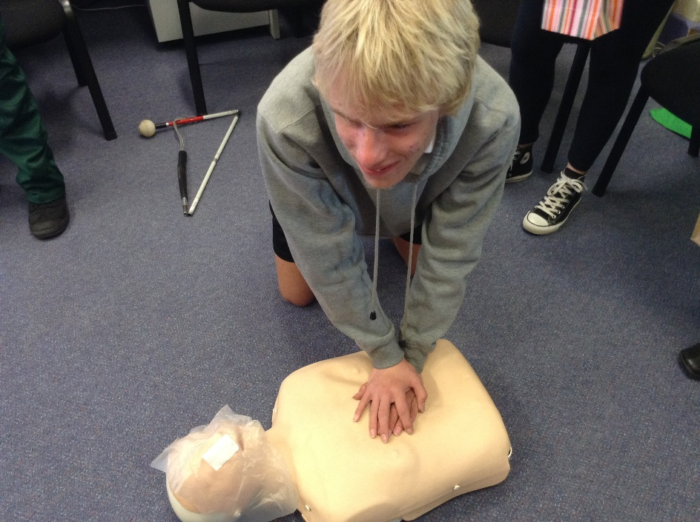
Figure 1: Year 9 student with vision impairment practicing his CPR on a life size doll's bust

