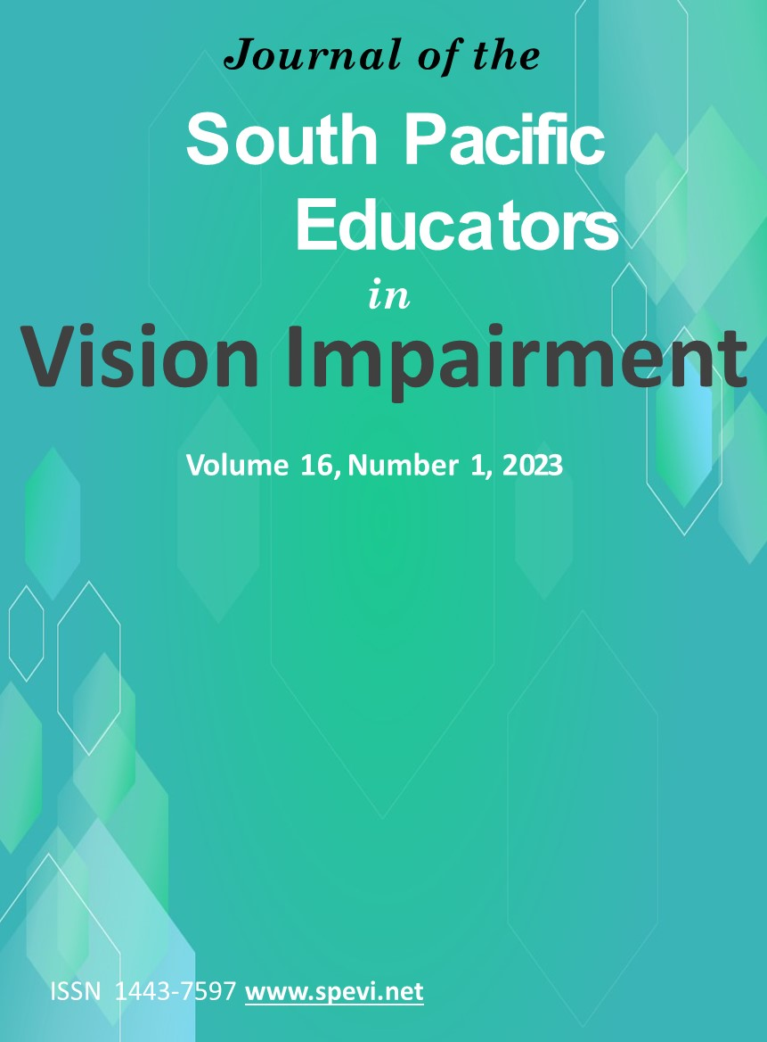

Table of Contents
Role of the SPEVI Journal 2
Editorial 6
SPEVI Co-Presidents’ Message 7
SPEVI New Zealand 9
Exploring family quality of life among families raising children with vision impairment: A review of the literature - Yikun Li, Sue Silveira & Kathleen Tait 13
Two Māori whānau reflect on accessing education for a visually impaired student in Aotearoa New Zealand - Rebekah Graham and Bridgette Masters-Awatere 31
Parent Perspectives on Engaging with Educators and Specialist Staff - Rebekah Graham and Rebekah Corlett 38
How to use Sonification in the classroom - Lily Gower & Phia Damsma 44
Report: International Council for Education of People with Visual Impairment (ICEVI) - Frances Gentle, President (global) and Jo Mosen, President (Pacific region) 54
Report: NextSense - Frances Gentle, Sue Silveira and Trudy Smith 57
South Pacific Educators in Vision Impairment Inc. Privacy Policy 2023 59

Role of the SPEVI Journal
The South Pacific Educators in Vision Impairment (SPEVI) Inc. is the major professional association for educators of students with vision impairments in Australia, New Zealand, and the South Pacific region. SPEVI acts as the professional body in matters pertaining to the education and support of preschool and school-age students who are blind, have low vision, deaf-blindness, or additional disabilities.
The Editorial Committee intends the Journal to be a vehicle for informing researchers, administrators and educators working in government and non-government education organisations, as well as specialist and generic teachers, orientation, and mobility (O&M) instructors, allied professionals, parents and others in our communities about research, issues, policies and their implications for practice in Australia, New Zealand and the Pacific Region.
Editorial Committee
Dr Bronwen Scott, Independent Pathways (Orientation and Mobility and CVI Solutions), Melbourne, Victoria, and Macquarie University, NSW
Dr Frances Gentle AO, NextSense Institute, and Macquarie University, NSW
Dr Sue Spooner, University of Auckland
Dr Michael Steer, AM, NextSense Institute, the University of Newcastle and Macquarie University
Dr Frances Mary D’Andrea, Assistant Professor of Practice, Program in Visual Impairment and Blindness, School of Education, University of Pittsburgh
Dr Mike McLinden, Emeritus Professor, School of Education, University of Birmingham, United Kingdom
Editorial Advisory Panel
Dr Jane Brown, Education Queensland
Ms Josie Howse, Adjunct Research Fellow with the NextSense Institute
Ms Michelle Knight, NextSense Institute
Ms Debra Lewis, Statewide Vision Resource Centre, Victoria
Dr Sue Silveira, NextSense Institute and Macquarie University
Design of front cover by Lena Karam.
© South Pacific Educators in Vision Impairment Inc. ISSN 2652-628X (Online).

This work is copyright. Apart from uses permitted under the Copyright Act 1968, no part may be reproduced by any process without written permission from SPEVI Inc. Requests and inquiries should be directed to the Editor, Dr Bronwen Scott, RIDBC Renwick Centre, Private Bag 29, Parramatta NSW 2124 Australia, Email: bronscott65@gmail.com.
Opinions expressed in this publication do not necessarily represent the views or policies of SPEVI and have been presented to stimulate informed debate.
Permission to Copy
No specific permission is required to photocopy or reproduce a single copy of a complete article as it appears in the Journal of South Pacific Educators in Vision Impairment, if the reprint is for free distribution within an educational organisation or classroom. Permission for other reprinting or re-publication must be obtained from the Editors.
SPEVI Journal Subscription and Membership
SPEVI membership is open to educators, professionals and parent groups supporting children and adults with vision impairments. This Journal is provided free of charge and is available on the SPEVI website: https://www.spevi.net/jspevi/.
Membership information and forms are available on the SPEVI website: https://www.spevi.net/join/.
Call for Articles
Original manuscripts, reports and news items are sought for the refereed and non-refereed sections of the next issue of JSPEVI. Topics appropriate for the journal include, but are not limited to the following:
- original research studies, with practical relevance to education of persons who are blind or vision impaired,
- literature and book reviews,
- conceptual, policy or position papers,
- descriptions, reviews or evaluations of innovative instructional curricula, programs, or models of education for persons who are blind or vision impaired, and
- letters to the Editor
Letters to the Editor
Members of the editorial committee wish to encourage discussions of important issues that affect the education of children and adults with vision impairments. The journal should be a vehicle for continuing dialogue about current and future directions. The editorial committee invites letters that explore the many issues facing professionals and families supporting learning with sensory disabilities, particularly those arising from articles in the journal.
Guidelines for Contributors
Manuscripts that are of a scholarly nature should be submitted electronically, with the content subdivided into the following two files:
File 1 Author information
Authors must submit a separate file containing (a) the manuscript title, (b) author or authors’ name, professional title/status and organisational affiliation of authors, and (c), preferred contact details (address, email, fax, telephone) for the principle author (or co-author) who will be handling correspondence.
File 2 Manuscript
Manuscript presentation: Manuscripts should be submitted in Arial 11-point font, double line spaced, with left aligned paragraphs, 2.54cm page margins (normal margin setting) and numbered pages. A running title header should be included on each page (with no authorship information included).
Size limit: The preferred size limit for scholarly manuscripts is 5000 words or less. The preferred size of agency reports is one A4 page of single line text.
Abstract: Academic manuscripts should include an abstract of 120 words or less, giving a brief summary of the overall content. The abstract may be followed by a list of key words.
Figures and tables: Numbered figures and tables should be included in the manuscript. Tables should be created using a table function, and figures submitted in Black and White, with consideration to the readability of the figure when reduced for publication.
Referencing guidelines: Citations and references included in manuscripts should conform in style to the American Psychological Association (APA). APA guidelines are available on the Griffith University website: https://www.griffith.edu.au/library/study/referencing/apa-7.
Acknowledgments and permissions: Please note that authors are responsible for all statements made in their work and for obtaining permission from copyright owners to reprint or adapt a table or figure, or to reprint a quotation of 100 words or more. In such instances, authors should write to the original author(s) and publisher(s) to request non-exclusive world rights in all languages to use the material in the article and in future editions. Please provide copies of all permissions and credit lines obtained. Credit (acknowledgement) should be included in the manuscript for any type of sponsorship, donations or grants, or technical assistance, or to professional colleagues who contributed to the content of the article, but who have not been listed as authors.
Compliance with ethics requirements: For manuscripts reporting original research studies, authors are responsible for ensuring that the reported research has been conducted in an ethical and responsible manner, with full compliance with all ethical requirements and legislation. This includes adherence to privacy and confidentiality guidelines regarding publication of participant information, including de-identification of participants’ information and data. Authors must confirm in the manuscript that written consent has been obtained prior to publication if participant information is included. Where such a person is deceased, authors are responsible for securing written consent of the deceased person’s family or estate. Authors are encouraged to consult the Australian Government National Health and Medical Research Council’s National Statement on Ethical Conduct in Human Research (2007) – Updated 2018, see https://www.nhmrc.gov.au/about-us/publications/national-statement-ethical-conduct-human-research-2007-updated-2018.
Manuscript review process: Manuscripts will be acknowledged upon receipt. Following preliminary editorial review, articles will be sent to members of the Editorial Advisory Panel and where warranted, to consulting reviewers who have expertise in the subject. This journal uses the “blind review” system. Reviewer feedback will be sent to the author/s with an invitation to revise the manuscript content and/or respond to the reviewers’ comments. The review process may sometimes take up to three to four months. The names of consulting reviewers will periodically be published in the journal. Reviewed manuscripts will remain the property of South Pacific Educators in Vision Impairment (SPEVI). Authors will be advised in writing if their manuscripts are not accepted for publication.
Manuscript submission: Please forward your contributions to the Convening Editor, Dr Bronwen Scott, Email: bronscott65@gmail.com.

Editorial
Dr Bronwen Scott
Welcome to the sixteenth volume of the Journal of South Pacific Educators for Vision Impairment (JSPEVI). As we embark on another year, the journal’s aim continues to be fostering scholarly exchange among organizations and individuals dedicated to advancing education for learners with blindness and low vision. All volumes of the journal are available in an open-access digital format, facilitating the widespread sharing of knowledge and insights through the SPEVI website: https://www.spevi.net/jspevi/.
This edition places a spotlight on families, acknowledging their pivotal role in the holistic development of children with blindness and low vision. Topics in this issue range from a comprehensive exploration of family quality of life in the context of raising children with vision impairment to an insightful reflection on the experiences of two Māori whānau navigating the landscape of education for students with vision impairment in Aotearoa New Zealand. The volume further explores dynamics between parents and educators in a report exploring "Parent Perspectives on Engaging with Educators and Specialist Staff." Understanding these dynamics is crucial for creating an inclusive and supportive educational environment.
Many readers will be familiar with the Sonokids BallyLand suite of educational software and apps supporting delivery of the Expanded Core Curriculum. This volume includes practical guidance on incorporating Sonification in the classroom, providing educators with ideas on how to enhance the learning experiences of students with blindness and low vision.
None of this would be possible without the dedication of our contributors, whose research and insights form the bedrock of JSPEVI. Thank you to each author for their invaluable contributions. I would also like to acknowledge the efforts of the JSPEVI Editorial Committee and Advisory Panel, without whom the journal would not be possible. Thanks once again to Lena Karam for her assistance in formatting and ensuring the journal is accessible.
Looking ahead, we anticipate the next SPEVI Conference scheduled for January 2024 in Brisbane. This conference will provide yet another platform for collaboration and knowledge exchange. We eagerly await the opportunity to engage with our SPEVI community, continuing to work toward a future where every learner has the opportunity to thrive in an inclusive and supportive educational environment.
Dr Bronwen Scott
Editor
bronscott65@gmail.com

SPEVI Co-Presidents’ Message
Welcome to the 16th volume of the SPEVI journal. SPEVI is a professional membership association which was established in 1955. For the past 68 years, SPEVI has been the leading professional body to advocate for excellence and equity in education for learners and students with blindness and low vision, including deafblindness and multiple disabilities.
We thank all of our valued members who have been actively involved in SPEVI in 2023 as we worked towards our mission to ensure learners and students with blindness and low vision are provided inclusive, responsive education communities. If you are not yet a member of SPEVI, we hope you consider strengthening your ties with SPEVI in 2024.
SPEVI Inc (Australia) and SPEVI New Zealand have both had a change to the SPEVI Committee of Management (COM). SPEVI Inc farewelled co-president Frances Gentle and SPEVI New Zealand president Sharon Duncan. We cannot thank Frances and Sharon enough for their commitment, leadership, and passion. SPEVI Inc has welcomed Melissa Fanshawe who was elected as co-president with Phia Damsma, and Ben Clare who was elected as vice-president and secretary. In New Zealand, Shiree Arrian and Lynda Williams have taken on the position of co-presidents, supported by Jude Shelley as treasurer and secretary.
In January 2023, SPEVI bear travelled to Auckland for the SPEVI 2023 conference, which was hosted by SPEVI New Zealand, with support from Australian and Pacific Island members. Papers from this fantastic event are available on the SPEVI website in the SPEVI Conference archive. The SPEVI website, news lists and Facebook pages have promoted and facilitated interchange of information and collaboration among educators, professionals, parent groups and the broader community, reaching over 500 subscribed users. You can read more about the past year’s activities in the respective Presidents’ reports.
In closing this message, we extend our sincere thanks to all SPEVI members and office bearers. We feel proud of the efforts made by SPEVI to advocate for access and participation in education for learners and students with blindness and low vision in the past and the present. As Co-Presidents, it is our great privilege to contribute to SPEVI’S direction and member priorities.
Shiree Arrian, Lynda Williams, Phia Damsma and Melissa Fanshawe
Co-Presidents, SPEVI
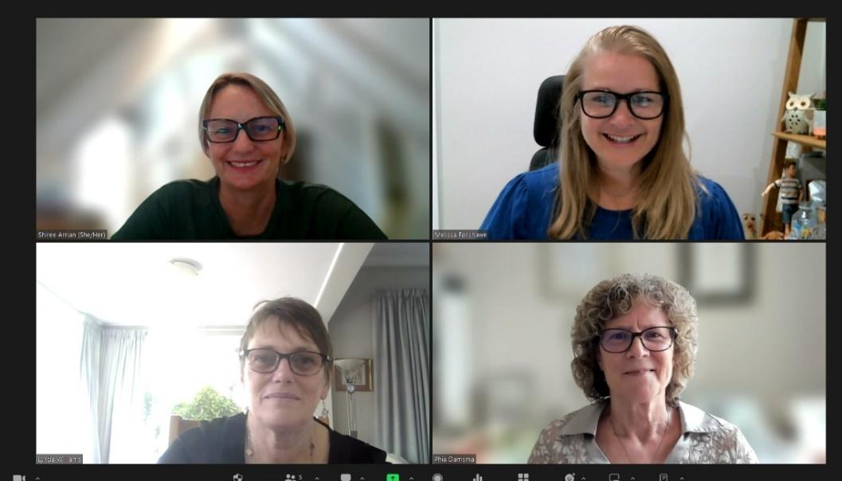
The four co-presidents of SPEVI on Zoom. On left (top)Shiree Arrian and Lynda Williams (SPEVI NZ) and right Melissa Fanshawe (top) and Phia Damsma (SPEVI Inc.)

SPEVI New Zealand
2022/23 Annual President’s Report
Tena koutou Tena koutou Tena koutou katoa
It is with pleasure that I present this President’s report, relevant to the period since the last AGM held on 15 September 2022.
SPEVI NZ Executive
The 2022-2023 SPEVI NZ Executive was made up of Jude Shelley (Secretary), Sue Arrojado (Treasurer), Sue Spooner, Kay Hood and Sharon Duncan (Chair). The executive meets regularly, via Zoom, in the late afternoon or evening and I would like to thank most sincerely each of them for their commitment to SPEVI. This past two years has been significant, with a focus on organising the 2023 Conference. Thank you – you are all amazing.
Membership
New Zealand currently has a membership of 35, including two life members and 13 members from (insert Pasifika countries).
SPEVI Conference 2023
The second online SPEVI Conference, hosted by SPEVI NZ, took place January 18 – 20th January 2023. The conference theme, 'Cultivating New Futures Together: Growth for Life' expressed the belief that we must work together to achieve the best outcomes for children and young people who are blind, deafblind or have low vision. The Expanded Core Curriculum, as the body of knowledge and skills needed by all learners with vision impairment, was recognised as central to the development of learning and skills for life. This conference provided an exciting opportunity to use our collective voices, skills, and ideas to bring about new growth and learning. Sincere thanks are extended to the organising committee for their dedication and hard work which contributed to the success of this conference: Sharon Duncan (Chair), Sue Arrojado (Treasurer), Sue Spooner, Jude Shelley, Kay Hood, Yin Yin Htay and Aimee Peterken from New Zealand; Barbara Farouk and Mereoni Daveta from Fiji; and Robyn Gaile, Ben Clare, Melissa Fanshawe and Joanne Mosen from Australia. We also thank the event planner Trudy Smith from NextSense for her amazing support. Our sincere thanks are also extended to the keynote speakers, Dr Cay Holbrook, Dr John Ravenscroft, and Lisa Hamm; Plenary presenters Dr Joanne Mosen and Lee Kumatat; Opening Address by Martine Abel-Williamson, and many presenters and panelists who shared their knowledge and expertise on the topics of Transitions, Innovative VI research and approaches, Community, Partnerships, Technology, and Families. This proved to be a very successful conference with some thought-provoking messages from the speakers.
A new initiative for this conference was the piloting of SPEVI Conference Hubs, set up as a means of improving access by people in the Pacific region. The Hubs, an initiative from Dr Joanne Mosen, and funded by SPEVI Inc and ICEVI, were located in Vanuatu (SPEVI), the Solomon Islands (ICEVI), and Kiribati (ICEVI) and were an undoubted success. The three hubs supported attendance, presenter opportunities and engagement with the SPEVI 2023 Conference from across the Pacific. SPEVI Inc also sponsored an evaluation of all three hubs. The project team submitted a thorough evaluation, to determine their effectiveness, uptake, strengths, opportunities for improvement, outcomes and future possibilities and recommendations for SPEVI Conference Hubs. The establishment of SPEVI conference hubs serves as a pilot for future conferences.
Another new initiative for this conference was a 3-month post-conference review, sent to all participants three months after the conference, prompting them of the commitments they made for reflecting on their practice due to content they had engaged with over the course of the three-day conference.
SPEVI Bear made appearances throughout the conference. We look forward to seeing SPEVI Bear again in Australia in 2025.
Connection with Australia and Pacific Countries
Over the past few years SPEVI NZ and SPEVI Inc (Australia) have valued strengthened our relationships with one another. Pivotal to this has been the connection with the Co-Presidents, Phia Damsma and Frances Gentle. Frances has recently stepped down from this position. Her professionalism, expertise and tire-less energy will be greatly missed. In honour of Frances’ enormous contribution and longstanding service to SPEVI, SPEVI Inc have initiated a Frances Gentle award. Our sincere thanks are extended to Frances. We look forward to our continued connection with current Co-President’s Phia Damsma and Melissa Fanshawe.
The inclusion on the Conference Committee of members from Australia and the Pacific Islands also supported strengthening our connections with one another.
Community of Practice Meetings
Co-hosted by New Zealand and Australia (Sharon Duncan, Lara Anderson and Bronwen Scott) the Early Intervention Vision Impairment Community of Practice continues to thrive with significant numbers attending the online sessions, which are held two monthly. Attendance is open to members and non-members and recordings of past sessions are made available on request. Five meetings have taken place over the past year. Topics have included ‘The F-words focus on six key areas of child development’, ‘Practical ideas for unpacking the sounds in a child’s everyday environment’, ’Active Learning’, ‘EIVI Practice Guidance’ and ‘Chronic Sorrow’. Lara, Sharon and Bronwen also presented on the CoP at the 2023 SPEVI conference and were able to collate a long list of suggestions for future meetings.
SPEVI Online
The SPEVI website, SPEVI Facebook and the SPEVI News List continue to provide important spaces for information sharing. The website serves as a repository for SPEVI publications, links to useful resources and provides announcements of upcoming events.
Subscription to the SPEVI News List is open to members and non-members. The List, managed by Phia Damsma, currently has 525 subscribers who share information from the field of VI Education, including current research, technology advances, and educational practices.
The SPEVI Facebook is managed by Ben Clare (Australia) in collaboration with SPEVI New Zealand members and has a good following. Along with the website, this space is helpful in educating the public on SPEVI’s work and activities and is a valuable space for communication about upcoming SPEVI Conferences.
The SPEVI Journal (JSPEVI) continues to be available for free download on the SPEVI website. We extend our thanks to Dr Bronwen Scott, the JSPEVI Convening Editor, and the current Editorial Committee (which includes Sue Spooner) and the Editorial Advisory Panel.
Recordings of conference presentations are also available on the website and well worth a visit. This repository is a valuable contribution to researchers and educators in VI Education in Australia, New Zealand and internationally. Recordings from the 2023 Conference have recently been uploaded, including recorded keynote presentations, paper and poster presentations and handout materials.
SPEVI LIVES (Leaders in VI) Meeting
SPEVI LIVES meetings provide a platform for leaders and organisational representatives in VI education to discuss current research, practitioner initiatives, resources, and issues with others in the field. The latest LIVES meeting took place during the online SPEVI conference in January 2023.
NZ ATVI (Association of Teachers of Visually Impaired)
At the last two AGMs we reported on the intended dissolution of the New Zealand Association of Teachers of Visually Impaired (ATVI). Any remaining funds held by the association are to be transferred to SPEVI NZ and be used for a specific project. The formal disestablishment of ATVI and transfer of funds is in the final stages of closure. The changes to the Barbara Armitage award agreed on at the last AGM will come into effect once the formal dissolution is completed.

Closing remarks
The SPEVI NZ Executive Committee look forward to connecting with you as we determine the future direction of SPEVI NZ.
Ngā mihi nui
Sharon Duncan
Immediate Past President

Special Awards
Congratulations Ben Clare – Lesley Hall Award for Lifetime Achievement
Ben Clare
Ben Clare, who is currently Vice-President, Secretary and 2025 Conference Convenor at South Pacific Educators in Vision Impairment (SPEVI Inc), was recently awarded the prestigious Lesley Hall Award for Lifetime Achievement. The following text has been taken from the Disability Leaders website: https://disabilityleaders.com.au/disability-leaders/national-awards/2023-recipients/.
The Lesley Hall Award for Lifetime Achievement – awarded to an individual who has shown commitment to the disability rights movement and worked overtime to achieve significant outcomes for disabled people.
Ben has worked for over 20 years throughout Australia & the Pacific. He worked and volunteered to teach children braille literacy and how to use computers with JAWS and NVDA. Ben advocates for and provides advice on disability inclusion and inclusive education to government bodies.
Congratulations Ben from all the SPEVI community on a well-deserved award.

Exploring family quality of life among families raising children with vision impairment: A review of the literature - Yikun Li, Sue Silveira & Kathleen Tait
Abstract
Despite being a low-incidence condition, childhood vision impairment challenges many aspects of family life. Vision impairment may significantly lower a child’s life expectancy and have a developmental impact on their skill attainment. Parents/carers of children with vision impairment are required to assist their child in everyday activities, while also sourcing appropriate medical intervention, therapeutic support, and advocating for their individual needs. Consequently, it is anticipated that childhood vision impairment may have a significant impact on Family Quality of Life. This literature review explored the needs of children with vision impairment, those of their families, and the development and assessment of Family Quality of Life in families of children with vision impairment.
Keywords: family quality of life, children, childhood vision impairment
Introduction
Raising a child with disability, or a chronic health condition, is associated with increased stress for families compared to raising a typically developing child (de Klerk & Greeff, 2011). Leyser and Heinze (2001) proposed that such stress restricts and disrupts family functioning and requires constant adjustments in the role’s family members play and in their relationships with each other. It is believed the increased stress impacts on the economic, social, emotional, and other aspects of family life (Keleynikov et al., 2023).
A child’s blindness or loss of vision can pose challenges for families (Ulster & Antle, 2005). Despite extensive research on the emotional and functional changes associated with a person’s vision impairment (VI), the impact of VI on the quality of family life is an under-researched area (Bambara et al., 2009). This paper aims to present a preliminary review of the contemporary literature, to discuss what is known about the impact of childhood VI on Family Quality of Life (FQoL). The key findings will be applied to the development of a project titled “Family Quality of Life among families raising children with vision impairment”.
A thematic search was performed by Yikun Li, the first author of this review, using ProQuest, CINAHL, Cochrane, MEDLINE, PubMed, Routledge, Scopus, and Wiley Online Library. The search was completed between July and December 2023. The review was limited to peer-reviewed journal articles written in English between 2003-2023. The search terms included Quality of Life [AND] vision impairment, children with vision impairment, childhood vision impairment, Family [AND] children with vision impairment and Family Quality of Life [AND] vision impairment. To gain a broader view of the existing literature, publications were included regardless of the research design and methodology. The total number of journal articles for this review was 109, with 65 articles found to be relevant to one or both key terms of the review: Family Quality of Life and childhood vision impairment.
Key findings from the contemporary literature on children with VI and FQoL
An overview of vision impairment
Vision, as an essential sense, plays a vital role in human development (Uzodinma et al., 2022). From a psychological perspective, 80-85% of an individual’s cognition, learning, perception, and other activities are mediated through vision (Ajuwon & Bieber, 2014). VI is defined as one or more functions of the eye or visual system being limited, which cannot be corrected with prescriptive lenses (World Health Organization [WHO], 2023). VI ranges from 3 per 10,000 in developed countries to 15 per 10,000 in developing countries, making it relatively rare (Abdolalizadeh et al., 2021; WHO, 2023).
Despite being a low-incidence disability, the impact of VI on a person and their family can be significant. According to the data from Global Burden of Disease (GBD) study, VI ranked third in terms of Disability-Adjusted Life Years (DALY) worldwide, from 1990 to 2017, indicating the risk that VI may significantly lower a person’s life expectancy (Abate et al., 2018). The lower the age of onset, the higher the health burden from VI becomes (Abate et al., 2018). Subsequently, VI poses a global financial burden due to the associated costs of productivity losses, medical attention, and social resources.
Childhood vision impairment
Childhood VI is a significant public health matter around the world (Pascolini & Mariotti, 2012). Children who are born preterm are at the highest risk of visual issues (Salt & Sargent, 2014). VI present from early on in life also has a developmental impact and affects children’s participation in many typical activities that their sighted peers engage in (Uzodinma et al., 2022). It is highly likely that children with VI will have additional impairment, the most common being intellectual disability (ID) and Autism Spectrum Disorder (Löfgren et al., 2016). Children with VI who have additional disabilities experience more severe functional limitations, compared to children with VI as single disability (Boulton et al., 2006).
Loss of vision can have multifaceted impacts not only on the child’s everyday living but also on their families’ overall functioning. When studied, families reported that their psychological well-being and Quality of Life (QoL) were influenced by their child’s visual diagnosis (Goodenough et al., 2021). To guarantee the well-being of the family around the child, the connection and dynamics between children and adults need to be understood (Alnahdi et al., 2022).

The notion of child and family
Family, a fundamental unit of the society, can be challenging to define in the contemporary world (Samuel et al., 2012). Heterogeneous family values and practices associated with diverse family structures, cultures and linguistics are often under-addressed in disability studies (Xu, 2007). One of the frequently cited definitions refers to family as “people who are closely involved in the day-to-day affairs of the household and support each other on a regular basis, whether related by blood, marriage or by close personal relationships” (Rillotta et al., 2010, p. 306).
Bronfenbrenner’s Bioecological Systems Theory
To explain child and family relations as well as their interactions with environmental factors, the bioecological model developed by Bronfenbrenner is a classic and valuable approach (Bronfenbrenner, 1977, 1995; Francisco Mora et al., 2023; Tudge et al., 2016). In the model, five concentric circles, which refer to nested but separated systems in a hierarchical manner, represent the world of the child (McLinden et al., 2020). The child is placed in the centre, surrounded by systems that can affect the child’s world, including micro, meso, exo, and macro systems (Bronfenbrenner & Morris, 2006).
The child is the main microsystem, surrounded by family, school, and friends (Francisco Mora et al., 2023). Darling (2007) stated the active person at the centre of the model is the central force in development. The mesosystem represents interactions between systems, for example the family and the school; while the exosystem contains greater factors that influence the child, such as economics and media (Bronfenbrenner & Morris, 2006). The macrosystem represents culture, language and values which are configured around the other systems (Francisco Mora et al., 2023).
McLinden et al (2022) adopted the bioecological model to discuss the “proximal and distal influences” (p. 57) on the education of children with VI. These authors emphasised that the various influences are complex and multi-dimensional and need to be acknowledged and understood by specialist educators. Vanderkerken et al., (2019) believed that the Bronfenbrenner model formed a valid representation of what the family-centred notion may look like, which considers an enabling and empowering way to support families. Family is one of the microsystems that directly interacts with the child. The child and their family are surrounded by greater systems, indicating they are influenced by a range of factors such as the social norms, mass media, and cultures (Bronfenbrenner, 1995; Bronfenbrenner & Morris, 2006).
In the case of children with VI, the Bronfenbrenner model can be applied and modified as seen in Figure 1; the original model can be viewed in work by Brofenbrenner and Morris (2006). The child with VI remains in the centre of the microsystem, with additional aspects added to represent essentials in the child’s life (Drew, 2022). For example, parents, siblings, the child’s school, and neighbourhood, which are closely related to the child can be added to the microsystem. The mesosystem consists of personal settings interacting with each other (e.g., parents interacting with the child’s school and parents interacting with the child’s siblings etc).
In the exosystem, the National Disability Insurance Scheme (NDIS) and vision support offered at school are included as critical supports for the child with VI (Morris & Sharma, 2011). Additionally, parental occupation may also be considered due to the potential impact on the child (Drew, 2022). Adam (2004) reported that frequent family relocations may negatively influence a child’s academic performance, self-esteem, and peer social relationships.
The macrosystem refers to the attitudes and ideologies of the society and cultural aspects in relation to the development of the child (Drew, 2022). Specifically, there may be certain views held by society regarding the child’s disability (Uzodinma et al., 2022). Stigmatisation towards disability and stereotypical thinking may be widely present, which impacts on the well-being of child and their family (McLinden et al., 2022).
Figure 1 Modified Bioecological Model for a Child with VI
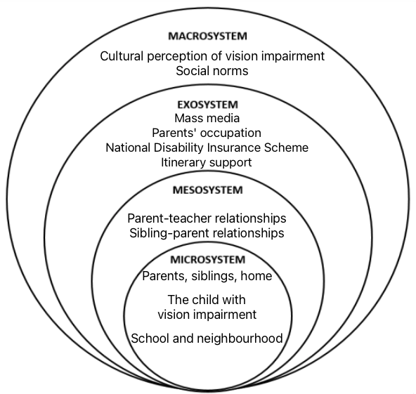
Bronfenbrenner and Morris (2006) emphasised that proximal processes are the driving force of the individual’s development. Proximal processes refer to the reciprocal interactions between the individual at the centre of the systems and the properties (people, objects and symbols) of the individual’s immediate settings. To explain it in the context of the child with VI, the relationship between the child with VI and people, objects, and symbols (things that make up their experiences of the world) is the engine that drives their development (McLinden et al., 2022). Among the various people the child with VI closely interacts with, their family is an essential element in the proximal processes. Therefore, family plays an important role in the child’s everyday living.
The impact of disability on the family
Literature suggests that a child’s disability impacts on their whole family (Wang & Brown, 2009). For example, families of children with disability have increased care responsibilities related to their children’s substantial needs. This care need is often associated with loss of employment, lack of time for self-care, compromised physical health and increased financial burdens (Bhopti et al., 2022; Brown et al., 2003). Bhopti et al., (2022) reported that as children with disability grow older, the challenges of caregiving increase. Such challenges may cause considerable stress among parents and caregivers (Fathizadeh et al., 2012). Additionally, it is reported that lower socioeconomic status and job insecurity may exacerbate the negative impact that disability has on the whole family (WHO, 2011).
On the other hand, the challenges of parenting a child with disability can be balanced by enriching family experiences and close relationships between family members (Alabri, 2023). Based on the experiences of families of children with ID, resilience, strength, and connection allow for reflection on positive rather than negative aspects (Cuskelly et al., 2009). Therefore, the interaction between the two systems, the individual (the child) and the microsystem to which the family belongs, can be dynamic, complex, and influential on the child and their family.
A holistic view of the family’s needs
When service providers understand that families of children with disability are situated within the greater Bronfenbrenner bioecological systems, it can facilitate improved collection of information to understand the families’ needs (Summers et al., 2005). This will in turn benefit professional-family collaboration, which may lead to improved service outcomes for children with disability (Zuna et al., 2009).
Exploring FQoL
It is recognised that within the field of disability studies, individual QoL should apply to both the conceptual and practical levels (Brown et al., 2006; Park et al., 2003). QoL is defined by the WHO as “an individual's perception of their position in life in the context of the culture and value systems in which they live and in relation to their goals, expectations, standards and concerns” (WHO, 1994, p. 28). FQoL is regarded as a logical extension to QoL from the perspectives of individual family members (Ajuwon & Bieber, 2014).
The family-centred approach has been increasingly adopted in healthcare and social services globally (Rouse, 2012). Similarly, FQoL is a concept that prioritises family outcomes (Gardiner & Iarocci, 2012). FQoL is defined as “conditions where the family’s needs are met, and family members enjoy their life together as a family and have the chance to do things which are important to them” (Park et al., 2003, p. 368).
The FQoL approach is considered as the paradigm shift in medical and disability arenas from “fixing” an individual’s deficits, to supporting and strengthening individuals and their families (Turnbull et al., 2007). In a FQoL framework posed by Wang and Brown (2009), families with better QoL became resources for and supported the functioning of the society.
Measuring FQoL
Alnahdi et al., (2022) conducted a scoping review of the scales measuring FQoL for families of children with ID, by investigating 120 studies published globally between 2003 and 2022 that met the review inclusion criteria. Alnahdi et al., (2022) discussed five commonly used scales that measure FQoL for the whole family, including the domains that each scale measured. The scales included:
- the Beach Center’s Family Quality of Life Scale (BC-FQoL)
- the Family Quality of Life Survey – 2006 (FQOLS-2006)
- the Family Quality of Life Questionnaire Chinese (FQoL-Q)
- the Family Quality of Life for Families with a Member with an ID, under and over 18 years old (CdVF-E)
- the Families in Early Intervention Quality of Life (FEIQoL)
Dominant views and controversies
When the FQoL scales are reviewed, three or more of the five measure relationships, communication, and family interactions (Alnahdi et al., 2022). Other important factors associated with FQoL that overlap in three of the scales are education, health, and material and financial well-being. A significant agreement has been found between BC-FQoL and FQoLS-2006, the two most used FQoL scales, in the domains of well-being, family relationships and disability related support. Access to information and services, professional support, influence of values and child functioning are included in one of the five scales (Alnahdi et al., 2022).
Alnahdi et al. (2022) discussed that the relationships/family interaction domain was the only category found in all five FQoL scales, indicating the critical association between interpersonal encounters within the family unit and FQoL. While the BC-FQoL scale and the CdVF-E scale emphasised the deep loving emotion between family members, the FEIQoL scale focused on social participation as a family unit (García-Grau et al., 2021; Park et al., 2003). In summary, the relationship between family members appeared to be a paramount domain when it comes to accessing FQoL among families raising children with ID, as all five scales emphasised the atmosphere within the family (Alnahdi et al., 2022)
Importance of FQoL
Based on a framework of FQoL, supporting families raising a child with disability is an important public policy. First, advancing families’ ability to have control over their decisions and improving their FQoL aligns with family autonomy and personal liberty (Wang & Brown, 2009). Second, families play an essential role in encouraging their members with disabilities to fully participate in society (Zuna et al., 2009). Third, what benefits the whole family should in turn benefit the individual with disability and vice versa (Wang & Brown, 2009). According to Australia’s Disability Strategy 2021-2031, the relationship between people with disability and their families is often one of mutual support. Therefore, it is vital to support families in their aspirations for family members with disability and to provide universal support services to meet the needs of the individuals and their families (Department of Social Services, 2021).
Implication of FQoL
The concept of FQoL can be a valuable outcome indicator in both research and applied settings as family plays a vital role in supporting child development and facilitating independence (Bhopti et al., 2022). However, FQoL has been found to be difficult to measure (Hoffman et al., 2006). Minimal attention has been paid to how different family members perceive the quality of life of their family as a collective unit (Alnahdi et al., 2022). One issue with measuring FQoL is that different family members may have different perspectives (Park et al., 2003). For example, literature suggests that mothers and fathers may present with different levels of stress and relief while receiving early intervention for their children with disabilities (Freund et al., 2005).
Alternatively, it is found that the quality of services impacts on FQoL (Bhopti et al., 2022). When delivering services to children with disability who heavily rely on their parents and other key family members, the way the family unit functions while trying to cope with uncertainties needs to be taken into consideration (Wang & Brown, 2009).
FQoL and parental QoL
In exploring family quality of life of families who are raising children with VI, it is necessary to separate FQoL from parental QoL. Studies have investigated experiences of parents caring for children with VI and their own parental quality of life (Guney et al., 2023). These studies focussed on parents’ opinions regarding their needs and concerns, the impact of their child’s VI on their emotional well-being and the strategies to assist them to cope with challenging situations (Lupón et al., 2018).
The needs of families raising children with vision impairment
The main responsibility of families and service providers is to meet the needs of children. For children with VI, this includes minimising the impact of VI on their development. The potential impact of childhood VI is extensive and can involve critical areas including:
- spatial awareness, (i.e., knowing where things are in space, and their postural and movement skills).
- use of hands and fine motor skills.
- understanding early concepts, (e.g., objects permanence which develops in early infancy).
- ability to locate sounds in space.
- understanding the meaning of words; misunderstanding can lead to difficulties with speech and language skill attainment.
- social interaction and communication; and
- self-care abilities (Salt & Sargent, 2014).
Children with severe VI or blindness experience delays in various areas in their development, have a higher frequency of hospitalisation and may have significantly lower life expectancy compared to their sighted peers (Bhaskaran et al., 2022). Studies show it is common for children with VI to experience problems in attention, initiative, communication, self-esteem and that they may experience anxiety (Alimovic, 2013; Sharma et al., 2002). It is believed that children with VI with additional disabilities experience more emotional and behavioural issues than children who have VI as single disability (Alimovic, 2013). Furthermore, many children with early onset VI experience long-term implications other than the practical difficulties associated with learning and developing their independence, which may affect their mental health and their ability to develop a strong self-image that embraces their VI (Harris & Lord, 2016).
Children with VI have decreased opportunities to learn from others through observations (Texas School for the Blind and Visually Impaired, 2023), leaving them with unique educational needs that fortunately can be met through differentiation. The need for differentiation has been recognised in the educational sector with the implementation of the Expanded Core Curriculum (ECC) (Goodenough et al., 2021; Hewett et al., 2022). The ECC applies specific adaptations to essential knowledge and skills for students with VI, associated with the student’s disability-specific needs (Opie, 2018).
Application of the ECC is managed in partnership between central specialist practitioners, support schools, students with VI and their families. The recently published Curriculum Framework for Children and Young People with Vision Impairment (CFVI) defines the central specialist practitioners working in the field of VI education as qualified teachers of children and young people with VI and registered qualified habitation specialists (Hewett et al., 2022). Advice on reasonable adjustments is provided for children through to Year 12 (NSW Department of Education, 2023). Strategies range from simple tips such as being seated closer to the whiteboard in the classroom and removing visual clutter, to more complex resolutions including using specialised software and technology. Such a multidisciplinary collaboration which results in individualised recommendations from specialist teachers and therapists is highly beneficial (Solebo & Rahi, 2014).
Measuring FQoL in families of children with VI
Family plays a vital role in supporting a child to thrive, especially when the child has a disability. Children with VI rely on their families for everyday participation, sourcing appropriate medical and therapeutic support and advocacy (Guney et al., 2023). FQoL is an emerging, yet a critical factor that reflects how well families manage their lives together. It is anticipated that childhood VI poses significant impact on FQoL. However, FQoL of families raising a child with VI has not yet been measured using validated tools.
In recent years, a number of measures have been validated to assess QoL in children with VI (Lupón et al., 2018). The use of these measures in both research and practice has helped to raise the awareness of QoL in these children. When these measures are being implemented, parents or other family members often act as a proxy for their children and express their concern regarding their children’s well-being when they have an eye condition or VI (Goodenough et al., 2021). While individual quality of life has been increasingly investigated among children with VI, the FQoL in families of children with VI is at the beginning of conceptualisation (Uzodinma et al., 2022).
Given the strong emphasis on family-centred approaches in the field of disability studies, it is recommended that services should be delivered to the family as a collective unit (Park et al., 2003). FQoL extends its scope beyond the child with a disability, investigating the needs of families as well as the strengths of the family (Smith-Bird & Turnbull, 2005). A good understanding of a family’s QoL helps professionals to appreciate how families are coping with challenges and uncertainties associated with VI. This may then allow professionals to collaborate with these families more effectively (Goodenough et al., 2021).
FQoL of families who are raising a child with disability can also become a useful indicator of policy initiatives as well as service outcomes (Bailey et al., 1998; Park et al., 2003). By measuring FQoL the child’s unique requirements as well as their families’ can be better understood by policy makers, service providers, teachers, researchers, etc (Park et al., 2003). These families may then be empowered through strategies from various stakeholders and be supported as a whole unit (Bagur et al., 2023).
Discussion
There is no doubt that children with VI require unique adaptations and specialist support. By understanding the family's quality of life, the needs of the child and their family can be better accommodated across different settings, including home, school, and the community. The Bronfenbrenner model emphasised that the proximal elements, including the child’s family, are paramount in the child’s development (Bronfenbrenner & Morris, 2006). The growth and thriving of families raising children with VI would in turn be beneficial to these children’s well-being.
Family plays essential roles in sourcing professional input for the child with VI for skill attainment, in advocating for the child with VI, and supporting the child to participate in meaningful activities. Childhood VI can have complex impacts on family functioning and FQoL. However, assessing such impacts remains challenging in today’s context. Few studies have examined the impacts of childhood VI on FQoL.
Frameworks that define educational and life support were discussed in the literature. The ECC, being globally recognised as the prerequisite to inclusion for students with VI, covers programs and skills that are essential to compensate for incidental learning of sighted peers (Opie, 2018). The recently released CVFI, again emphasised that children with VI need to access appropriate and equitable education. The CVFI called for effective collaborations between different stakeholders around the child with VI, including parents/carers, classroom teachers, VI specialist educators, and other professionals by communicating using shared vocabulary. (Hewett et al., 2022).
Growing research interest has been identified in assessing FQoL in various groups such as families of children with ID. Based on the current validated tools that measure FQoL, there is some inconsistency in the domains that should be included in the tools (Alnahdi et al., 2022). Additionally, specific tools that measure FQoL in families of children with VI are scarce. This leaves an ongoing lack of understanding about the impact that childhood VI poses on FQoL.
Traditionally, families’ voices have been assessed through qualitative approaches including extensive interviews with family members (Brown et al., 2003). However, the recent decades have witnessed the validation of several scales that quantify FQoL (Alnahdi et al., 2022; Hoffman et al., 2006; Horsman et al., 2003; Stein & Jessop, 2003).
Based on the key literature findings, a research project which combines quantitative and qualitative approaches will be used to explore attitudes and opinions of parents and significant family members of children with VI. It is anticipated that the outcome will assist to reach conclusions about FQoL in families raising children with VI, potentially revealing information about their emotional adaptations to the child’s VI over time, and the type of support they find the most helpful in their journeys. An accessible online survey approved by Macquarie University Human Research Ethics Committee, will be used to reach diversely located participants living across Australia within a short timeframe; hopefully a rapid turnaround in data collection will be achieved, as opposed to conducting interviews and focus groups (Creswell & Creswell, 2023).
The family focused Family Quality of Life scale developed by the Beach Centre on Disability (Park et al., 2003) has been chosen as a validated tool already applied widely in the field of disability studies, including in Australia (Hussain & Tait, 2015). The authors anticipate that application of this tool will support the development of a preliminary view of the impact of childhood VI on FQoL, among Australian families. The findings are also likely to raise awareness of family well-being of children with VI and the importance of accessing appropriate services once a visual diagnosis is made.
Conclusion
FQoL research remains in its infancy in Australia and further investigation is required to assess the impact of childhood VI on FQoL. Such information will be valuable to inform relevant stakeholders such as policy makers, service providers and educators of children with vision impairment. This will see professionals well placed to implement essential programmes that provide effective support for families with a child with VI.

References
Abate, K. H., Abil, O. Z., Aboyans, V., Abu-Rmeileh, N. M. E., Adebayo, O. M., Agarwal, G., Al-Aly, Z., Alsharif, U., Aminde, L. N., Anwari, P., Artaman, A., Ausloos, M., Babazadeh, A., Behzadifar, M., Bello, A. K., Bernabe, E., Boufous, S., Briko, A. N., Choi, J.-Y. J., . . . Zar, H. J. (2018). Global, regional, and national disability-adjusted life-years (DALYs) for 359 diseases and injuries and healthy life expectancy (HALE) for 195 countries and territories, 1990–2017: A systematic analysis for the Global Burden of Disease Study 2017. Lancet, 392(10159), 1859-1922. https://doi.org/10.1016/S0140-6736(18)32335-3
Abdolalizadeh, P., Chaibakhsh, S., & Falavarjani, K. G. (2021). Global burden of paediatric vision impairment: A trend analysis from 1990 to 2017. Eye, 35(8), 2136-2145. https://doi.org/10.1038/s41433-021-01598-8
Adam, E. K. (2004). Beyond quality: Parental and residential stability and children's adjustment. Current Directions in Psychological Science: A Journal of the American Psychological Society, 13(5), 210-213. https://doi.org/10.1111/j.0963-7214.2004.00310.x
Ajuwon, P. M., & Bieber, R. (2014). Vision impairment and quality of life. International Public Health Journal, 6(4), 341. https://www.proquest.com/docview/1655509237/fulltextPDF/338A47F5A8384383PQ/1?accountid=12219
Alabri, W. (2023). Maternal perspectives: The needs of Saudi families of children with Down’s syndrome. Journal of Intellectual Disabilities, 27(1), 221-237. https://doi.org/10.1177/17446295211044406
Alimovic, S. (2013). Emotional and behavioural problems in children with visual impairment, intellectual and multiple disabilities. Journal of Intellectual Disability Research, 57(2), 153-160. https://doi.org/10.1111/j.1365-2788.2012.01562.x
Alnahdi, G. H., Alwadei, A., Woltran, F., & Schwab, S. (2022). Measuring Family Quality of Life: Scoping review of the available scales and future directions. International Journal of Environmental Research and Public Health, 19(23), 15473. https://doi.org/10.3390/ijerph192315473
Bagur, S., Cañas-Lerma, A. J., Mut-Amengual, B., & Verger, S. (2023). The impact of family characteristics on the level of empowerment and the level of Family Quality of Life of parents using early childhood intervention services. International Journal of Developmental Disabilities, 1-10. https://doi.org/10.1080/20473869.2023.2232561
Bailey, D. B., McWilliam, R. A., Darkes, L. A., Hebbeler, K., Simeonsson, R. J., Spiker, D., & Wagner, M. (1998). Family outcomes in early intervention: A framework for program evaluation and efficacy research. Exceptional Children, 64(3), 313-328. https://doi.org/10.1177/001440299806400302
Bambara, J. K., Wadley, V., Owsley, C., Martin, R. C., Porter, C., & Dreer, L. E. (2009). Family functioning and low vision: A systematic review. Journal of Visual Impairment and Blindness, 103(3), 137-149. https://doi.org/10.1177/0145482X0910300303
Bhaskaran, S., Flora, J., Perumalsamy, V., & Durairaj, D. C. (2022). Visual impairment in children with multiple disabilities in schools for children with special needs in South India. Indian Journal of Ophthalmology, 70(4). https://doi.org/10.4103/ijo.IJO_1851_21
Bhopti, A., Brown, T., & Lentin, P. (2022). Does Family Quality of Life get better as the years go by? A comparative mixed‐methods study between early years and school‐aged children with disability in Australia. Journal of Policy and Practice in Intellectual Disabilities, 19(4), 379-395. https://doi.org/10.1111/jppi.12433
Boulton, M., Haines, L., Smyth, D., & Fielder, A. (2006). Health‐related Quality of Life of children with vision impairment or blindness. Developmental Medicine and Child Neurology, 48(8), 656-661. https://doi.org/10.1111/j.1469-8749.2006.tb01335.x
Bronfenbrenner, U. (1977). Toward an experimental ecology of human development. The American Psychologist, 32(7), 513-531. https://doi.org/10.1037/0003-066X.32.7.513
Bronfenbrenner, U. (1995). Developmental ecology through space and time: A future perspective. In P. Moen, G. H. Elder, Jr., & K. Lüscher (Eds.), Examining lives in context: Perspectives on the ecology of human development (pp. 619–647). American Psychological Association. https://doi.org/10.1037/10176-018
Bronfenbrenner, U., & Morris, P. A. (2006). The bioecological model of human development. In W. Damon & R. M. Lerner (Eds.), Handbook of Child Psychology (6th ed., Vol. 1, pp. 793-828). Wiley.
Brown, I., Anand, S., Fung, W. L. A., Isaacs, B., & Baum, N. (2003). Family Quality of Life: Canadian results from an international study. Journal of Developmental and Physical Disabilities, 15(3), 207-230. https://doi.org/10.1023/A:1024931022773
Brown, I., Brown, R., Baum, N., Isaacs, B., Myerscough, T., Neikrug, S., Roth, D., Shearer, J., & Wang, M. (2006). Family Quality of Life Survey: Main caregivers of people with intellectual or developmental disabilities. Toronto, ON, Canada: Surrey Place Centre.
Creswell, J. W., & Creswell, J. D. (2023). Quantitative methods. In Research Design: Qualitative, Quantitative, and Mixed Methods Approaches (6th ed. pp. 157-190). Sage.
Cuskelly, M., Hauser-Cram, P., & Van Riper, M. (2009). Families of children with Down syndrome: What we know and what we need to know. Down Syndrome Research and Practice (12), 202-210. https://library.down-syndrome.org/en-gb/research-practice/online/2008/families-down-syndrome-what-need/
Darling, N. (2007). Ecological Systems Theory: The person in the center of the circles. Research in Human Development, 4(3-4), 203-217. https://doi.org/10.1080/15427600701663023
de Klerk, H., & Greeff, A. P. (2011). Resilience in parents of young adults with visual impairments. Journal of Visual Impairment and Blindness, 105(7), 414-424. https://doi.org/10.1177/0145482X1110500704
Department of Social Services. (2021). Australia’s Disability Strategy 2021-2031. Canberra Australian Government. https://www.disabilitygateway.gov.au/document/3106
Drew, C. (2023, November 30). Seven exosystems examples and an easy definition (Bronfenbrenner). https://helpfulprofessor.com/exosystem-examples/
Fathizadeh, N., Takfallah, L., Badrali, N., Shiran, E., Esfahani, M. S., & Akhavan, H. (2012). Experiences of blind children caregivers. Iranian Journal of Nursing and Midwifery Research, 17(2 Suppl 1), 143-149. PMID: 23833597; PMCID: PMC3696972.
Francisco Mora, C. T., Ibáñez-García, A., & Balcells-Balcells, A. (2023). Participants’ bias in disability research on Family Quality of Life during the 0–6 Years Stage. Behavioral Sciences, 13(9), 753. https://doi.org/10.3390/bs13090753
Freund, P. J., Boone, H. A., Barlow, J. H., & Lim, C. I. (2005). Healthcare and early intervention collaborative supports for families and young children. Infants and Young Children, 18(1), 25-36. https://doi.org/10.1097/00001163-200501000-00004
García-Grau, P., McWilliam, R. A., Martínez-Rico, G., & Morales-Murillo, C. P. (2021). Rasch analysis of the families in early intervention Quality of Life (FEIQoL) Scale. Applied Research in Quality of Life, 16(1), 383-399. https://doi.org/10.1007/s11482-019-09761-w
Gardiner, E., & Iarocci, G. (2012). Unhappy (and happy) in their own way: A developmental psychopathology perspective on Quality of Life for families living with developmental disability with and without autism. Research in Developmental Disabilities, 33(6), 2177-2192. https://doi.org/10.1016/j.ridd.2012.06.014
Goodenough, T., Pease, A., & Williams, C. (2021). Bridging the gap: Parent and child perspectives of living With Cerebral Visual Impairments. Frontiers in Human Neuroscience, 15, 689683-689683. https://doi.org/10.3389/fnhum.2021.689683
Guney, Y. G., AbaoĞLu, H., DemİRok, T., & Aki, E. (2023). Caregiving children with visual impairments: Occupational balance and Quality of Life perspective. International Journal of Disabilities Sports and Health Sciences, 6(2), 111-118. https://doi.org/10.33438/ijdshs.1252793
Harris, J., & Lord, C. (2016). Mental health of children with vision impairment at 11 years of age. Developmental Medicine and Child Neurology, 58(7), 774-779. https://doi.org/10.1111/dmcn.13032
Hewett, R., Douglas, G., McLinden, M., James, L., Brydon, G., Chattaway, T., Cobb, R., Keil, S., Raisanen, S., Sutherland, C., & Taylor, J. (2022). Curriculum Framework for Children and Young People with Vision Impairment (CFVI): Defining specialist skills development and best practice support to promote equity, inclusion and personal agency. Royal National Institute of Blind People. https://www.rnib.org.uk/professionals/health-social-care-education-professionals/education-professionals/curriculum-framework-for-children-and-young-people-with-vision-impairment/
Hoffman, L., Marquis, J., Poston, D., Summers, J. A., & Turnbull, A. (2006). Assessing family outcomes: Psychometric evaluation of the Beach Center Family Quality of Life Scale. Journal of Marriage and Family, 68(4), 1069-1083. https://doi.org/10.1111/j.1741-3737.2006.00314.x
Horsman, J., Furlong, W., Feeny, D., & Torrance, G. (2003). The Health Utilities Index (HUI): Concepts, measurement properties and applications. Health and Quality of Life Outcomes, 1(1), 54-54. https://doi.org/10.1186/1477-7525-1-54
Hussain, R., & Tait, K. (2015). Parental perceptions of information needs and service provision for children with developmental disabilities in rural Australia. Disability and Rehabilitation, 37(18), 1609-1616. https://doi.org/10.3109/09638288.2014.972586
Keleynikov, M., Benatov, J., & Cohen, N. (2023). Emotion regulation among parents raising a child with disability: A systematic review and conceptual model. Journal of Child and Family Studies, 32(3), 858-875. https://doi.org/10.1007/s10826-022-02530-8
Leyser, Y., & Heinze, T. (2001). Perspectives of parents of children who are visually impaired: Implications for the field. RE:view (Washington, D.C.), 33(1), 37. http://simsrad.net.ocs.mq.edu.au/login?url=https://search.ebscohost.com/login.aspx?direct=true&db=aph&AN=4495099&site=ehost-live
Löfgren, S., de Verdier, K., Ek, U., & Fernell, E. (2016). Early childhood blindness – etiologies and comorbidity. Acta Ophthalmologica, 94(S256). https://doi.org/https://doi.org/10.1111/j.1755-3768.2016.0700
Lupón, M., Armayones, M., & Cardona, G. (2018). Quality of life among parents of children with visual impairment: A literature review. Research in Developmental Disabilities, 83, 120-131. https://doi.org/10.1016/j.ridd.2018.08.013
McLinden, M., McCall, S., & Hodges, L. (2020). Learning through touch: Supporting learners with multiple disabilities and vision impairment through a bioecological systems perspective (2nd ed.). Routledge.
McLinden, M., Douglas, G., Hewett, R., Cobb, R., Keil, S., Lynch, P., Roe, J., & Stewart Thistlethwaite, J. (2022). Developing the parameters of a conceptual framework and the role of the specialist practitioner. In Promoting equitable access to education for children and young people with vision impairment: A route-map for a balanced curriculum (pp. 49-67). Taylor & Francis Group.
Morris, C., & Sharma, U. (2011). Facilitating the inclusion of children with vision impairment: Perspectives of itinerant support teachers. Australasian Journal of Special Education, 35(2), 191-203. https://doi.org/10.1375/ajse.35.2.191
NSW Department of Education. (2023). Itinerant support teachers. NSW Department of Education. https://education.nsw.gov.au/teaching-and-learning/disability-learning-and-support/programs-and-services/itinerant-support-teachers
Opie, J. (2018). Educating students with vision impairment today: Consideration of the expanded core curriculum. The British Journal of Visual Impairment, 36(1), 75-89. https://doi.org/10.1177/0264619617730861
Park, J., Hoffman, L., Marquis, J., Turnbull, A. P., Poston, D., Mannan, H., Wang, M., & Nelson, L. L. (2003). Toward assessing family outcomes of service delivery: Validation of a family quality of life survey. Journal of Intellectual Disability Research, 47(4-5), 367-384. https://doi.org/10.1046/j.1365-2788.2003.00497.x
Pascolini, D., & Mariotti, S. P. (2012). Global estimates of visual impairment: 2010. British Journal of Ophthalmology, 96(5), 614-618. https://doi.org/10.1136/bjophthalmol-2011-300539
Rillotta, F., Kirby, N., Shearer, J. (2010). A comparison of two Family Quality of Life Measures: An Australian Study. In: Kober, R. (eds) Enhancing the Quality of Life of people with intellectual disabilities. Social Indicators Research Series, vol 41. Springer, Dordrecht. https://doi.org/10.1007/978-90-481-9650-0_17
Rouse, L. (2012). Family-centred practice: Empowerment, self-efficacy, and challenges for practitioners in early childhood education and care. Contemporary Issues in Early Childhood, 13(1), 17-26. https://doi.org/10.2304/ciec.2012.13.1.17
Salt, A., & Sargent, J. (2014). Common visual problems in children with disability. Archives of Disease in Childhood, 99(12), 1163. https://doi.org/10.1136/archdischild-2013-305267
Samuel, P. S., Rillotta, F., & Brown, I. (2012). The development of family Quality of Life concepts and measures. Journal of Intellectual DisabilityRresearch, 56(1), 1-16. https://doi.org/10.1111/j.1365-2788.2011.01486.x
Sharma, S., Sigafoos, J., Carroll, A., Sharma, S., Sigafoos, J., & Carroll, A. (2002). Challenging behaviour among Indian children with visual impairment. The British Journal of Visual Impairment, 20(1), 4-6. https://doi.org/10.1177/026461960202000102
Smith-Bird, E., & Turnbull, A. P. (2005). Linking positive behavior support to Family Quality-of-Life Outcomes. Journal of Positive Behavior Interventions, 7(3), 174-180. https://doi.org/10.1177/10983007050070030601
Solebo, A. L., & Rahi, J. (2014). Epidemiology, aetiology and management of visual impairment in children. Archives of Disease in Childhood, 99(4), 375-379. https://doi.org/10.1136/archdischild-2012-303002
Stein, R. E. K., & Jessop, D. J. (2003). The Impact on Family Scale revisited: Further psychometric data. Journal of Developmental and Behavioral Pediatrics, 24(1), 9-16. https://doi.org/10.1097/00004703-200302000-00004
Summers, J. A., Poston, D. J., Turnbull, A. P., Marquis, J., Hoffman, L., Mannan, H., & Wang, M. (2005). Conceptualizing and measuring Family Quality of Life. Journal of Intellectual Disability Research, 49(Pt 10), 777-783. https://doi.org/10.1111/j.1365-2788.2005.00751.x
Texas School for the Blind and Visually Impaired. (2023, November 30). What is the Expanded Core Curriculum? Texas School for the Blind and Visually Impaired. https://www.tsbvi.edu/programs/ecc
Tudge, J. R. H., Payir, A., Merçon-Vargas, E., Cao, H., Liang, Y., Li, J., & O'Brien, L. (2016). Still misused after all these years? A reevaluation of the uses of Bronfenbrenner's Bioecological Theory of Human Development. Journal of Family Theory and Review, 8(4), 427-445. https://doi.org/10.1111/jftr.12165
Turnbull, A. P., Poston, D. J., Minnes, P., & Summers, J. A. (2007). Providing supports and services that enhance a family’s Quality of Life. In I. Brown & M. E. Percy (Eds.), A comprehensive guide to intellectual and developmental disabilities (pp. 559-569). P. H. Brookes.
Ulster, A. A., & Antle, B. J. (2005). In the darkness there can be light: A family's adaptation to a child's blindness. Journal of Visual Impairment and Blindness, 99(4), 209-218. https://doi.org/10.1177/0145482X0509900403
Uzodinma, U. E., Ede, M. O., Dike, I. C., Onah, N. G., Obiweluozo, P. E., Onwurah, C. N., & Onuorah, A. R. (2022). Improving Quality of Family Life among Christian parents of children with low vision in Nsukka Catholic Diocese using rational emotive family health therapy. Medicine, 101(25), e27340-e27340. https://doi.org/10.1097/MD.0000000000027340
Vanderkerken, L., Heyvaert, M., Onghena, P., & Maes, B. (2019). The relation between Family Quality of Life and the Family‐Centered Approach in families with children with an intellectual disability. Journal of Policy and Practice in Intellectual Disabilities, 16(4), 296-311. https://doi.org/10.1111/jppi.12317
Wang, M., & Brown, R. (2009). Family Quality of Life: A framework for policy and social service provisions to support families of children with disabilities. Journal of Family Social Work, 12(2), 144-167. https://doi.org/10.1080/10522150902874842
World Health Organization Quality of Life Group. (1994). Development of the WHOQOL: Rationale and current status. International Journal of Mental Health, 23(3), 24-56. https://doi.org/10.1080/00207411.1994.11449286
World Health Organization. (2011). World Report on Disability. https://www.who.int/publications/i/item/9789241564182
World Health Organization. (2023, November 30). Blindness and vision impairment. https://www.who.int/news-room/fact-sheets/detail/blindness-and-visual-impairment
Xu, Y. (2007). Empowering culturally diverse families of young children with disabilities: The Double ABCX model. Early Childhood Education Journal, 34(6), 431-437. https://doi.org/10.1007/s10643-006-0149-0
Zuna, N. I., Selig, J. P., Summers, J. A., & Turnbull, A. P. (2009). Confirmatory factor analysis of a Family Quality of Life scale for families of kindergarten children without disabilities. Journal of Early Intervention, 31(2), 111-125. https://doi.org/10.1177/1053815108330369
Authors: Yikun Li, Macquarie University (Master of Research candidate).
Dr Sue Silveira (corresponding author), NextSense and Macquarie University sue.silveira@nextsense.org.au (M) 0477 202 129.
Associate Professor Kathleen Tait, Macquarie University.

Two Māori whānau reflect on accessing education for a visually impaired student in Aotearoa New Zealand - Rebekah Graham and Bridgette Masters-Awatere
Educators and schooling systems across the globe struggle to meaningfully address visually impaired (VI) learners access needs (Cryer, 2013; Stone et al., 2019). Being unable to access educational resources to meaningfully participate in school curriculums impacts on social and academic outcomes (Miyauchi, 2020). Factors such as receiving their materials later than classmates, not having visual concepts adequately explained, and the classroom teacher's general lack of comfort in working with VI learners are all deterrents to learning (Bell & Silverman, 2019). The failure of schools and educators to provide appropriate resources in a timely manner contributes to VI learners feeling excluded and isolated from their peers (Whitburn, 2014).
Aotearoa New Zealand (NZ) provides a variety of state-funded support and accommodations for VI learners. This includes adapted materials and methods, assistive technology, specialist teachers (Resource Teacher Vision or RTV’s), and visual aids, all of which are designed to enable the VI learner to access the core curriculum (BLENNZ, 2017). Whānau (Māori family) members of a VI learner may or may not be included in decision-making by educators and schools regarding the type of supports the VI learner requires for educational achievement. NZ, as a signatory to UNCRPD (United Nations Convention on the Rights of Persons with Disabilities), UNDRIP (United National Declaration on the Rights of Indigenous Persons), along with Te Tiriti o Waitangi (The Treaty of Waitangi, which documents the partnership between Māori and the British Crown), has a particular set of obligations and responsibilities to ensure equitable access to educational materials and experiences for ākonga kāpō (Indigenous blind student). Nonetheless, educational services for ākonga kāpō have historically been poor (Bevan-Brown & Walker, 2013; te Momo, 2007). Māori report feeling forced to choose between culturally appropriate services or disability support (Higgins et al., 2013). Access barriers faced by all VI learners disproportionately impact on ākonga kāpō due to levels of unmet need (King, 2019), ongoing access barriers (Himona et al., 2019), and experiences of racial discrimination and low-quality service provision (Graham & Masters-Awatere, 2020). Ongoing work is needed to ensure educational environments are not disabling or discriminatory for ākonga kāpō (Macfarlane et al., 2020).
Bevan-Brown (2013a, b), Higgins et al (2009, 2010, 2013), and te Momo (2007) provide the only original research undertaken regarding the experiences of ākonga kāpō and their whānau of accessing NZ-based education. It has been almost ten years since research with ākonga kāpō and their whānau has been published. We were curious to know if experiences of exclusion have continued. This article presents our findings from qualitative interviews with the primary caregivers of two ākonga kāpō regarding their experiences of accessing educational services.
Semi-structured in-depth interviews were undertaken with two whānau members of ākonga kāpō. Students were aged 10-18 years, enrolled in a state-funded school, blind, and enrolled with the national provider of specialist education services to blind and low vision students. Interviews were with the primary caregiver of the student and conducted primarily in English, with Māori terms and concepts utilised throughout. Interview transcripts were professionally transcribed, and the transcripts used in the analysis. A case study approach (Flyvbjerg, 2011) was taken, and we drew on Kaupapa Māori approaches (Smith, 2021) to research methods; our interpretations privilege te Ao Māori. Informed consent was obtained from all participants and the University of Waikato Human Research Ethics Committee provided ethical approval for this research (reference HREC(Health)2021#65).
The first caregiver, Participant A, is the grandparent of a VI learner enrolled in a Māori language school. Initially, Participant A faced challenges in obtaining a diagnosis for their grandchild, whom the school initially misinterpreted as having behavioural problems. After multiple specialist appointments and referrals, the grandchild was diagnosed with a degenerative eye condition and received support including an iPad, large print resources, and one-on-one teaching. However, Participant A remained distrustful of the school's decision-making. The second caregiver, Participant B, is the parent of a fully blind student recently enrolled in a mainstream school, having transferred from a specialist school. Participant B is positive about the educational support her child received (specialist teaching staff, assistive technology, braille resources) to attend school full-time. However, achieving this requires ongoing advocacy by Participant B.
Participant A talked at length of the challenges faced in obtaining a diagnosis and the misinterpretation of her grandchild’s behaviour. One particular discriminatory interaction with an eye specialist is recounted below:
And then [eye specialist] goes, "Oh, it's difficult to explain what's actually happening to his eyesight." And I looked at her, and I go, "Do I have dumb Māori tattooed across here?" [points to forehead] And [eye specialist] goes, "What's that supposed to mean?" [It means] "I'm not that stupid. I know how to understand things."
Eventually, after multiple appointments and referrals to eye clinicians (at Participant A’s own expense), they obtained a diagnosis. This meant that the child was eligible for educational supports and services: a full learning assessment, specialist teaching staff, and additional resourcing. Participant A describes the difference this made:
We found out that he needs all aids at school. [RTV] organized … him an iPad that he uses at school for following up things, and stuff. And all his resources at school, they've all had to be changed to big letters. And because he used to sit at the back of the class, they wouldn't bring him to the front, until [RTV] told them that he needs to be in the front, because he can't see that far. And if you're going to put him at the back, you need to be writing big letters … he has got a teacher’s aide … he's one-on-one with her all day, every day. And then [RTV] once a fortnight.
While Participant A was pleased and relieved that their grandchild now received much-needed supports, the hurt caused by health and education remains front of mind. So much so, that when first asked about experiences of the school, the first words were “They’re dumb”. When expanding on this, Participant A described instances of their grandchild disengaging from the classroom environment. Underpinning this frustration was anger at not being believed:
And they didn’t believe me, they didn’t believe me…they never thought to think that there might be something [physically] wrong with him. All that time, they thought it was a behaviour problem. So, they basically just shoved him over there [hand waving to distant corner] and left him there.
Participant A had to strongly advocate with both education and health professionals to obtain a diagnosis for her grandchild. The ongoing impact of this is a sense of distrust and discomfit. One example is captured in the following quote:
Some visiting teacher [said] that they could give him some coloured balls so he can see them. And I go, “Yeah, no. Do you play rugby with your coloured balls?” She goes, “Well, it'll help him to see things.” “He's playing with boys the same age as him. What do you think those boys are going to do to him if they see him playing with a coloured ball in rugby? What do you think they're going to do?” “Well, if you explain…” And I go, “This is a rugby game you're talking about; you're playing with kids who love playing rugby, and they see him with a coloured ball, what do you think they're going to do to him? Not to mention all the other kids that see him playing with that ball.” He's not going to be the laughingstock of anybody … I'm not going to give him a bloody coloured ball to run around with. Come on!
Underpinning this scenario is a sense of wariness with the visiting teacher and their decision-making. Past negative interactions with specialists and educators have left Participant A unsure if they can be fully trusted and uncertain if they have her grandchild’s best interests at heart.
Participant B initiated a change in schooling from specialist to mainstream due to concerns regarding development of age-appropriate social skills. Participant B is highly positive about the educational supports their young person receives and described instances of inclusive practice. This included a teacher aide for participation in kapa haka (Māori cultural identity expression), an orientation and mobility instructor to support independent movement around the school, the provision of a keycard to enable independent access to appropriate toileting facilities, and intentionally engaging the young person in activities to foster social inclusion. Below, Participant B describes current access to assistive technology:
She does have a laptop, an iPad, her Polaris, and a Mountbatten brailler. Those technology things all help her with writing braille and supporting her … She has an App called Ballyland on her iPad. That's just teaching her how to swipe so that when she gets older, she's able to use her phone independently. She knows how to swipe with her phone, up, down, navigate it and that kind of stuff.
This is not without challenges. During the first set of Covid-related restrictions in NZ (25 March to 13 May 2020), accessing online learning was difficult due to technological devices being incompatible:
Some of the apps that we use on our laptops or phones or computers aren't accessible on her Polaris … I found it really hard and very overwhelming to try and get my head around Google Docs to help her and support her with her schoolwork [during lockdown].
The material for learning was supplied on Google Docs. However, as noted by Participant B, their young person could not access this material without significant support. Participant B later requested printed documents, which the school was able to supply during subsequent Covid-related lockdowns. Alongside incompatible technology, timeliness for braille translation remains difficult:
It can take about 3-4 weeks for something to be brailled up so it's accessible. But the school doesn't send it through on time. So then [teacher aide] is having to go through it and read all the written stuff, because [student] can't read it, obviously. She misses out that way.
Participant B noted the need for staff to “think outside the box”, and, while “teachers had potential” in terms of supporting their child, this was not always realised. Subsequently Participant B works closely with staff regarding the everyday realities of blindness, braille as literacy, and to ensure educational materials are provided in a timely fashion. Despite this additional unpaid work, Participant B was positive about the subject inclusion she observed:
Wood tech, arts, that kind of thing, being able to make it accessible for her. Cooking is different every week. [Child] needs a lot of repetition. Her school have been really adaptable, really flexible. So, she's moving up in her cooking classes with her peers, but she's able to do her recipes from last year and just repeat them so then she can gain those skills better. With tech and art, it can be a bit harder, but her tech teachers are beginning to learn how to adapt [the curriculum].
While the school did their best to provide an inclusive education, there remained a high demand on Participant B to provide support and advocacy to ensure this occurred adequately.
Discussion
Whānau identified access to multiple forms of accessible technology and adaptive equipment, access to supports for cultural expression (e.g., kapa haka) and language (e.g., te reo Māori), and positive experiences with specialist staff. Whānau also described attempts by educators to promote social inclusion and positive social interaction. These experiences indicate that having access to culturally relevant specialist support makes a significant difference for ākonga kāpō. However, access appeared to be contingent on whānau-based advocacy. Without this advocacy, it is unclear whether supports for inclusive education would have occurred. Whānau are a core source of strength and vitality for Māori (Macfarlane & Macfarlane, 2019), and even more so when navigating alienating environments (Graham & Masters-Awatere, 2020). This was particularly evident in the case of Participant A, who had to navigate a discriminatory health system to obtain a relevant diagnosis and educational supports. The capacity of these two whānau to be persistent and articulate in navigating difficult systems played a critical role in securing access to assistive technologies, specialist staff, and accessible materials. Engaging with multiple organizations, culturally incompetent practitioners, and exhaustive administrative processes can alienate whānau and creates barriers to high-quality services (Cormack et al., 2018). It is worth exploring how educators and whānau of ākonga kāpō can be more effective in this regard. We are also concerned that ākonga kāpō without whānau advocacy go without support. More research is needed to explore how widespread this issue may be.
Acknowledgements: The authors acknowledge the work of Ngareta Wairepo, who conducted the research interviews.
Conflict of Interest: There are no financial interests or other potential conflicts of interest.
Confirmation: We have not submitted our paper elsewhere and our manuscript is not in press. We have not previously published this work in any media format, including online,
Ethics Statement: The Health Human Research Ethics Committee at the University of Waikato provided ethical approval for this research. Approval reference: HREC(Health)2021#65.
Explanation of Māori Words: A translation of Māori kupu (words) has been provided after the first use.

References
Bell, E.C., & Silverman, A.M. (2019). Access to math and science content for youth who are blind or visually impaired. Journal of Blindness Innovation and Research, 9(1). https://doi.org/http://dx.doi.org/10.5241/9-152
Bevan-Brown, J. (2013a). Including people with disabilities: An Indigenous perspective. International Journal of Inclusive Education, 17(6) 571-583. https://doi.org/10.1080/13603116.2012.694483
Bevan-Brown, J., & Walker, T. (2013b). Taking culture into account: A Māori perspective on visual impairment. Journal of Visual Impairment and Blindness, 107(5), 388–392. https://doi.org/10.1177/0145482x1310700508
BLENNZ. (2017). Blind and Low vision Education Network NZ (BLENNZ) Curriculum. Retrieved from https://www.blennz.school.nz/curriculum/blennz-curriculum/
Cormack, D., Stanley, J., & Harris, R. (2018). Multiple forms of discrimination and relationships with health and wellbeing: Findings from national cross-sectional surveys in Aotearoa/New Zealand. International Journal for Equity in Health, 17(1). https://doi.org/10.1186/s12939-018-0735-y
Cryer, H. (2013). RNIB Centre for Accessible Information (CAI) Literature review #6 Teaching STEM subjects to blind and partially sighted students.
Flyvbjerg, B. (2011). Case Study. In N. K. Denzin & Y. S. Lincoln (Eds.), The SAGE Handbook of Qualitative Research (4th ed., pp. 301–316). Sage.
Graham, R., & Masters-Awatere, B. (2020). Experiences of Māori of Aotearoa New Zealand’s public health system: a systematic review of two decades of published qualitative research. Australian and New Zealand Journal of Public Health, 44(3), 193–200. https://doi.org/10.1111/1753-6405.12971
Higgins, N., Phillips, H., Cowan, C., & Tikao, K. (2009). Identity, cultural well-being and growing up kapo Maori. ChildreNZ Issues, 13 (11), 13-20.
Higgins, N., Phillips, H., Cowan, C., Wakefield, B., & Tikao, K. (2010). Growing up kāpo Māori: Whānau, identity, cultural well-being, and health / E tipu kāpo Māori nei: Whanaungatanga, Māramatanga, Māoritanga, Hauoratanga. Auckland, NZ; Donald Beasley Institute. Accessed from https://www.donaldbeasley.org.nz/assets/publications/haua-maori/Growing-up-kapo-Maori.pdf
Higgins, N., Phillips, H., & Cowan, C. (2013). Eighty years of growing up kāpo (blind) Māori: What can we learn about inclusive education in New Zealand? International Journal of Inclusive Education, 17(8), 812–826. https://doi.org/10.1080/13603116.2011.602519
Himona, P., Talamaivao, N., Yeh, L-C., & Paterson, K. (2019). Māori Health Disability Statistical Report. Wai 2575, #B24.
King, P.T. (2019). Māori With Lived Experience of Disability Part I. Wai 2575, #B22.
Macfarlane, A., & Macfarlane, S. (2019). Listen to culture: Māori scholars’ plea to researchers. Journal of the Royal Society of New Zealand, 49(sup1), 48–57. https://doi.org/10.1080/03036758.2019.1661855
Macfarlane, A., Macfarlane, S., & Mataiti, H. (2020). Cultural and sociocultural influences and learners with special needs. In A.J. Martin, R.A. Sperling, & K.J. Newton (Eds.), Handbook of Educational Psychology and Students with Special Needs (pp. 602–621). Routledge.
Miyauchi, H. (2020). A systematic review on inclusive education of students with visual impairment. Education Sciences, 10(11), 346. https://doi.org/10.3390/EDUCSCI10110346
Smith, L.T. (2021). Decolonizing methodologies: research and indigenous peoples (3rd ed.). Zed Books.
Stone, B.W., Kay, D., & Reynolds, A. (2019). Teaching Visually Impaired College Students in Introductory Statistics. Journal of Statistics Education, 27(3), 225–237. https://doi.org/10.1080/10691898.2019.1677199
te Momo, I.P. (2007). From darkness to dawn? A forum for Kāpō Māori. Master’s Thesis, University of Waikato, Hamilton
Whitburn, B. (2014). ‘A really good teaching strategy’: Secondary students with vision impairment voice their experiences of inclusive teacher pedagogy. British Journal of Visual Impairment, 32(2), 148–156. https://doi.org/10.1177/0264619614523279
Authors: Rebekah Graham, Parents of Vision Impaired NZ
ORCiD: https://orcid.org/0000-0002-6576-4023 Bridgette Masters-Awatere, School of Psychology, University of Waikato, NZ.
ORCiD: https://orcid.org/0000-0002-7684-5080
Corresponding author: Rebekah Graham. Address: PO Box 5629, Frankton, Hamilton 3242. Phone: +64 226215740. Email: rgraham@pvi.org.nz

Parent Perspectives on Engaging with Educators and Specialist Staff - Rebekah Graham and Rebekah Corlett
Introduction
Schools and educators in Aotearoa New Zealand (NZ) are encouraged to develop collaborative relationships with parents and whānau of enrolled children (Ministry of Education, 2008, 2020). The national curriculum framework requires schools to engage in consultation with stakeholders such as parents, caregivers, whānau and students (Ministry of Education, 2008, 2010). This reflects international best practice, which recognises that effective partnerships between school and home positively correlate with continuity of learning and successful learner outcomes (Adger, 2001; Billet et al., 2007). The positive involvement of parents and whānau in a disabled child’s life correlates to positive educational outcomes (Wilder, 2014). However, the reality of what successful collaborative relationships look like in everyday life is not always clear to teachers or parents (Harris & Kaur, 2012). The experiences of parents and whānau of disabled learners in NZ suggests that collaborative partnerships are not yet consistently experienced across learning environments and schools (Kearney, 2016; Macfarlane, Macfarlane & Mataiti, 2020). One such example involves the use of language. We have intentionally utilised identity-first language (e.g., disabled learner) throughout this paper. This follows the recommended best practice by the Office for Disability Issues in New Zealand and replicates the identity-first language of the New Zealand Disability Strategy 2016-2026 (Ministry of Social Development, 2016). However, we acknowledge that, for some families, person-first language (e.g., child with disabilities) is preferred.
Collaborative relationships involve “negotiating as equal partners about the curriculum knowledge worth knowing and how that knowledge would be measured” (Harris & Kaur, 2012, p.10). While some parents may feel confident negotiating this and in effectively advocating for their child, other parents may have less capacity, energy, or confidence to do so, exacerbating the inequity of opportunity for disabled children. A core difficulty with partnership in the current consumer-driven educational environment is the inequity created where well-educated and articulate parents exercise their rights through process engagement, yet marginalised and excluded parents from more deprived backgrounds have more barriers to overcome in order to exercise theirs (Parsons & Lewis, 2010). These types of inequities compound across areas of exclusion (Ingham et al., 2022), leaving disabled children increasingly disadvantaged and excluded from full participation in their education.
We write as parents. We each have a child with a diagnosed disability who attends a local publicly funded state school. This full-time attendance is made possible due to respective children being the recipients of state-funded support via Ongoing Resource Scheme (ORS). As such, the authors recognise their own privilege: in NZ over 1 in 3 disabled children do not receive such support, despite clear evidence of need (McCulloch, 2022). As well as their own experiences, we draw on our collective observations of working in the disability sector alongside other parents of vision impaired (Graham) and neurodivergent (Corlett) young people. We focus on practical suggestions for educators on two key areas: managing emotionality and effective communication.
Practical suggestions for partnering: Managing emotionality.
Emotionality is challenging (Pahl, 2009). Parents may have difficult, complex, and conflicting feelings regarding their parenting journey within the context of disability (Heiman, 2022). The wider context of the parent experience includes deficit-based experiences (Lalvani & Polvere, 2013), emotional load (Faw & Leustek, 2015), and feelings of overwhelm from the everyday care requirements (Saßmann et al., 2022). Parents are not blank slates; many of us have past experiences of having to “fight the system” in order to access a diagnosis and support. By the time we get to the first day of school we may have several years of negative experiences, included being dismissed and devalued during previous engagements with professionals. We may feel defensive and guilty about our genetics, our past stereotypical beliefs, or previous (negative) social interactions. Parents are at different stages on this journey. Sometimes we may not have the right words to articulate all that we feel. Other times we may not have the capacity to ‘couch’ our responses in socially acceptable ways. This means that we can (unintentionally) come across as defensive, rude, or judgemental of your best intentions.
Below we make some practical suggestions for reflexive practice regarding engaging with parent emotionality. These are questions to reflexively ask post-engagement with a parent, particularly where you find the parent ‘difficult’ or ‘hard work’, or where you may notice that the parent is ‘short’ in their responses, or if the parent seems to ‘over-react’ to what you consider are ‘small’ or ‘unimportant’ matters. We present these questions as a tool to promote further understanding.
- When the parent presents as ‘short’ And you feel dismayed that your best efforts are not being adequately recognised and appreciated by the parent, it may be worth asking if you are expecting parents and whānau to prioritise your feelings and give you a ‘lift’? As parents, we are responsible for managing our child’s emotions and our own (complex) feelings. There is rarely additional capacity available to also manage the feelings of educators and teaching staff. Where professionals and teachers require additional emotional support, this ideally should be delivered from one’s line manager and/or colleagues. Expecting additional emotional labour by parents is an unrealistic and unfair ask.
- When a parent presents as ‘ungrateful’ for the accommodations being made, it is worth asking if you are expecting the parents and whānau of a disabled child to be perform gratitude for minimal and basic efforts at inclusion. Disabled children have a right to an inclusive education and to reasonable accommodations to be made as a matter of course. Inclusion is not an optional added extra and should not come with an expectation of effusive thanks and gratitude.
- Parents are highly sensitised to negative attitudes and stereotypes around disability. While we understand that educators mean well, certain phrases or comments can be highly offensive and ableist. A common example is the use of the disabled child as ‘inspiration porn’. Stella Young’s TED talk “I am not your inspiration thank you very much” (https://www.ted.com/talks/stella_young_i_m_not_your_inspiration_thank_you_very_much) is excellent viewing. Our children attend school to obtain an education, not to act as inspirational mascots for others. Addressing your own attitudes towards disability, knowing what inspiration porn is (and how to avoid it!), and being aware of your language are all ways to avoid playing into unhelpful stereotypes or perpetuating negative attitudes.
- Lastly, it is worth considering the ways in which your educational practice makes room for collaborative working relationships. Specifically, how do you work alongside specialist staff? What processes do you have in place to implement specialist advice and recommendations? How is the expertise of parents and whānau sought, recognised, and implemented?
Practical suggestions for partnering: Communication
Communication can be challenging. Parents and teachers sometimes use different words and different ways to communication and so can talk past each other. For parents who are managing multiple modes of communication with health, education, and social services, having clear and direct language is helpful. Having to wade through several paragraphs to try to interpret coded language is not helpful. When working with parents and whānau of a disabled learner, there are several practical everyday things schools and educators can do to communicate a sense of value and care:
- Are you using dignifying and respectful language? Are you using the parents’ preferred descriptors and terms? If the parent corrects your terminology, apologise briefly and switch to using their stated preference. If you wish to discuss descriptors and terminology, do so at a later date (i.e., avoid being defensive, offended, or attempting to argue the point). For parents, it is likely not the first time we’ve heard disrespectful terms or slurs, which is why we may “overreact” in response.
- Do school staff and/or school communications use deficit-oriented language regarding disability? Deficit-language should not occur in either individual parent communications or in whole of school communications. For example, the way in which disabled students are described in school newsletters – is this positive and strengths-based? Are donation requests framed in demeaning ways? (e.g., sentences such as “this fundraiser is for children who need learning support” unwittingly communicates that children who need support are a money drain).
- Are parents and whānau prioritized when arranging times to meet (e.g. for IEP’s). Parents and whānau are volunteers within this education context. We are often the only ones who are not being paid to attend meetings (and may have to take leave from paid work in order to attend). When an educator says, “this is the only time we professionals can meet” and/or expects parents to shuffle their schedules, this communicates that parents are not viewed as equal partners. While perhaps unintentional, such statements frame parents as less important than the paid professionals in the room.
- How much jargon and acronyms are you using? This can be alienating. It is useful to have all acronyms fully explained - specially to start with! While parents do become familiar, initially the wall of capital letters (e.g., RTV’s, IEPs, O&M, ILS, SENCO, OT, SLT) can be overwhelming.
- Are your school communications (i.e. apps, newsletters, notices) accessible for blind and low vision parents? Do they make sense for neurodivergent parents?
- Parents do not always know how to communicate in the way that teachers like to hear – being upfront with how you like to be communicated with is useful too.
Conclusions
Our experiences and observations are that some parents and some disabled children get excellent support and flourish in school. However, this is inconsistent across schools and regions. While some children flourish, other parents report instances of bullying and unwillingness by schools and teachers to adapt to the needs of the disabled learner (Kearney, 2016). We are hopeful that by continuing to communicate the parent experience that this will facilitate ongoing conversations and work to build positive working relationships with schools and parents.

References
Adger, C. (2001). School–Community-based Organization Partnerships for Language Minority Students’ School Success, Journal of Education for Students Placed at Risk, 6(1/2), 7-25. http://dx.doi.org/10.1207/S15327671ESPR0601-2_2
Billett, S., Ovens, C., Clemans, A. & Seddon, T. (2007). Collaborative Working and Contested Practices: forming, developing and sustaining social partnerships in education, Journal of Education Policy, 22(6), 637-656. http://dx.doi.org/10.1080/02680930701625288
Faw, M. H. & Leustek, J. (2015). Sharing the Load: An Exploratory Analysis of the Challenges Experienced by Parent Caregivers of Children with Disabilities. Southern Communication Journal, 80(5), 404-415, doi:10.1080/1041794X.2015.1081978
Heiman, T. (2002). Parents of Children with Disabilities: Resilience, Coping, and Future Expectations. Journal of Developmental and Physical Disabilities 14, 159–171. https://doi.org/10.1023/A:1015219514621
Ingham, T.R., Jones, B., Perry, M., King, P.T., Baker, G., Hickey, H., Pouwhare, R., & Nikora, L.W. (2022). The Multidimensional Impacts of Inequities for Tāngata Whaikaha Māori (Indigenous Māori with Lived Experience of Disability) in Aotearoa, New Zealand. International Journal of Environmental Research and Public Health, 19(20), 13558. https://doi.org/10.3390/ijerph192013558
Kearney, A. (2016). The right to education: What is happening for disabled students in New Zealand? Disability Studies Quarterly. 36(1): Winter. https://doi.org/10.18061/dsq.v36i1.4278
Lalvani, P., & Polvere, L. (2013). Historical perspectives on studying families of children with disabilities: A case for critical research. Disability Studies Quarterly, 33(3). https://doi.org/10.18061/dsq.v33i3.3209
Macfarlane, A., Macfarlane, S., & Mataiti, H. (2020). Cultural and Sociocultural Influences and Learners with Special Needs. In Handbook of Educational Psychology and Students with Special Needs (1st ed., pp. 602–624). Routledge. https://doi.org/10.4324/9781315100654-28
McCulloch, G. (2022, December 3). 'It's a broken system': More than a third of disabled children funding applications denied. Stuff Auckland. Retrieved from: https://www.stuff.co.nz/national/education/300751074/its-a-broken-system-more-than-a-third-of-disabled-children-funding-applications-denied
Ministry of Education. (2008). BoT and Implementing the NZC, The New Zealand Curriculum Online. http://www.NZCurriculum.tki.org.nz/Ministry-curriculum-guides/Implementation-packs-for-schools/BoT-and-implementing-the-NZC
Ministry of Education. (2010). Effective Governance: working in partnership. Wellington: Ministry of Education.
Ministry of Social Development (November 2016). New Zealand Disability Strategy 2016-2026. Wellington: Office of Disability Issues. Retrieved from: https://www.odi.govt.nz/nz-disability-strategy/about-the-strategy/new-zealand-disability-strategy-2016-2026/
Pahl, K. (2009). Emotionality: A Brief Introduction. MLN 124(3), 547-554. https://doi.org/10.1353/mln.0.0147.
Parsons, S. & Lewis, A. (2010). The home‐education of children with special needs or disabilities in the UK: views of parents from an online survey, International Journal of Inclusive Education, 14:1, 67-86, doi:10.1080/13603110802504135
Saßmann, H., Kim-Dorner, S-J., Berndt, V., Biester, T., Dehn-Hindenberg, A., Heidtmann, B. Jorch, N., Lilienthal, E., Nellen-Hellmuth, N., Neu, A., Schaaf, K., Ziegler, R., & Lange, K. (2022). Understanding Daily, Emotional, and Physical Burdens and Needs of Parents Caring for Children with Type 1 Diabetes. Journal of Diabetes Research, 2022. https://doi.org/10.1155/2022/9604115
Wilder, S. (2014). Effects of parental involvement on academic achievement: a meta- synthesis, Educational Review, 66(3), 377-397, doi:10.1080/00131911.2013.780009
Authors: Dr Rebekah Graham, Pākehā, National Executive Director, Parents of Vision Impaired (NZ). Contact details: PO Box 5629, Frankton, Hamilton 3242, rgraham@pvi.org.nz, +64226215740
Rebekah Corlett, MNZOM, Ngāti Porou, VIPs Equity in Education

How to use Sonification in the classroom - Lily Gower & Phia Damsma
Introduction
Sonification is a technology to represent information, or data, in non-speech sound.
Visual information such as a shape, a pie chart, or a graph, can pose access barriers to students who are blind or vision impaired. Sonification’s potential for increased access to STEM education and careers by persons who are blind or vision impaired is formally recognised by the United Nations (United Nations Office of Outer Space Affairs, 2023). Rather than through sight or touch, sonification provides access by listening to data. An ever-increasing number of sonification projects are being developed around the world. Examples are NASA’s ‘A Universe of Sound’, aiming to engage new audiences with mesmerizing sonifications of distant galaxies (https://chandra.si.edu/sound/), The LightSound Project that uses sonification to make solar eclipse events accessible to observers who are blind (https://astrolab.fas.harvard.edu/LightSound.html), and ‘Accessible Oceans’, a marine biology research project using sonification to explore ocean data with sound (https://accessibleoceans.whoi.edu/). It is important to note that each such project may apply its own algorithm to the way data is sonified. A higher tone may indicate a higher value, or a brighter pixel, for example. Specific sounds and musical instruments can add layers of information which help a listener to analyse, interpret and understand the data.
‘CosmoBally on Sonoplanet’ is an educational game app developed by Sonokids Australia for mobile touch devices such as iPads and Android tablets. It is a free app, available from the Apple AppStore and Google PlayStore, and introduces young students who are blind or vision impaired to sonification. This app is part of the Sonokids Ballyland suite of accessible apps and software that support the development of digital skills by students who are blind or vision impaired. CosmoBally on Sonoplanet was launched in 2022 and aims to encourage the uptake of sonification in the classroom by mainstream and specialist teachers supporting young students who are blind or vision impaired. The project website (https://www.sonoplanet.com) provides more information and examples of accessible, multi-sensory sonification projects. Sonification examples can also be found on the Perkins website (https://www.perkins.org/resource/sonification-summary-page/).
The educational game app
The main character in CosmoBally on Sonoplanet is an astronaut called CosmoBally. Growing up in Ballyland, she dreamt of one day going into space. Students may already be familiar with this story from Sonokids’ other free, space-themed app ‘Ballyland CosmoBally in Space’, in which CosmoBally shares snippets of information about the planets in our solar system with her friends in Ballyland. CosmoBally’s signature sound is ‘C-B’ in morse code. Excitingly, in the new app she has just discovered Sonoplanet, where everything and everyone is sonified…
In 2023 users of the CosmoBally on Sonoplanet app were invited to apply for a free, ready-made 3D printed tactile learning tool of CosmoBally that enables students who are blind or vision impaired to get to know CosmoBally through touch. (Note: this tool’s general attraction was such that one school soon after receiving it, reported it stolen from the Braille room! Of course, another 3D printed CosmoBally travelled their way soon after this unfortunate incident.)
Figure 1: App icon CosmoBally on Sonoplane
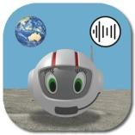
The CosmoBally on Sonoplanet app is specifically designed for young students as a first and basic introduction to sonification. Thus, its method of sonification needs to be easily understood. During recent SPEVI and Round Table Conferences presentation participants took part in a quiz. Sonokids was able to confirm that participants in the quiz could interpret their method of sonification to correctly identify sonified shapes after less than 3 minutes of instruction (Damsma et al., 2023). In essence, the Sonokids method works this way: the tempo of a double tone increases to the right and decreases to the left. In the vertical plane, the pitch increases the higher a data point is located on the screen. As a result, a special quality of the Sonokids sonification method is its capacity to add directional information to a shape: not only can you hear if it is a vertical or horizontal line that is being sonified, but the sonification also lets you hear if it goes from top to bottom/ from bottom to top, or from left to right or right to left. This enables a student who is blind, or vision impaired to follow the process of creation, rather than for instance being presented a ready-made raised line drawing of a shape. Ten-year-old Morgan, who is blind, was instrumental in testing the prototypes of the app. She commented: “I like being able to actually hear the shape being drawn”.
After a virtual countdown and brief space flight to Sonoplanet, the CosmoBally on Sonoplanet app offers students four educational games that support early learning of sonification. In Game 1, a quiz, students learn to compare and identify sonified shapes. In Game 2 they virtually collect interesting items from the planet’s surface while tracing a sonified rectangle with their finger on the touch screen. In Game 3 they can create and listen to sonified drawings by dragging a finger over the screen. Game 4 is an action game involving a digital game grid with rows and columns. Attentive listening skills are needed to analyse information from sets of two sonifications to locate resident aliens (‘Saliens’) hiding in a rocky, pitch-dark part of Sonoplanet.
Sonification for Learning
Sonification has a place for integrated cross-curricula learning and as a medium to be inclusive for all students. Sonification can be used to address areas of both mainstream curriculum and the Expanded Core Curriculum for Students with Vision Impairment (ECC) e.g. in orientation and mobility, in sport, and in mathematical graphing calculators such as Desmos (Allman et al., 2014). It can be applied to have the whole class listening to the stars or to inspire works of art and musical pieces.
In 2021 co-author Phia Damsma gave a presentation for the NextSense Vision Impairment Conference (VISCON) titled ‘Sonification in Education: From Outer Space to Spatial Orientation’ (Damsma, 2021). After attending this presentation, co-author Lily Gower explored the NASA sonifications of astronomical data of objects in space, which in turn inspired integrated arts project ‘Star Stories’ at SASSVI. This project is a beautiful celebration of dance and music inspired by First Nations stories of the sky. Star Stories was a collaboration between SASSVI students, creative arts teacher Lily Gower, dance practitioner and descendant of the Barkindji People of NSW Adrianne Semmens and Audio Describer Eliza Lovell. Further information on this project can be found at https://sassvi.sa.edu.au/.
Figure 2: Students listening to NASA sonification of the Butterfly Nebula
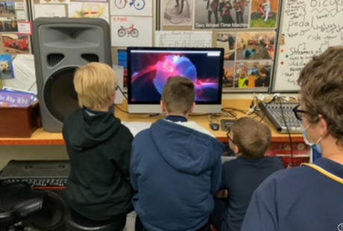
From March 2022 to February 2023 an online qualitative user survey on the Sonoplanet website was conducted in order to gain initial insights into the perceived capabilities and skills of young students who are freely engaging with sonification through the CosmoBally on Sonoplanet app. The survey identifies learning outcomes as reported by 17 educators who used the app with their students. These outcomes include both the development of sonification skills as well as important non-sonification skills (Damsma, under review).
Using sonification to identify and understand lines, directional concepts
Game 1 of the app (Hearing shapes) introduces the Sonokids method of sonification by way of a quiz format. In part 1, two sonifications are played, one after the other, and the student needs to listen to, interpret and analyse the sonification to determine if the sonified shapes were the same or different. In the first levels, the shapes are lines, being drawn in different directions. In game 4 of the app (Find the Saliens) sonified ‘indicators’ provide information about a Salien’s exact location in the game grid. In the design stage the app developers gave careful consideration to best practice for introducing directional and spatial concepts in these two games, and the terminology around them. Specialist Teachers (Vision Impairment) and other vision professionals were consulted, via informal online interviews and via the SPEVI Mathematics Facebook Group. As a result, in the default setting of game 1 the terminology used for lines gradually transitions from what is perceived to be basic (such as ‘side-to-side’) to advanced (such as ‘horizontal)’. In Game 4, adjustable settings allow for selecting either ‘grid terms’ (spoken rows and columns) or ‘spatial terms’ (‘top left corner’). Preliminary results from the previously mentioned online survey on the Sonoplanet website suggest that the survey participants report ‘learning directional concepts’ as the second most important learning outcome of the app, after ‘skills to analyse and interpret sounds’.
Application to curriculum
SASSVI runs two "Learning for Life" days per term, where students take part in learning activities designed specifically to address areas of the ECC. For the past two years Lily Gower has used the “Learning for Life” day to focus on tactile graphics skills and sonification. Sonification is applied to facilitate students’ progression of learning of the concepts of lines and shapes, from directional terms such as horizonal and vertical, to columns and rows, grids and coordinates, to compass directions and mapping, and other areas of tactile graphics. The CosmoBally on Sonoplanet app was used to introduce students at SASSVI to sonification, to tune in, and practice aural discrimination skills, and as a jumping off point into other activities.
As illustrated by the following photos, during these activities students wore headphones, and each had an iPad with CosmoBally on Sonoplanet installed. While the app is designed for use on iPads or Android tablets, in a situation where these were not available in sufficient numbers, downloading and using the app on an iPhone showed to be another effective way to engage a student who had previously demonstrated to be comfortable with using iPhone technology.

Figure 3: Students wearing headphones, each with an iPad using the CosmoBally on Sonoplanet app
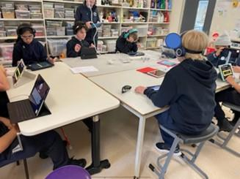
Figure 4: Student with an iPhone engaging with CosmoBally on Sonoplanet app Game 3 (Sonified Drawing)
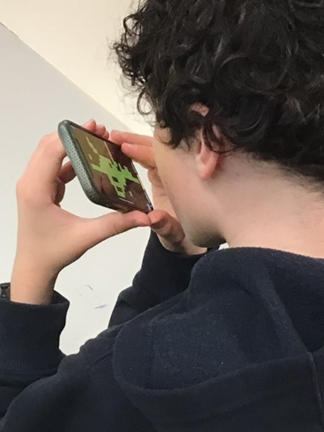
Details of "Learning for Life" activities and their learning intentions are described in the following section which provides 2 excerpt examples of lesson plans, developed by Lily Gower, using the CosmoBally on Sonoplanet app.

Lesson 1: What is sonification?
Learning Intention: For students to develop their ability to recognise, interpret, use and create tactile graphics, in particular maps or images using coordinates, grid lines and different types of graphs.
Key Question: What is sonification? Where is sonification used? Why is sonification useful?
- Listen to a range of different types of sonified lines – This was done using game 1 of the app.
- As you listen to each line, draw it in the air using your finger. (Kinaesthetic learning is important). Discuss using terminology of increasing complexity (e.g. up and down/side to side, vertical/horizontal)
- Listen to a range of different sonified shapes using the app. Draw what you hear using a Raised Line Drawing Kit (RLDK) or pen and paper.
- To develop conceptual understanding of vertical and horizonal lines, go out into the courtyard and use your bodies to explore concepts of vertical (standing up) and horizontal (lying down) lines. Go back to the art room – when we talk about vertical and horizontal lines in graphics, we are talking about lines in a 2D plane. Explore concept using Wikki Stix on raised desk slopes or pieces of card.

Figure 5: Students working on their understanding of vertical and horizontal lines using their bodies in the courtyard
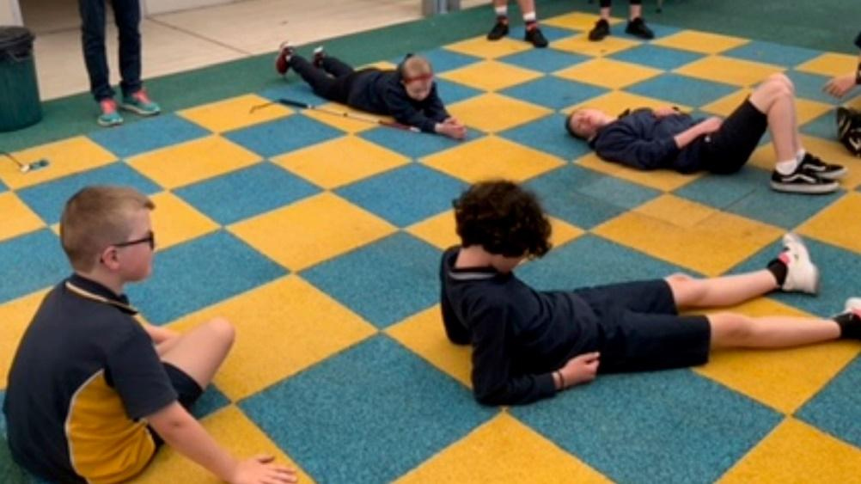

Figure 6: Student using her body to demonstrate her understanding of vertical and horizontal lines
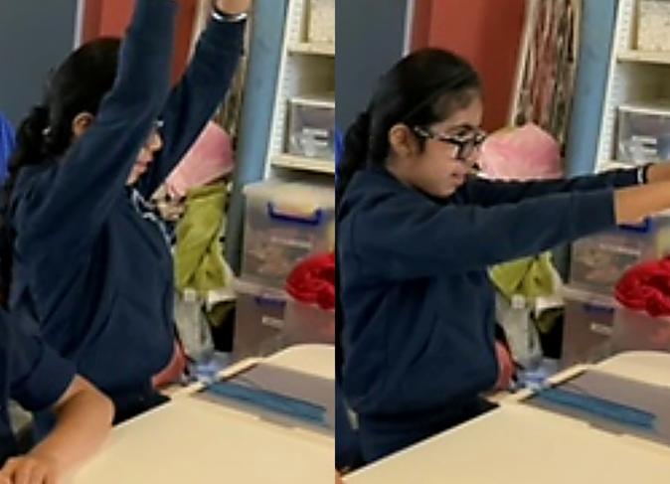
Lesson 2: Conceptual understanding of grid lines.
- Students tune in by playing CosmoBally on Sonoplanet app Game 4: Find the Saliens. This game is set up as a grid with rows and columns.
- Have students use lines or Wikki Stix to create a page of ‘rows’.
- Have students use lines or Wikki Stix to create a page of ‘columns’
- Ask - What would happen if you added columns to your page of rows? (you get a grid)!
- Discuss what systems you might be able to use to navigate columns and rows. Hopefully this will be easy, and students will automatically think of grid references.
- Have students use print/braille to label a grid with letters and numbers. Practice putting gems/stickers in particular locations on their grid.
- Consolidation of columns and rows. Play ‘Battleships’ to consolidate understanding of columns and rows. Tactile users to play a simplified version using ‘child’s Ply’ grids [childsPly].
Figure 7: Students using Wikki Stix to work on their understanding of vertical, horizontal and grids as per the lesson plan
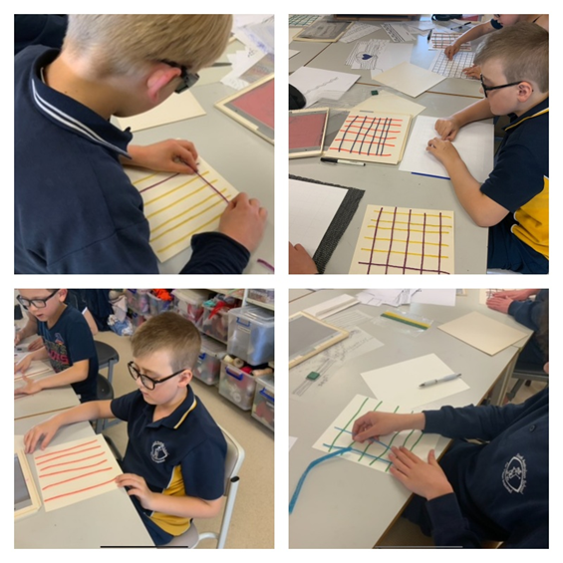
Figure 8: A student playing a game using a wooden grid and wooden tiles consisting of different tactile shapes. The grid is placed on a piece of card with braille and print coordinates written on the x and y axis
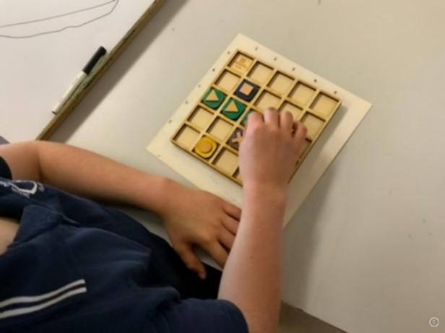
Figure 9: Student and staff member playing the traditional board game “Battle Ships” and (right)using a wooden grid and wooden tiles consisting of tactile shapes
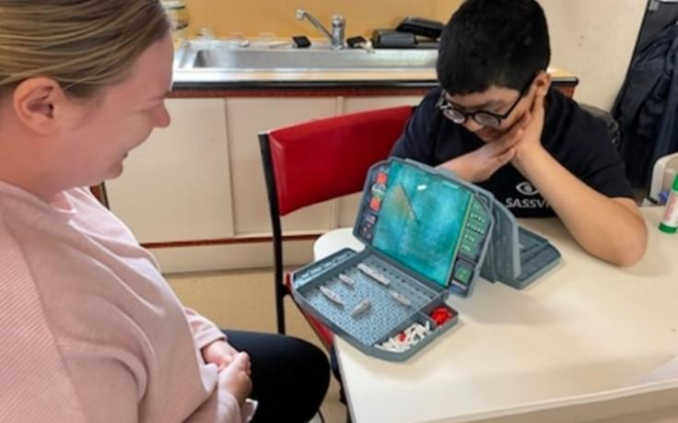
In the school courtyard students listened to sonified examples of graphs played from the Perkins website. They were working together to create what they thought the maths graph would look like using their bodies and a large piece of rope. This was a great problem solving and team building activity.
Figure 10: Students trying to represent a sonified maths graph in the shape of the rope they are holding up
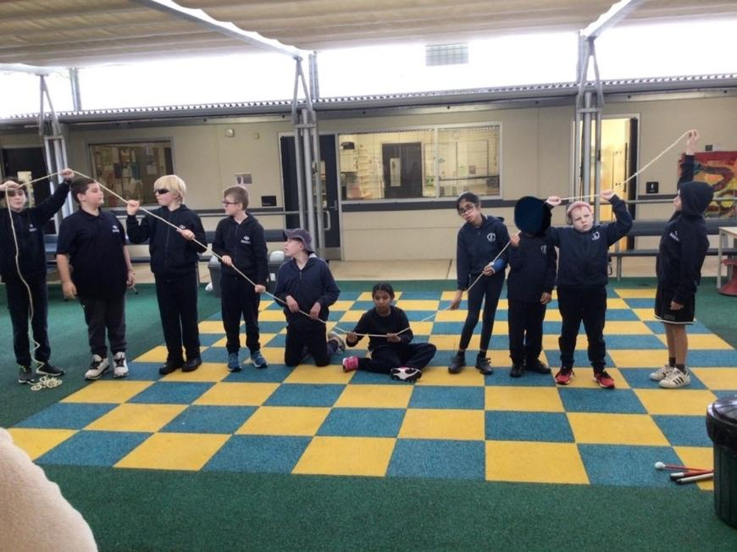
Conclusion
By sharing background information about the design and purpose of the educational game app CosmoBally on Sonoplanet combined with original lesson suggestions and examples of how sonification and the app can be applied to teach specific learning intentions, the co-authors aim to inspire educators to engage with sonification and use sonification to support learning by students who are blind or vision impaired.
Acknowledgements
We sincerely thank students, parents, and staff from SASSVI for their permission to share images.
The development of CosmoBally on Sonoplanet app was supported by funding from South Pacific Educators in Vision Impairment (SPEVI) Inc. The 3D printed CosmoBally tactile learning tool was supported by Mable Community Fund.
References
Allman, C., Lewis, S., & Spungin, S. J. (2014). ECC essentials: teaching the expanded core curriculum to students with visual impairments (Allman, S. Lewis, & S. J. Spungin, Eds.). AFB Press.
Child’sPly. https://childsply.wixsite.com/catalogue/vision
Damsma, P. (2021). ‘Sonification in Education: From Outer Space to Spatial Orientation’. Presentation for Vision Impairment Conference (VISCON), NextSense Institute, Sydney, Australia, 20-21 August 2021. https://www.youtube.com/watch?v=Jzx_uMLBAUM
Damsma, P., Norgaard, J. T., & Cashmore, C. (2023, June 26-30). Accessible Sonification Design for Young Learners [Conference session]. International Conference on Auditory Displays, Norrköping, Sweden. https://www.itn.liu.se/~nikro27/icad2023-papers/ICAD23_paper_7434.pdf
Damsma, P. (2023). Hearing a Circle: An Exploratory Study of Accessible Sonification for Young Children with Blindness and Low Vision. Advance. Preprint. https://doi.org/10.31124/advance.24563305.v1
NASA Chandra Sonification of the Butterfly Nebula. https://svs.gsfc.nasa.gov/13998?linkId=140419351
Sonification World Chat. https://sonificationworldchat.org/
United Nations Office of Outer Space Affairs (2023, April). Sonification: a tool for research, outreach and inclusion in space sciences. Special Report by the Space for People with Disabilities Project. https://www.unoosa.org/documents/pdf/Space4PersonswithDisabilites/UNOOSA_Special_Report_on_Sonification_2023.pdf
Authors: Lily Gower, South Australian School & Services for Vision Impaired (SASSVI). Email: Lily.gower464@schools.sa.edu.au
Phia Damsma, Creative Director of Sonokids Australia, Email: phia@sonokids.com

Report: International Council for Education of People with Visual Impairment (ICEVI) - Frances Gentle, President (global) and Jo Mosen, President (Pacific region)
Website: https://icevi.org/
Dear Readers
We are pleased to present the following summary report of the activities of ICEVI during 2023. In preparing the report, we acknowledge, with thanks, the many members, partners, and supporters who have contributed to the mission, values and goals of ICEVI throughout the year.
ICEVI returned to in-person regional conferences during 2023. The ICEVI East Asia conference was held in Jogjakarta, Indonesia, on 18-20 September; and the ICEVI Africa conference was held in Nairobi, Kenya, on 10-12 October 2023. Attendance at both conferences far exceeded expectations. In addition to the quality of the conference programs, the high attendance rates may be due in part to our human desire to reconnect in person, especially after two years of physical separation due to the global pandemic.
ICEVI will be holding its World Conference and General Assembly in Ahmedabad, India, on 14-17 November 2024. The conference theme is “Inclusion in Diversity: Equity and Accessibility for All”, and the conference aims include promoting the exchange of ideas, experience, research, and practice worldwide in the field of VI education, drawn from the seven world regions of ICEVI. For details of the 2024 World Conference, please visit the conference website, https://icevi2024wc.org/.
ICEVI hosted and participated in a range of meetings, workshops, and other events during 2023. These included the Vision Alliance meeting of ICEVI, World Blind Union and the International Agency for Prevention of Blindness (IAPB), held online in March; the UN Conference of States Parties to the Convention on the Rights of Persons with Disabilities (CRPD), held in New York in June; DeafBlind International meetings of the global deafblind education committee, Board meetings of the WIPO Accessible Books Consortium, and the WIPO 10th anniversary celebrations of the Marrakesh Treaty, held in Geneva in July 2023. In November and December, ICEVI, in collaboration The Nippon Foundation (Japan) and Resources for the Blind Inc (Philippines), hosted the Regional Mathematics master training workshop for teachers, and the Regional Youth Summit for graduates of ICEVI’s higher education initiative, with both events held in the Philippines.
We invite you to visit the ICEVI website, https://icevi.org/, to access the January 2023 issue of The Educator, the March and August issues of E-News, 2022 and 2023 annual reports, the Math Made Easy YouTube channel, which contains more than 600 instructional mathematics videos, and the Partnerships for Change YouTube channel, which features case studies drawn from ICEVI’s higher education initiative.
Report on ICEVI Pacific, by Jo Mosen, regional President
2023 was a busy year for ICEVI Pacific. We started the year with ICEVI Pacific supporting the coordination and funding of Pacific Hubs to support attendance at the SPEVI conference, held online in January. ICEVI funded two Pacific hubs for the SPEVI Conference with SPEVI funding a third Pacific hub and an evaluation of the hubs undertaken by one of our board members, Associate Professor Angela Page from the University of Newcastle. Participants from all three hubs (Solomon Islands Vanuatu and Kiribati) completed an evaluation survey and participated in follow up interviews, with overwhelming positive feedback about the hubs. Angela reported that overall, participants provided appreciation towards the hubs including funding to support booking a central location, reliable internet, cost-free registration, opportunities for local side events and catering that facilitated communal discussions. She is now writing a peer reviewed journal article to further promote the success of these hubs and how the key components that made the hubs such a success, can be used for improved inclusion in other conferences. As a result of the hubs, there was significantly greater attendance from the Pacific region than ever before, with approximately 60 Pacific Islanders across the three hubs.
Teburantaake Kaei, one of the Kiribati local hub coordinators and ICEVI Pacific Vice President, shared that “it was great that people from the Ministry of Education were able to also attend as it was held in the ministry’s boardroom”. She noted “it was a good opportunity to promote inclusion” sharing that ministry staff “heard the interest and energy from the room so joined in”. Teburantaake noted the importance of this stating “the conference hubs are attracting important people who would not be selected to attend in person conferences but have their interest in the topic sparked due to the proximity of the hub to ministry offices”.
Another success of the hubs were seen through follow up events. For example, the local hub coordinators requested a follow up session with keynote presenter, John Ravenscroft. As a result of this follow up event, Solomon Island participants have developed a community interested in vision impairment inclusion in education and key follow up actions to promote this topic in schools. In addition, the hubs motivated Pacific presentations with Vanuatu and Kiribati delivering pre-recorded video presentations at the SPEVI conference and Jo Mosen, ICEVI Pacific President delivering a plenary session on inclusive education in the Pacific.
In March, ICEVI Pacific President and four of our board members attended the Pacific Disability Forum Conference in Nadi, Fiji. At this event, ICEVI Pacific hosted a side-event where 30 people from across the Pacific shared stories, experienced a range of adaptive technology and enjoyed the Fijian hospitality with a delicious dinner.
Angela Page also promoted the success of the hubs at a presentation at the 51st Annual Conference of the Oceania Comparative and International Education Society (OCIES), hosted by the National University of Samoa (NUS) in November 2023 where she also managed a poster presentation, sharing the recently developed ICEVI Pacific advocacy brochure.
The ICEVI Pacific advocacy brochure was developed collaboratively with positive input across the region with board members Martine Able Williamson, WBU President, Sonia Wasi from the Vanuatu Education Support Program and Angela Page from the University of Newcastle, playing a significant role in its development.
ICEVI Pacific donated a desk top video magnifier to the National Library of Kiribati. The handover of this device occurred in November 2023 and included training and an electronic version of the user manual. The video magnifier was showcased in International Day of Persons with Disabilities events, as the first assistive device for people with vision impairment in the library and has motivated library staff to establish an access corner for students and adults who come in to use the library. The Kiribati national library manager, Teewata, shared that “we are very proud of our reading screen machine”.
Before the year came to a close, the ICEVI Pacific President compiled a response to the new DFAT Disability Equity and Rights Strategy. The ICEVI Pacific commissioned 2021 Scoping Study, written by Mereoni Daveta and Deborah Rhodes, was well utilized in preparing a strong response with relevant evidence from the Pacific region. The ICEVI Pacific President also prepared a response on behalf of SPEVI that was submitted to DFAT by the SPEVI Presidents.
The year closed with the sad passing of Dr Kevin Murfitt OAM. At ICEVI Pacific we remembered Kevin’s contribution across the region with the funeral attended remotely by a number of our board including our secretary, Robyn McKenzie. We close with a tribute from Ipul, a leader in the disability movement from PNG who shared that she “is really sad to hear of this tragedy” and that “the PNG Blind Union in PNG ADP were very sad to hear of the passing of a great mentor in Kevin”.

Report: NextSense - Frances Gentle, Sue Silveira and Trudy Smith
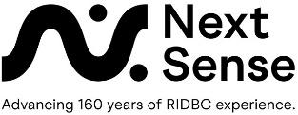
Launch of competency exams in Unified English Braille (UEB)
NextSense is pleased to announce the launch of four online competency examinations in Unified English Braille: UEB Literary, UEB Introductory Mathematics, UEB Advanced Mathematics, and UEB Extension Mathematics. The exams have been developed in response to requests from UEB Online subscribers for a pathway to braille competency certification for study and employment purposes.
In the tradition of the UEB Online training programs, the exams are fully accessible, self-paced, and may be completed at any time of the year. The content of each exam follows the content taught in the corresponding UEB Online training programs. An administration fee of AUD70.00 is charged by NextSense for each competency exam. Candidates will require a PC or laptop and internet connection to register on via the UEB Online website. Registration enables each candidate to access their personal account from any computer and to receive notifications via their personal dashboard on the status of current and completed UEB exams and training courses. Successful candidates receive a certificate of competency and detailed information on their performance in each exam they complete. Unsuccessful candidates are offered the opportunity to re-sit their chosen exam up to three times (if needed) within the next 12-month period. Unsuccessful candidates are provided with a list of their braille code errors and referred to the training support provided in the resource section of the UEB Online website.
We invite you to visit the UEB Online website for detailed information about the examination process - https://uebonline.org/
Master of Disability Studies
The course is suited to qualified teachers wishing to obtain a specialist qualification to teach students who have vision impairment, and also allied health and other professionals seeking to complete studies in disability. The course is delivered online and on demand with a 16-day practicum. Commonwealth supported places and scholarships are available and students can access all services and benefits offered by both NextSense and Macquarie University.
Within the Blindness Low Vision specialisation, students complete units that address inclusion and collaboration, educational adjustments, literacy and technology, foundational studies in vision impairment, research in sensory disability, orientation and mobility, and professional experience.
Within the Sensory Disability specialisation, students complete units that address inclusion and collaboration, perspectives in disability, foundational studies in vision impairment and deafness/hard of hearing, research in sensory disability and professional experience.
The Master of Disabilities Studies remains popular in the field, with 277 students.
Continuing Professional Education 2024
We have a range of exciting events coming up that may be of interest to you all:
- The CVI practice framework: An approach for working with children who have cerebral visual impairment in an education or habilitation/rehabilitation context. Dr Nicola McDowell is returning to share information about the Austin assessment on the 21 March. If you registered to watch this in 2022-23 then you will receive free access to the final lecture. If you are joining us in 2024, you can watch sessions 1-5 before joining us for session 6. Event information.
- Braille Music Introductory Course: This introductory course into Music Braille is designed to give vision support teachers an overview of music transcription. Event information.
- Exploring Multisensory Communication for Blind, Low Vision, and Diverse Needs Inclusion: This 3-day event provides a range of workshops for teachers, therapists, families, and students. Event information.
- Let’s Get Thinking! Executive Functions, Divergent Thinking, and TVI Influence through Instruction and Graphic Literacy for Students with Visual Impairments: These two days will focus on understanding the thinking skills of students, and how we can support our students with VI to engage with and understand visual information in the classroom. Featuring Kim Zebehazy. Event information.
- BLV Masterclass Series- more details to come, but there will be a technology focus featuring world class international presenters! Scheduled Courses link.
- Missed one of our great programs over the last 2 years? Follow up on our On-Demand page to catch up!

South Pacific Educators in Vision Impairment Inc. Privacy Policy 2023
SPEVI Inc is an Association incorporated under the laws of NSW, Australia – Registration number INC9889733.
Australian business number (ABN) 44 545 374 588.
Your privacy is important to us. SPEVI is committed to upholding the spirit of the New Zealand Privacy Act 2020, Australian Privacy Act 1988 and Australian Privacy Principles 2012.
Collecting and keeping your information safe
SPEVI maintains a register of members as required by the NSW Government Fair Trading. The registered information is drawn from the SPEVI Membership Form, and consists of member names, email addresses, SPEVI membership numbers, join date, and the optional member information of country, state, role, and organisation/affiliation. SPEVI does not retain bank account details or qualification details, such as academic transcripts (Membership Category 2).
SPEVI retains member information for the following specific purposes:
- To comply with the Australian and New Zealand Privacy Acts and Privacy Principles. These laws regulate the handling of personal information about individuals, including the collection, use, storage and disclosure of personal information, and access to and correction of that information.
- To enable SPEVI to maintain effective business and accounting standards.
- SPEVI does not supply information about members to marketing organisations or third parties without your consent, unless required by law.
How SPEVI uses your personal information
- To facilitate communication between the SPEVI Committee of Management, SPEVI Councillors, and SPEVI members,
- To manage email distribution of information to members,
- To inform members about the activities of the Association, and
- To provide information to government and regulatory authorities, as required or authorised by law.
How can you access your personal information?
- SPEVI members have the right to access their personal information, free of charge, subject to some exceptions allowed by the law.
- For privacy and security reasons, requests for information must be submitted in writing to the SPEVI Membership Secretary (contact details below). Written requests must include the member’s name and current email address.
Help us ensure we hold accurate information
SPEVI takes all reasonable precautions to ensure that the personal information we collect is accurate, complete, and up to date. However, the accuracy of information depends to a large extent on the information you provide. For this reason, please inform the SPEVI Secretary of any changes or corrections in your personal information, such as your name and email address. Email: spevisecretary@gmail.com

About SPEVI
The South Pacific Educators in Vision Impairment (SPEVI) Inc. is the major professional association for educators of students with vision impairments in Australia, New Zealand and the South Pacific region. SPEVI acts as the professional body in matters pertaining to the education and support of persons who are blind, have low vision, deaf-blindness, or additional disabilities. SPEVI membership is open to educators, professionals and parent groups who support and promote education for persons with vision impairment.
SPEVI Inc. is an Association incorporated under the laws of NSW, Australia – Registration number INC9889733.

SPEVI Vision
To promote educational systems in Australia, New Zealand and the South Pacific in which diversity is valued and disability is not viewed as a characteristic by which to judge a person’s worth.

SPEVI Mission
To stimulate professional and public debate and action on vision impairment issues and change which affect or have the potential to affect the daily lives of persons who are vision impaired, while emphasising concepts of inclusive, responsive educational communities and interdependence between learners and families within those communities where all people are valued.

SPEVI Aims
- To be recognised as the professional body of educators whose specialty is in matters pertaining to the education of persons with vision impairment in Australia, New Zealand, and Pacific Island Countries.
- To advocate on behalf of members, persons with vision impairment and parents/carers for equitable education access and participation, in accordance with international and national disability anti-discrimination legislation.
- To encourage the highest standards in the educators of persons with vision impairment by promoting research and professional training for general and specialist teachers.
- To promote and facilitate the interchange of information and collaboration among educators, professionals, parent groups and the broader community concerning education and equal opportunity for persons with vision impairment.
- To encourage the use of appropriate mainstream and assistive technologies, resources and optical and non-optical aids, in the education of persons with vision impairment, and to promote teacher education programs in the use and care of existing and new techniques and technology.

SPEVI Structure
SPEVI operates at two levels:
- National level, by means of the Committee of Management.
- Local level (state/territory), by means of a Branch comprising SPEVI Councillors and members who reside in the location.

SPEVI Code of Ethics
- All members of SPEVI will:
- Work for the good of SPEVI and actively support and promote its Aims as defined in the SPEVI Constitution.
- Act honestly and with respect and integrity at all times.
- Provide leadership for all members of SPEVI to foster high ethical standards.
- Act to enhance public awareness of SPEVI’s objects; and
- Maintain transparency of decision-making within SPEVI.

Committees of Management
SPEVI is managed at the national level in Australia and New Zealand by a Committee of Management. The national Committees, subject to SPEVI’s Constitution and to any resolution passed by SPEVI in general meeting, are responsible for the governance and management of the activities of the Association and its members. The Australian Committee manages and supports Australian and the Pacific Island members.

Australia Committee of Management, 2020-22
Co-Presidents: Phia Damsma and Dr Melissa Fanshawe
Vice-President: Ben Clare
Immediate Past President: Dr Frances Gentle
JSPEVI Editor: Dr Bronwen Scott: bronscott65@gmail.com
Secretary: Ben Clare: spevisecretary@gmail.com
Treasurer: David Rice: spevi.treasurer@gmail.com
Membership Secretary: Ben Clare: membershipspevi@gmail.com
Public Officer: Dr Sue Silveira
Directors: Pranitha Moodley and Emily White
Access Coordinator, Web and List administrator: Phia Damsma: webmaster@spevi.net
SPEVI Representative, International Council for Education of People with Visual Impairment: Joanne Mosen
SPEVI Facebook Editors: Ben Clare: bwclare@gmail.com; and Yin Yin Htay: yinyin.htay@blennz.school.nz
SPEVI Representative, Round Table on Information Access for People with Print Disabilities: Phia Damsma

New Zealand Committee of Management, 2019 - 2020
All communications to Email: spevinz@gmail.com and Attention - President, Treasurer or Secretary.
Co-Presidents: Shiree Arrian and Lynda Williams
Treasurer: Lynda Williams/Jude Shelley
Secretary: Jude Shelley
Executive Committee Member: Sue Spooner

Whānau refers to extended family, the family group, and is a familiar term of address to a number of people. In the modern context the term is sometimes used to include close family friends.

